Збірник наукових праць. Галузеве машинобудування, будівництво
Academic journal. Industrial Machine Building, Civil Engineering
http://journals.nupp.edu.ua/znp
https://doi.org/10.26906/znp.2023.59.0000

UDC 69.005.52:622.271.3.05

Improving the efficiency of the screw
unit of plastering plants

Salnikov Roman¹*, Rudyk Rostyslav²

¹ National University «Yuri Kondratyuk Poltava Polytechnic» https://orcid.org/0009-0001-0408-4358
² National University «Yuri Kondratyuk Poltava Polytechnic» https://orcid.org/0000-0001-8386-977X
*Corresponding author E-mail: itm.rsalnikov@nupp.edu.ua

The article focuses on enhancing the efficiency of screw units in small-sized plastering installations for pumping mortars within the construction industry. It delves into the analysis of existing plastering unit structures, evaluating their respective advantages and disadvantages. Additionally, the article provides an overview of various mortar pumps and their associated parameters. A key objective of the study is to conduct a comparative analysis of current small-sized plastering unit designs and to elevate the effectiveness of mortar pumping. Mathematical models are presented to determine coefficients that consider the non-uniformity of conditions for the concrete mixture's end, as well as the necessary pressure for optimal filling of the working cylinder with the concrete mixture. Furthermore, the article explores the utilization of innovative technologies and materials to enhance the efficiency and functionality of the screw unit.

Keywords: screw unit, plastering unit, mortar, productivity, pumping, mortar pump

Підвищення ефективності роботи гвинтового
вузла штукатурних установок

Сальніков Р. Ю^{1*}., Рудик Р. Ю²

¹Національний університет «Полтавська політехніка імені Юрія Кондратюка»
² Національний університет «Полтавська політехніка імені Юрія Кондратюка»
*Адреса для листування E-mail: itm.rsalnikov@nupp.edu.ua

У статті розглядається критична необхідність підвищення ефективності гвинтових агрегатів у малогабаритних штукатурних установках для перекачування розчинів у будівельній галузі. Проводиться комплексний аналіз існуючих конструкцій штукатурних агрегатів, оцінка їх відповідних переваг і недоліків. Крім того, у статті пропонується ретельний огляд різних типів розчинонасосів і пов’язаних з ними параметрів, що забезпечує цілісне розуміння поточних технологій перекачування розчинів. Основним завданням дослідження є проведення порівняльного аналізу існуючих конструкцій малогабаритних штукатурних агрегатів, основною метою якого є підвищення ефективності процесів перекачування розчину. Це включає в себе детальний аналіз операційних механізмів і показників продуктивності цих підрозділів з метою визначення областей для вдосконалення та оптимізації. У статті також введено математичні моделі, які відіграють вирішальну роль у визначенні коефіцієнтів, що враховують нерівномірність умов кінцевого стану бетонної суміші. Ці моделі допомагають розрахувати необхідний тиск для оптимального наповнення робочого циліндра бетонною сумішшю, тим самим сприяючи загальній ефективності та результативності процесу перекачування. У статті досліджено застосування інноваційних технологій і матеріалів для підвищення ефективності та функціональності шнекового агрегату. Впроваджуючи передові досягнення та матеріали, мета полягає в тому, щоб підвищити продуктивність і експлуатаційні можливості штукатурних установок малого розміру, що в кінцевому підсумку призведе до покращення процесів перекачування розчину в будівельній галузі. Підсумовуючи, стаття є цінним ресурсом для професіоналів, дослідників і зацікавлених сторін у галузі, які прагнуть підвищити ефективність штукатурних установок малого розміру та оптимізувати процеси перекачування розчину в будівництві. Він містить повний огляд поточного стану штукатурних установок і технологій накачування розчину, а також пропонує розуміння можливих областей для вдосконалення та інновацій.

Ключові слова: гвинтовий вузол, штукатурний агрегат, будівельний розчин, продуктивність, перекачування, розчинонасос

Introduction.
Improving the efficiency of the screw unit of small-sized plastering installations for pumping mortars is an urgent problem in the field of construction technology and engineering. Ensuring high-quality and productive operation of these plants is essential for the construction industry, which is constantly developing and improving. Today's construction sector faces a number of challenges, including increased competition, the need to reduce costs and increase productivity. One of the ways to solve these problems is to improve the equipment and technologies used at construction sites. Screw assemblies in small plastering plants are a key component for supplying mortars, and their efficiency can have a significant impact on workflow productivity. However, in order to achieve maximum productivity and quality of work, it is necessary to take into account various aspects, such as the design of the screw assembly, the properties of mortars, the parameters of the working environment and other factors. It is also important to select rational materials and technologies for the manufacture of screw assembly components. In this study, we will investigate various aspects of improving the efficiency of the screw unit of small-sized plastering plants for pumping mortars. The article discusses the types of plastering and finishing works, types of plastering installations and mortar pumps, analyzes the existing designs of plastering units, analyzes their advantages and disadvantages.

Review of the research sources and publications.
Furnishing works in construction make up about 35% of the total labor intensity of works, and they use a wide range of technologies and materials.
Ukrainian scientists were also engaged in the development and improvement of various types of mortar pumps for pumping mortars. Nazarenko I.I. [1], Onyshchenko O.G. [1.3], Yemelyanova I.A. [10-13] Korobko B.O. [7] are the most famous among them.
Publications provide a comprehensive overview of the current state of plastering units and mortar pumping technologies, while also offering insights into potential areas for improvement and innovation. The sources cover a wide range of topics related to the efficiency of screw units in small-sized plastering installations for pumping mortars within the construction industry.

Definition of unsolved aspects of the problem
There is a need for standardized guidelines or industry standards for the design and performance of small-sized plastering plants. The lack of universally accepted standards can lead to differences in efficiency and effectiveness across departments.
There is a lack of comprehensive understanding of the integration of advanced materials, such as high-performance polymers or composite materials, into the design of screw assemblies to improve durability and performance.
There is a need for further research to optimize pumping parameters to achieve the most efficient injection processes.
Addressing these unresolved aspects will contribute to the comprehensive improvement of screw assemblies in small plastering plants, resulting in more efficient and sustainable mortar pumping processes in the construction industry.

Problem statement
Comparative analysis of existing designs of small-sized plastering units, with further increase in the efficiency of pumping mortar.

Basic material and results
Today, two types of solution pumps are used: screw pumps and hose pumps.
Hose solution pumps (Fig. 1, а) allow for a continuous supply of the pumped mixture [4]. The working body of such a pump is a piece of elastic hose along which two or more rollers roll, deforming the hose, completely blocking the passage area under the roller, continuously pushing the solution into the mortar pipeline. The mixture is sucked in due to the elastic properties of the elastic hose. For better recovery of the hose dimensions in cross-section, a vacuum suction circuit is used and the entire mechanism is placed in a sealed chamber. This greatly complicates the design of the pump and its maintenance.
Hose mortar pumps are mainly used for pumping mortars that occupy an intermediate position between plaster mortars and concrete mixtures with a fraction size of up to 7 mm.
The scope of application of hose solution pumps is limited by economic feasibility due to the very short service life (less than 20 hours) of the main working body — the hose. When operating under a vacuum-free suction scheme, the hose quickly loses its elasticity, which leads to the loss of performance of the solution pump.
Screw pumps (Fig. 1, b) are used for pumping plaster mortars. The main features of the pump are uniformity of flow, compactness, simplicity of design and operation and light weight. The pump assembly of a single screw pump includes a cast iron or steel single-head screw with a specific pitch and a rubber cage with an elastic working surface. The propeller receives rotation from the electric motor through a gearbox. The cross-section of a screw is a circle, the center of which is shifted relative to the axis of the screw by an amount of eccentricity. The working surface of the cage is a double-threaded screw with a pitch twice that of a steel thread. Due to this design, when the working surfaces of the screw and the cage come into contact, a closed line is formed, the totality of which limits the closed chambers. During the rotation of the screw, the chambers are filled with the mixture to be transported and move continuously along the axis of the screw from the hopper to the discharge nozzle. Unlike reciprocating pumps, screw pumps do not have valves. The tightness of the chamber is ensured by tension in the connection of the screw with the elastic cage.

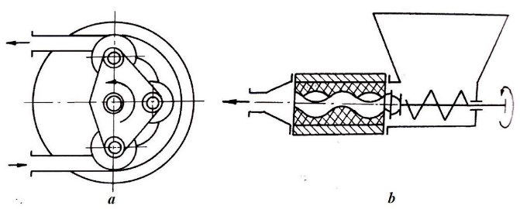
Figure 1 – Diagram of hose (a) and
screw (b) solution pumps

Recently, screw solution pumps have become more widely used, but depending on the manufacturer, they may not be economically feasible or have a low capacity. Therefore, it is advisable to improve the existing design.
On construction sites, various plastering units with screw mortar pumps are used, one of which is SO-152 [1]. It provides filtering, feeding and application of plaster mortars to the surface to be treated. The SO-152 unit, complete with a compressor unit, can carry out surface coating by spraying. It consists of two compact main units: a mortar pump and a receiving hopper with a vibrating sieve. Both nodes are connected to each other by a rubber-fabric sleeve with a quick coupling.

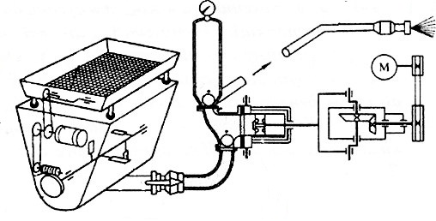
Figure 2 – Diagram of the
plastering unit SO-152

The finished solution, delivered to the place of work, is unloaded onto a vibrating sieve. The vibrator provides 50 Hz oscillations to a movable frame with a sieve set at an angle of 5° to the horizontal, for convenient removal of large inclusions, that did not pass through the sieve cell. The solution filtered through a vibrating sieve enters the receiving hopper, and from there through the suction hose to the working chamber of the mortar pump. It is then fed through a pressure solution pump to the nozzle and applied to the treated surface.
The advantages of this design of the plastering unit are compactness for ease of transportation from one workplace to another and the presence of a vibrating screen, which allows you to prepare a mortar with aggregates of certain fractions.
The disadvantage is the division of the structure into two units mounted on independent frames, which leads to an increase in the bulkiness and cost of such equipment. The performance and pressure figures generated by the mortar pump are also insufficient for a wide range of uses of this equipment.
Plastering unit SO-150 is designed for surface application of putty mixtures, primers or water-adhesive paints on treated surfaces. The plaster is applied with a fishing rod using compressed air, and the primer and paint are applied with a pressure pump.
The unit is built on the basis of a screw pump with a loading hopper, a feed hose with a fishing rod and an electrical cabinet. The unit is driven by a two-speed electric motor through a V-belt transmission and a gearbox. At the bottom of the hopper there is a conveyor that mixes the inlet mixture and directs it to the suction part of the pump.
The disadvantage of putty units is their low productivity and unsuitability for supplying slow-moving and dry mixtures.
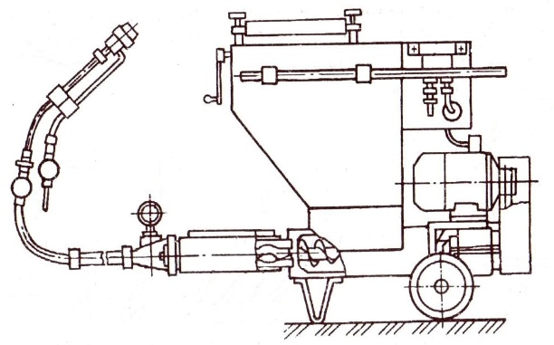
Figure 3 – Diagram of the SO-150
plastering unit

Plastering unit SO-154A is designed for the preparation of finishing mortars both from ready-made dry mortars and from its constituent components, which are loaded directly into the unit; transportation of ready-made solutions through pipelines; mechanized application to the work surface [2]. The unit can prepare and transport water-based priming and painting solutions, oils and adhesive putties. It is equipped with a mortar pump, a vibrating sieve, and a device for applying a coloring compound.

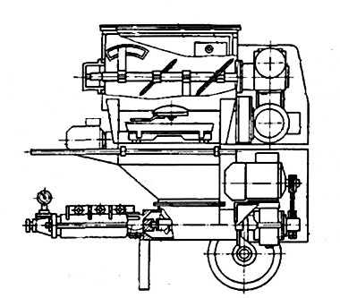
Figure 4 – Diagram of the plastering
unit SO-154A

Next to the hopper is an electric motor, from where the movement is transmitted to the blade shaft by means of a V-belt transmission and a worm gearbox. Under the agitator there is a vibrating sieve with a replaceable flat sieve, which is driven by another electric motor of low power. The screw pump, located under the vibrating sieve, consists of a receiving hopper with a screw and a clamp with a screw and clamp at the bottom. The pump drive includes an electric motor, a gearbox and a V-belt drive. There is a pressure gauge on the pump housing.
Screw mortar pumps SO-78 and EUROMIX 400 are used for pumping fine-grained concrete mixtures with aggregate size up to 10 mm. But their disadvantage, as well as the SO-154A plastering unit, is that when working with abrasive mixtures, the fixed elastic clamps and screws of the mortar pump wear out quickly.

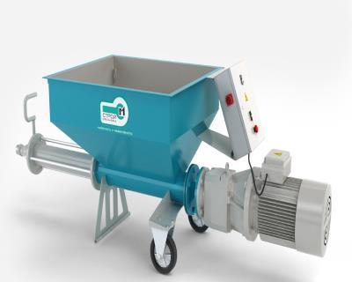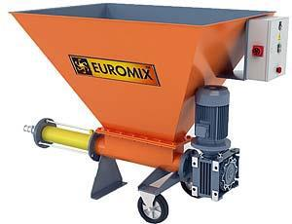
а b
Figure 5 – Screw solution pumps:
a) SO-78, b) EUROMIX 400

Universal plastering machine USHM-150 prepares plaster, gypsum, lime-cement and cement-sand mortars from dry components, filters them through vibrating sieves, transports them through mortar pipelines and applies them to the treated surfaces under the influence of compressed air.

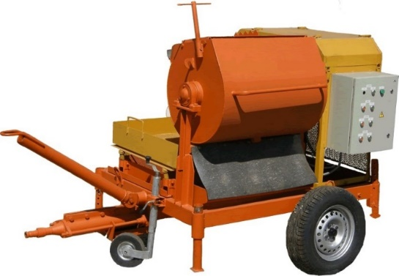
Figure 6 – Universal plastering
machine USHM-150

The advantages of such an installation include versatility. The disadvantages include the small volume of the working chamber of the mixer, increased power consumption and overall dimensions, weight.
Plastering machine T-101 based on a screw pump is a mobile small-sized high-performance machine of continuous and cyclic action, working with ready-made dry mixes [2]. It is designed for the preparation and application of plaster mortars on prepared treated surfaces.

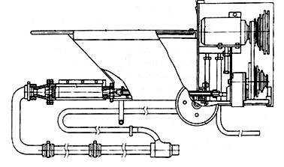
Figure 7 – Plastering machine T-101

The disadvantage of the plastering machine is the impossibility of preparing the plaster mortar directly in the hopper from individual components, which significantly reduces the scope of its application. Stepped speed adjustment is time-consuming and takes time to change the position of the drive belt on the pulleys.
The PFT G4 plastering machine is used for kneading, feeding and applying mortars to vertical and horizontal surfaces [3].

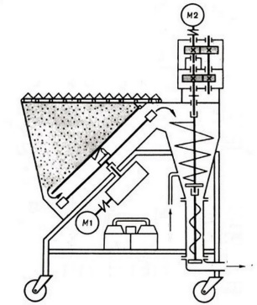
Figure 8 – Diagram of the PFT G4 plastering machine

PFT G4 prepares and injects mortars from dry components, which significantly reduces its versatility on the construction site. The receiving hopper has a capacity of 150 litres and must be constantly replenished with the components of its chamber.
The PFT ZP 3 XL MIX unit (Fig. 9) is used for the preparation and delivery of mortars to construction sites. Plaster or masonry mortar prepared in the built-in mixer is supplied directly to the facility. The capacity of the pump is adjusted depending on the concentration of the solution. The unit can be switched on and off using the remote control.
With small volumes of work or a significant distance from the mortar plant to the construction site, it is recommended to use plastering and mixing plants with mortar pumps and plastering units [4]. In this case, the preparation of mortar is carried out directly at the construction site, which significantly reduces the consumption of working materials.

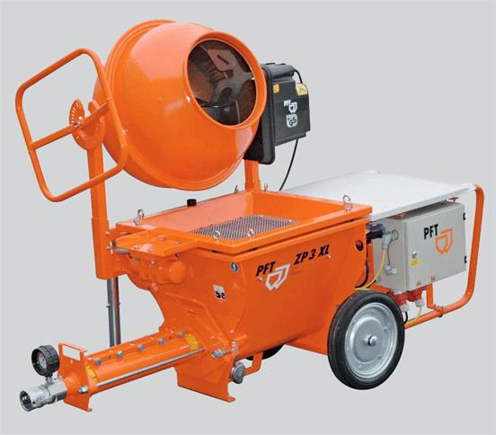
Figure 9 – Plastering station
PFT ZP 3 XL MIX

The disadvantage of plastering stations is that gravity mixers are inefficient for plaster lime-sand mixtures, have low productivity, limited transportation range and high cost.
The PFT SWING L screw mortar pump has a short service life of the screw feeder, is unsuitable for supplying slow-moving concrete mixtures and has a high cost.

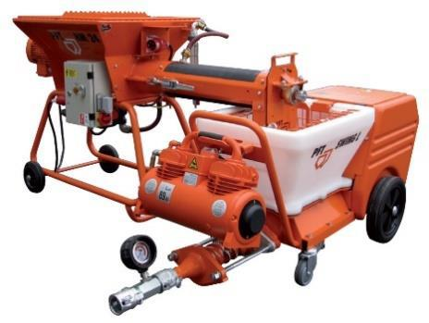
Figure 10 – Screw Solution Pump
PFT SWING L

The pressure generated by the screw can be determined at the distance to which the mixture is supplied under the pressure of the working piston of the pump with the suction valve open. When calculating the parameters, air resistance was not taken into account, because the frontal air resistance at speeds of 5 m/s is insignificant, and the change in velocity for a jet with a diameter of 45 mm and the density of the mixture from 2300 to 2500 kg/m³ will be less than 1 [4]. At the same time, the unit of the mortar concrete pump, including a loading hopper with a screw and with a suction valve body, is considered at a height of 1 m (Fig. 11).
The velocity of the concrete mixture flow jet (m/s) discharged through the open suction valve can be determined by the Torricelli formula [10]:

(1.1)

where – height of the column of concrete mixture that creates overpressure, m;
– a coefficient that takes into account the non-identity of the conditions for the end of the concrete mixture;
– acceleration of gravity.

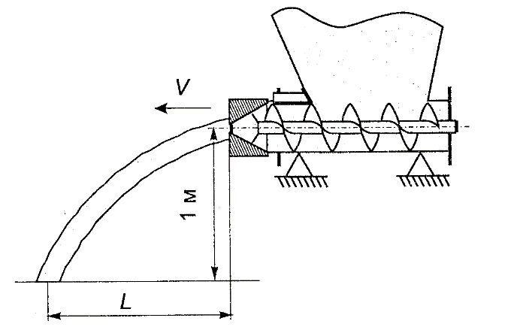
Figure 11 – Diagram of a loading hopper with a screw shaft and a stirrer

As a result of mathematical processing of experimental data, taking into account the factor of mobility of the concrete mixture Р₁, a second-order mathematical model was obtained, which allows to determine the coefficient , which takes into account the non-identity of the conditions for the end of the concrete mixture [8].

(1.2)

Using Torricelli's formula and the conditions of the experiment in the presence of forced loading of the machine, it is also possible to determine the required pressure that ensures the maximum filling of the working cylinder with concrete mixture, using the dependence:

(1.3)

where: – a coefficient that takes into account the non-identity of the conditions for the end of the concrete mixture;
– the distance to which the jet of concrete mixture is supplied, m;
ρ – mixture density, kg/m³.

The presence of forced loading when using slow-moving concrete mixtures makes it possible to ensure a denser filling of the working cylinder with the mixture, therefore, to achieve a higher volumetric coefficient of efficiency, as well as to ensure the operation of the pump, compared to the existing ones, with increased productivity. The change in the productivity of a mortar concrete pump with forced loading depending on the mobility of the concrete mixture is evidenced by the data shown in the figure 12.
The issue of increasing the efficiency of the screw unit of small-sized plastering installations for pumping mortars is quite relevant and important for the construction industry, because it can have a positive effect on the quality and timing of construction, as well as reduce the cost of labor and materials [9].
One of the important factors is also to conduct research on the geometry of the propeller, which determines the direction and speed of movement of the pumped material. It depends on the diameter of the screw, the pitch and the angle of inclination of the tooth, which, with the right calculations, can ensure maximum fluid flow with minimal energy losses due to friction.

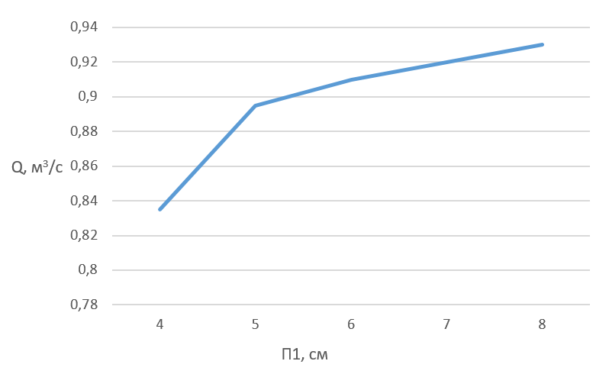
Figure 12 – Dependence of the performance of a forced-loading mortar pump on the mobility of the concrete mixture

The use of automatic control systems will ensure optimal parameters for pumping mortars, depending on their characteristics and operating conditions of the screw unit. Wireless data transmission and screw control systems can also be used, which will provide more accurate and efficient control of the pumping process.
The use of these technologies makes it possible to provide more accurate and efficient control of the process of pumping mortars, reduce the cost of energy supply of the screw unit, increase its service life and reduce the cost of maintenance. In addition, the use of innovative technologies makes it possible to increase the safety of the screw unit and reduce the risk of accidents.

Conclusions
An analysis of existing structures for pumping mortars and other mortars using screw assemblies and their technical characteristics was carried out and the main problems and shortcomings were identified.
To improve the operation of the unit, first of all, it is proposed to use screw assemblies made of polymeric materials, which will ensure greater strength and wear resistance of the elements of the unit, as well as reduce its weight and energy supply costs.
Maintaining the correct operation of the unit will reduce the loss of solution and ensure better pumping of components. This can be ensured by adjusting the speed of rotation of the unit, pressure and temperature of the solution.

References
1. Баладінський В.Л., Назаренко І.І., Онищенко О.Г. (2002). Будівельна техніка. Київ-Полтава: КНУБА-ПНТУ. |  | 1. Baladinslyi V.L., Nazarenko I.I., Onyshchenko O.G. (2002). Building machinery. Kyiv-Poltava: KNUCA-PNTU
2. Будівельна техніка: Навчальний посібник / В.Л. Баладінський, О.М. Лівінський, Л.А. Хмара та ін. – К.: Либідь, 2001. – 368 с. |  | 2. Construction Machinery: Textbook / V.L. Baladinsky, O.M. Livinsky, L.A. Khmara and others. Kyiv, Lybid Publ., 2001. – 368 p.
3. Онищенко О.Г., Драченко Б.Ф., Головкін О.В. Механізація опоряджувальних робіт у будівництві. – К.: Урожай, 1998. – 320 с. |  | 3. Onyshchenko, O.G., Drachenko, B.F., Golovkin, O.V. Mechanization of Construction Works. Kyiv, Urozhay Publ., 1998. – 320 p.
4. Головкін О.В. Універсальна розчинозмішувальна установка / О.В. Головкін, В.Б. Надобко, В.У. Уст’янцев // Прогресивні технології та машини для виробництва будматеріалів, виробів та конструкцій: всеукр. конф.: тези докл. – Полтава, 1996. – С. 98 – 100. |  | 4. Golovkin O.V., Nadobko V.B., Ust'yantsev V.U. Progressive Technologies and Machines for the Production of Building Materials, Products and Structures: Vseukr. Conf.: Theses of the Doc. – Poltava, 1996. – P. 98 – 100.
5. Агрегат штукатурно-змішувальний СО-180 [Електронний ресурс]. – [Цит. 2007, 12 лютого]. – Режим доступу: http://www.visma.narod.ua/nacoc-co-180.htm. – Назва з титул. екрану |  | 5. Agregat plaster-mixing-mixing SO-180 [Electronic resource]. [Cited in 2007, February 12]. Retrieved from http://www.visma.narod.ua/nacoc-co-180.htm. – Title with title. Screen
6. Л. В. Кучеренко, Т. В. Рабоча, Я. О. Стрілець (2013). Сучасні підходи підвищення ефективності виконання тонкошарового штукатурного покриття. Науково-технічний збірник “сучасні технології, матеріали і конструкції в будівництві”, 1 (14), 47-50 |  | 6. L. V. Kucherenko, T. V. Rabocha, and Y. O. Strilets (2013). Modern approaches to improving the efficiency of thin-layer plaster coating. Scientific and Technical Journal "Modern Technologies, Materials and Structures in Construction", 1 (14), 47-50
7. Korobko B.O. Feed Solution in the Pipeline aith the Compensators Mortar Pump of Various Design Solutions Pressure Pulsations Degree Determination / B.O. Korobko, V.V. Virchenko, M.V. Shapoval. Feed Solution in the Pipeline aith the Compensators Mortar Pump of Various Design Solutions Pressure Pulsations Degree Determination // International Journal of Engineering & Technology, Vol 7, № 3.2 (2018). – P. 195 – 202. // International Journal of Engineering & Technology, Vol 7, № 3.2 (2018). – P. 195 – 202 |  | 7. Korobko B.O. Feed Solution in the Pipeline aith the Compensators Mortar Pump of Various Design Solutions Pressure Pulsations Degree Determination / B.O. Korobko, V.V. Virchenko, M.V. Shapoval. Feed Solution in the Pipeline aith the Compensators Mortar Pump of Various Design Solutions Pressure Pulsations Degree Determination // International Journal of Engineering & Technology, Vol 7, № 3.2 (2018). – P. 195 – 202. // International Journal of Engineering & Technology, Vol 7, № 3.2 (2018). – P. 195 – 202.
8. Баранов А.М. Теоретичні основи розробки компенсаторів при подачі будівельних сумішей поршневими насосами. // ХДТУБА ХОТВ АБУ, Харків: Науковий вісник будівництва, №4, 1998, - С. 83-87 |  | 8. Baranov A.M. Theoretical foundations for the development of compensators when supplying building mixtures with piston pumps. KSTUBA HOTV ABU, Kharkiv: Scientific Bulletin of Construction, No. 4, 1998, - P. 83-87.
9. Задорожний А.О. Обладнання мокрого торкретування при проведенні відроізоляційних робіт.// Придніпровський науковий вісник. Технічні науки №72 (139), 1998. – с. 6-10 |  | 9. Zadorozhnyi A.O. Equipment of wet shotcrete when conducting vidozolyatsional works. Technical Sciences No. 72 (139), 1998. – pp. 6-10
10. Ємельянова І.А., Задорожний А.О., Гузенко С.О., Меленцов М.О. Двопоршневі розчинобетононасоси для умов будівельного майданчика: Монографія/ під ред. Ємельянової І.А.// Харків. 2011. – 196 с. |  | 10. Emelyanova I.A., Zadorozhnyi A.O., Guzenko S.O., Melentsov M.O. Two-piston mortar concrete pumps for the conditions of the construction site: Monograph. Yemelyanova I.A. // Kharkiv. 2011. – 196 p.
11. Ємельянова І.А. Малогабаритне обладнання для умов виконання торкрет-робіт і транспортування будівельних сумішей в умовах будівельного майданчика.// Полтава. 2009. – 84 с. |  | 11. Emelyanova I.A. Small-sized equipment for the conditions of execution of shotcrete works and transportation of building mixtures in the conditions of the construction site. 2009. – 84 p.
12. Ємельянова І.А., Баранов А.М., Задорожний А.О., Ніконов Д.В., Лихолет М.А. Вивчення можливих двопоршневих прямоточних розчинобетононасосів для транспортування бетонних розчинів. – Науковий вісник будівництва, №8. Харків: ХДТУБА, 1999 – с.149-154. |  | 12. Emelyanova I.A., Baranov A.M., Zadorozhnyi A.O., Nikonov D.V., Lykholet M.A. Study of possible two-piston direct-flow mortar concrete pumps for transportation of concrete mortars. – Scientific Bulletin of Construction, No. 8. Kharkiv: KhDTUBA, 1999 – p.149-154.
13. Ємельянова І.А., Баранов А.М., Задорожний А.О., Проценко А.Н., Регмі У.К. Використання обладнання мокрого торкретування в умовах реконструкції будівель і споруд.// Науковий вісникбудівництва, №2 – Харків: ХДТУБА, 1998 – с. 26-29. |  | 13. Yemelyanova I.A., Baranov A.M., Zadorozhnyi A.O., Protsenko A.N., Regmi U.K. Use of wet shotcrete equipment in the conditions of reconstruction of buildings and structures.// Scientific Bulletin of Construction, No. 2 – Kharkiv: KSTUBA, 1998 – p. 26-29.
14. Wilson R. Nyemba, Ngonidzashe L. Shangwa, Simon Chinguwa, Charles Mbohwa (2020). Conceptualization, development and design of a mortar spraying machine. Procedia CIRP, 91, 396-401  https://doi.org/10.1016/j.procir.2020.03.105 |  | 14. Wilson R. Nyemba, Ngonidzashe L. Shangwa, Simon Chinguwa, Charles Mbohwa (2020). Conceptualization, development and design of a mortar spraying machine. Procedia CIRP, 91, 396-401  https://doi.org/10.1016/j.procir.2020.03.105
15. Hwang BG, Shan M, Ong JJM, Krishnankutty P. (2020) Mechanization in building construction projects: assessment and views from the practitioners. Production Planning & Control, 31(8), 613–628.  https://doi.org/10.1080/09537287.2019.1667547 |  | 15. Hwang BG, Shan M, Ong JJM, Krishnankutty P. (2020) Mechanization in building construction projects: assessment and views from the practitioners. Production Planning & Control, 31(8), 613–628.  https://doi.org/10.1080/09537287.2019.1667547
16. Javier Pinilla Melo, N. Flores Medina, Alberto Sepulcre Aguilar, Francisco Hernández Olivares (2017). Rheological and thermal properties of aerated sprayed mortar. Construction and Building Materials, 154, 275-283.  https://doi.org/10.1016/j.conbuildmat.2017.07.185 |  | 16. Javier Pinilla Melo, N. Flores Medina, Alberto Sepulcre Aguilar, Francisco Hernández Olivares (2017). Rheological and thermal properties of aerated sprayed mortar. Construction and Building Materials, 154, 275-283.  https://doi.org/10.1016/j.conbuildmat.2017.07.185
17. Tae-Ho Kang, Soo-Ho Chang, Soon-Wook Choi, Jin-Tae Kim, Bong-Gyu Kim, and Chulho Lee (2022). Development of Accelerator Control System for Wet Shotcrete Spraying Equipment. TUNNEL & UNDERGROUND SPACE, 6(32), 353-362.  https://doi.org/10.7474/TUS.2022.32.6.353 |  | 17. Tae-Ho Kang, Soo-Ho Chang, Soon-Wook Choi, Jin-Tae Kim, Bong-Gyu Kim, and Chulho Lee (2022). Development of Accelerator Control System for Wet Shotcrete Spraying Equipment. TUNNEL & UNDERGROUND SPACE, 6(32), 353-362.  https://doi.org/10.7474/TUS.2022.32.6.353
18. Hwang, Byoung-Il; Park, Jong-Pil; Yoo, Byung-Hyun; Lee, Dong-gyu (2020). Evaluation of Spraying Characteristics for Masonry Buildings Seismic Retrofit Fiber-Reinforced Mortar. Journal of the Korea Academia-Industrial cooperation Society, 11 (21), 37-43.  https://doi.org/10.5762/KAIS.2020.21.11.37 |  | 18. Hwang, Byoung-Il; Park, Jong-Pil; Yoo, Byung-Hyun; Lee, Dong-gyu (2020). Evaluation of Spraying Characteristics for Masonry Buildings Seismic Retrofit Fiber-Reinforced Mortar. Journal of the Korea Academia-Industrial cooperation Society, 11 (21), 37-43.  https://doi.org/10.5762/KAIS.2020.21.11.37

