**Збірник наукових праць. Галузеве машинобудування, будівництво**

**Academic journal. Industrial Machine Building, Civil Engineering**

[**http://journals.nupp.edu.ua/znp**](http://journals.nupp.edu.ua/znp)

[**https://doi.org/10.26906/znp.2023.58.ХХХХ**](https://doi.org/10.26906/znp.2023.58.ХХХХ)

**UDC 666.972.2:620.1**

**Research on modes and operating parameters of   
construction mixes preparing equipment**

**Rudyk Rostyslav1**\*, **Bidanets Serhii2**

1 National University «Yuri Kondratyuk Poltava Polytechnic» <https://orcid.org/0000-0001-8386-977X>

2 National University «Yuri Kondratyuk Poltava Polytechnic» <https://orcid.org/0000-0002-5346-9545>

*Corresponding author E-mail: [rostyslavrudyk@nupp.edu.ua](mailto:rostyslavrudyk@nupp.edu.ua)

This research paper examines the various modes and parameters of operation of equipment used for preparing mortars in the construction industry. The study emphasizes the significance of ensuring the proper functioning of mixers and mixers on construction sites, as it directly affects the time and energy consumption involved in mortar preparation. The paper discusses different types of mixers, including gravity mixers and concrete mixing buckets, and provides an analysis of their advantages and disadvantages. Additionally, the research presents calculations and formulas for determining the power consumption and energy efficiency of mixers. The findings of the study highlight the necessity for a scientific approach in selecting components based on their energy efficiency in construction site conditions. By considering energy efficiency, construction professionals can optimize the performance of mixers and reduce energy consumption, leading to cost savings and environmental benefits. This research contributes to the existing knowledge in the field and provides valuable insights for decision-making in the selection and operation of mortar preparation equipment in the construction industry.

**Keywords:** Concrete mixtures, concrete mixer, mortar, preparation, energy efficiency, productivity

**Дослідження режимів та параметрів роботи обладнання**

**для приготування будівельних розчинів**

**Рудик Р.Ю.**1*, **Біданець С.С.2**

1Національний університет «Полтавська політехніка імені Юрія Кондратюка»

2 Національний університет «Полтавська політехніка імені Юрія Кондратюка»

*Адреса для листування E-mail: [rostyslavrudyk@nupp.edu.ua](mailto:rostyslavrudyk@nupp.edu.ua)

У статті розглянуто різні режими та параметри роботи обладнання, що використовується для приготування будівельних розчинів у будівельній галузі. Ефективне приготування будівельних розчинів має вирішальне значення для своєчасного завершення будівельних проектів і загальної продуктивності галузі. Дослідження підкреслює важливість забезпечення належного функціонування змішувачів на будівельних майданчиках, оскільки це безпосередньо впливає на витрати часу та енергії на приготування розчину. Стаття містить аналіз різних типів змішувачів, які використовуються в будівельній галузі, включаючи гравітаційні змішувачі та ковші для змішування бетону. Кожен тип змішувача оцінюється на основі його переваг і недоліків, враховуючи такі фактори, як простота використання, потужність змішування та вимоги до обслуговування. Результати цього аналізу можуть допомогти фахівцям-будівельникам у виборі найбільш підходящого змішувача для конкретних вимог проекту. Крім того, в дослідженні наведено розрахунки та формули для визначення енергоспоживання та енергоефективності змішувачів. Дослідження також підкреслює важливість врахування енергоефективності при проектуванні та експлуатації змішувачів, оскільки це може призвести до значної економії енергії та екологічних переваг. В результаті досліджень є необхідність наукового підходу до вибору компонентів на основі їх енергоефективності в умовах будівельного майданчика.

**Ключові слова:** бетонна суміш, бетонозмішувач, будівельний розчин, приготування, енергоефективність, продуктивність

**Introduction**.

Nowadays, the production of various concrete products in Ukraine requires special attention. Usually, the production of concrete mixtures and mortars takes place at modern enterprises, equipped with highly efficient mechanized means, or directly on the construction site.

In the global construction engineering industry equipment for concrete preparation of various characteristics and purposes is used depending on the characteristics of its further use. However, the importance of the proper functioning of mixers and mixing devices on construction sites is paid with little attention. Therefore, the use of time for the preparation of the finished product and the energy consumption are much higher, compared to the production of similar products in the factory. Due to the limited working space on construction sites, additional equipment is usually required to meet the needs of construction activities.

**Review of the research sources and publications**.

One of the key aspects of successful mortar preparation is the proper selection of modes and equipment operation parameters. In the modern construction industry, much attention is paid to the efficiency and quality of construction work. Ukrainian [1-4], [10-14] and foreign [16-19] scientists were engaged in the analysis of various structures for the preparation of concrete mixtures and mortars. They were engaged not only in the development of new materials, but also in the search for rational solutions for the process of mixing mortars.

**Definition of unsolved aspects of the problem**

One of the main problems when mixing mortars on the construction site, which constantly needs to be addressed or improved, is the problem of energy efficiency.

There is a need to investigate the effective use of automation and control systems, which can help in optimizing energy efficiency during the concrete mix preparation process.

Insufficient theoretical grounding of the energy parameters of work processes related to the preparation of concrete mixtures from the point of view of efficient use of consumed power and reduction to a rational level of energy intensity at all stages does not allow the creation of effective technological sets of equipment for various construction conditions. This restrains the development of high-performance technologies for construction work on the construction site.

**Problem statement**

The purpose of this work is to investigate the modes and operating parameters of equipment for preparing construction mixes and to optimize the construction process with a focus on energy efficiency.

To achieve this goal, it is necessary to analyze the main methods of preparing mortars and methods for determining the energy efficiency of the equipment used for mixing, determine the advantages and disadvantages of such equipment and methods for calculating energy efficiency, determine the further vector of research.

**Basic material and results**

Using different mixers to prepare concrete mortar directly on the construction site has become a common practice in the construction industry. This opens up opportunities for optimizing the construction process and ensures the high quality of concrete structures. Different types of faucets are used depending on the specific requirements and needs of the construction project.

Mixers on the construction site allows to precisely control the composition of the concrete mixture and consistency, which makes it possible to create rational conditions for a specific construction task. This practice simplifies the process of making concrete, allowing you to quickly adjust and adapt the mixture to changing construction conditions [6].

On-site mixers also help reduce the cost of transporting the finished concrete mix from the plant, which improves production efficiency. They avoid overproduction and store concrete in the required quantities, which helps to save resources.

In general, the use of concrete mortar mixers directly on the construction site is an important component of modern construction [9]. It simplifies the construction process, increases quality control and allows efficient use of resources, ensuring high productivity and reliability of construction projects. Gravity and forced mixers, which differ in the principle of operation, mobility and mixing method, have become widely used.

One of the most common types of equipment for the preparation of concrete mortars on a construction site is a gravity mixer (Fig. 1). In gravity mixers, materials are mixed in a rotating drum with blades fixed on the inner surface. As the drum rotates, the material is captured and lifted by the blades, and then, due to the action of gravitational forces, it moves down.

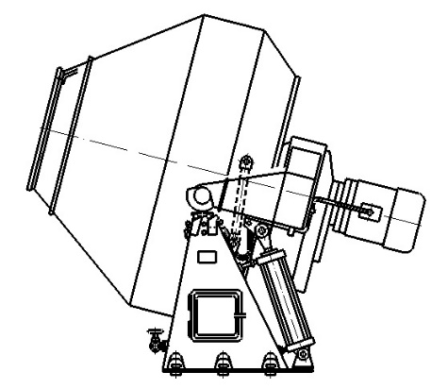

Figure 1 – Gravity Concrete Mixer

Gravity mixers are noted for their simple design, low energy consumption, and the ability to mix materials with large particulate matter. However, they also have their disadvantages, such as the relative duration of the mixing process and the difficulty of achieving complete homogeneity of the mixture when mixing materials that are rigid and have a fine-grained structure.

Concrete mixing buckets are also widely used (Fig. 2). These are special devices designed for mixing concrete, cement mixtures and other building materials directly on the construction site, using the power and mobility of the chassis on which they are installed (tractor, own self-propelled).

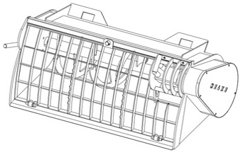

Figure 2 – Concrete mixing bucket

The front loader operator loads the necessary mixing components into the bucket. After that, the bucket rises above ground level and the rotation of the working body inside the bucket begins. This mixing takes place under conditions of high speed and intensity to ensure homogeneous mixing of materials. Due to the mobility of the chassis on which it is installed, it is possible to move the concrete mixture around the construction site at the time of mixing.

The advantages of this equipment are mixing efficiency, quality control and mobility. And the disadvantages are the difficulty of cleaning to avoid contamination of subsequent mixtures and the dependence on an excavator, which is sometimes not suitable for all construction projects.

When comparing these mixers, you need to take into account that they have different designs, mixing times and energy efficiency, and the technical performance of the mixers is determined according to their volume and mixing time:



where, *П* – mixer performance, m3/h;

*tc* – cycle time duty, s;

*Vn* – volume of the finished mixture, m3;

*kmwb* – coefficient that takes into account the volume of the mixer's working body (*kmwb* = 0,92…0,98);

*kf* – coefficient filling the faucet body with mortar;

*tpr* – mix preparation duration, s;

*tpu* – mix pumping duration, s;

*tdt* – downtime and maintenance time, s.

Most of the works [10-11] devoted to mixing considered the processes of movement and mixing of building mixtures, the identification of the efficiency of mixing, and the catalyzing of chemical processes. Only a small part of the work relates to the study of the movement and suspensions and other viscoplastic bodies mixing.

In the works of foreign scientists [5], the rational diameter ratio, blade width and mixer body size, as well as the dependence of power and efficiency of mixing on the speed were established. To calculate the power, W, the following formula was proposed:



where *С* – resistance coefficient;

D – mixing ladle diameter, m;

H – mixing ladle height, m.

,  – density and viscosity of the medium to be stirred;

 – blade rotation speed;

 – indicator of the degree depending on the mixing conditions.

In research, the equation of energy consumed for mixing is presented in the form of a functional dependence on the criteria of Reynolds and Froude.

Most scientists have come to the conclusion that when determining the power consumption during the mixing of viscous liquids, the most significant influence is exerted by the Reynolds criterion.

The intensity of the mortar mixer action is characterized by the time required to achieve a specific technological result at a constant speed of rotation of the working body or vice versa. According to the work [14], the intensity of mixing can be determined using the angular velocity of the working body , rad/s; linear velocity of the working body on the outer diameter, , m/s; power , W, which is spent on mixing, which is reduced to a unit of volume or a unit of mass of the mixture; Reynolds' criterion



where  – diameter of the mixer working body, m;

 – density kg/m3;

 – structured viscosity coefficient, Pa·s.

As mentioned earlier, mixing efficiency is characterized by the amount of energy expended to achieve the desired technological effect. Of the two mortar mixers, the one that achieves a certain technological effect at lower energy consumption will be more efficient. To select the optimal size and operating modes of mortar mixing plants, it is also necessary to apply the mixing efficiency.

In studies, the following formula is provided to calculate power

, Kw

It is clear that in the study of fluid flow in each case it is necessary to take into account the most significant principal factor. In some cases, it is not possible to take into account the Reynolds and Froude criteria at the same time. If the mixer blades are completely immersed in the solution, then the main importance is Re. The forces of gravity will be negligible, so in some cases the Froude criterion can be ignored.

According to the conducted analysis, the method of calculating screw-type mixers was used, the starting point of which is Newton's law. The proposed dependencies for calculating the power of mixers can be presented in the general case

, Kw

where *rout*, *rin* – outer and inner radiuses of the blade, respectively;

 – indicator of the degree depending on the mixing conditions;

*b* – blade width.

ψ – initial current phase.

In the study of the main regularities of fluid movement in mixers, the importance of certain components that significantly affect the design power was revealed, namely, the shape of the free surface, the distribution of flow rates, the circulation pattern and the dependence of the above phenomena on the design and kinematic parameters of the mixers. The values of the drag coefficients are set depending on the ratio of the blade size and their number. Therefore, the specific power consumption per unit volume of the mixture is in the ratio

, Kw/l

where A – constant ratio;

D – mixer blade diameter, m.

Analyzing this expression, it can be concluded that the specific power consumption decreases with an increase in the blade diameter, and therefore the hopper size.

In the study of energy indicators [12], namely, the specific energy consumption of mixers of cyclic forced action, it is proposed to calculate the value by the formula

, W/l

where *Pе* – power on the mixer drive shaft, W;

V– mixer hopper volume, l.

It has been established that the value of the  has some deviations from the mean. Of particular interest are the unexplored deviations of the magnitude *qe* from the average towards a decrease in specific energy consumption. Dependence analysis of mixers power and other parameters of the volume can be used for the predictive calculation of mixers, therefore, it is proposed to use the dependence of the drive power on the volume of the mixer to assess the technical level of existing mixer designs. It has been determined that the technical characteristics of the existing equipment do not take into account a number of design and technological indicators.

According to the studies analysis of the relationship between specific energy consumption  of installed electric motors and mixer capacity V by different types of domestic production. According to the results of the research [12] a dependency graph  was obtained, shown in Fig. 3. It was concluded, that by deviation of the  value, gravity cyclic mixers have less than cyclic forced mixers.

Specific energy consumption  of cyclic forced mixers have a significant range of values. This confirms the assumption that there is no unified method for calculating the energy performance of cyclic forced mixers.

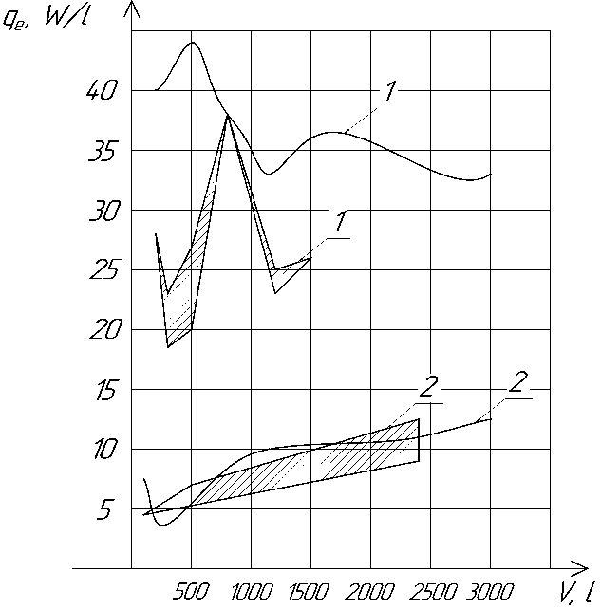

Figure 3 – Dependence of specific energy consumption on forced volume *1*

and gravity *2* cyclic mixers 

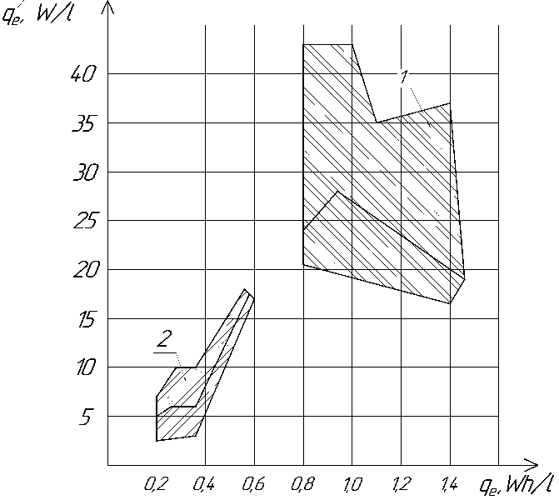

Figure 4 – Dependence of specific energy consumption on the relative power consumption of forced *1* and gravitational *2* cyclic mixers 

Figure 4 shows a graph of dependency , that is, the specific energy consumption from the relative power consumption, which is determined by the following formula

, W/l

where *П* – mixer productivity, l/h.

A decrease in specific energy consumption is associated with a decrease in relative power consumption. This allows to assert that it is not enough to know the power of the drive to assess the efficiency of mixers, since energy consumption depends on the power of the electric motor, its efficiency, power reserve factor and mixing time [13].

Most studies show that for concrete mixtures, the energy consumption for mixing depends on the speed of rotation in the first and second powers, for liquids the power indicator is three or four.

There is a need to develop a methodology that includes design features, working bodies, modes of their operation, total energy consumption in the conditions of work on the construction site.

**Conclusions**

As a result of the research, an analysis was conducted on the main methods of preparing mortars and the energy efficiency aspects of different mixing methods. Promising approaches to enhance the manufacturing process of mortars in the construction industry were identified. Considering the advantages and disadvantages of various mixing methods and their energy efficiency, it can be argued that developing a scientific approach to component selection based on the highest energy efficiency in construction site conditions is both possible and necessary.

**References**

|  |  |  |
| --- | --- | --- |
| 1. Назаренко І., Клименко М., Свідерській А., Печерський В. (2017). Визначення раціональних параметрів гравітаційних бетонозмішувачів. ГБДММ, 90, 67-72. |  | 1. Nazarenko І., Klymenko M., Svidersky A., Pechersky V. (2017). Definition of rational parameters of drum concrete mixers. GBDMM, 90, 67-72 |
| 2. Онищенко О.Г., Попов С.В., Вірченко В.В. (2010). Вплив геометричних параметрів на ефективність роботи цівкового зачеплення змішувачів для приготування будівельних розчинних сумішей. Збірник наукових праць (Галузеве машинобудування, будівництво) № 27, 3–8. |  | 2. Onishchenko O.G., Popov S.V., Virchenko V.V. (2010). The influence of geometric parameters on the efficiency of the nozzle engagement of mixers for the preparation of building mortar mixes. Collection of scientific papers (Industrial engineering, construction) No. 27, 3–8. |
| 3. Ємельянова І.А., Гордієнко А.Т., Субота Д.Ю. (2018). Особливості виконання бетонних робіт в умовах будівельного майданчика. *Будівництво. Науковий вісник будівництва*, 3 (93), 205-214  <https://doi.org/10.29295/2311-7257-2018-93-3-205-214> |  | 3. Emeljanova I.A., Gordienko A.T., Subota D.Yu. (2018). Features the performance of concrete works at the construction site. *Civil Engineering. Scientific bulletin of civil engineering,* 3 (93), 205-214  <https://doi.org/10.29295/2311-7257-2018-93-3-205-214> |
| 4. Емельянова И.А., Анищенко А.И., Сорокотяга А.С. (2013). Перспективы использования бетоносмесителя гравитационно-принудительного действия в условиях строительной площадки. *Галузеве машинобудування, будівництво*, 1(36), 9-15 |  | 4. Emeljanova I.A., Anishchenko A.I., Sorokotyga O.S. (2013). Determination of basic indicators of technology package equipment consisting of concrete mixers gravitational enforcement action and trough belt feeders. *Industrial Machine Building, Civil Engineering*, 1(36), 9-15 |
| 5. Dils, J., De Schutter, G. & Boel, V. (2012). Influence of mixing procedure and mixer type on fresh and hardened properties of concrete: a review. Mater Struct 45, 1673–1683.  https://doi.org/10.1617/s11527-012-9864-8 |  | 5. Dils, J., De Schutter, G. & Boel, V. (2012). Influence of mixing procedure and mixer type on fresh and hardened properties of concrete: a review. Mater Struct 45, 1673–1683.  https://doi.org/10.1617/s11527-012-9864-8 |
| 6. Ємельянова І.А., Блажко В.В. (2015). Сучасне обладнання для приготування будівельних сумішей в умовах будівельного майданчика. *Матеріали IV Міжнародної науково-технічної конференції молодих учених та студентів. Актуальні задачі сучасних технологій*. Тернопіль*,* 93-94 |  | 6. Emljanova I.A., Blazhko V. V. (2015). Modern equipment for making smsey building in a construction site. Materials of the IV International Scientific and Technical Conference of Young Scientists and Students. Current problems of modern technologies. Ternopil, 93-94 |
| 7. Назаренко І.І., Клименко М.О., Чичур А.І., Сахно С.В. (2011). Перспективні конструкції автобетонозмішувачів. *Теорія і практика будівництва*, 7, 2-9 |  | 7. Nazarenko I.I., Klymenko M.O., Chichur A.I., Sakhno S.V. (2011). Promising constructions of truck-mounted concrete mixers. *Theory and practice of construction*, 7, 2-9 |
| 8. Вірченко В.В. (2011). Приготування будівельних сумішей за допомогою ефективних змішувачів. *Вісник КНУ ім. М. Остроградського,* 1/2011 (66), 71-74 |  | 8. Virchenko V.V. (2011). Mixing and construction mortar solutions with the effective mixers. *Bulletin of Kremenchuk Mykhailo Ostrohradskyi National University*, 1/2011 (66), 71-74 |
| 9. Rudyk R., Kuzub Yu (2022). Justification of new equipment development for preparing concrete solutions. Academic journal. Industrial Machine Building, Civil Engineering, 1 (59), 11-16 |  | 9. Rudyk R., Kuzub Yu (2022). Justification of new equipment development for preparing concrete solutions. Academic journal. Industrial Machine Building, Civil Engineering, 1 (59), 11-16 |
| 10. Онищенко О.Г., Ващенко К.М. (2006). Розрахунок потужності та визначення опорів, що виникають при роботі стрічкового шнекового розчинозмішувача . Вісник КДПУ: Зб. наук. праць. Кременчук: КДПУ,№ 1(36), 58-63 |  | 10 Onishchenko O.G., Vashchenko K.M. (2006). Calculation of power and determination of resistances that arise during the operation of a belt screw mortar mixer. Bulletin of the KDPU: Vol. of science works Kremenchuk: KDPU, No. 1(36), 58-63 |
| 11. Онищенко О.Г., Ващенко К.М. (2004). Розроблення конструкції бункера-змішувача на основі аналізу конструктивних особливостей машин для прийому, перемішування і видачі будівельних розчинів. Галузеве машинобудування, будівництво. Полтава,6-11. |  | 11. Onishchenko O.G., Vashchenko K.M. (2004). Development of the design of the hopper-mixer based on the analysis of the design features of the machines for receiving, mixing and dispensing construction mortars. Industrial engineering, construction. Poltava, 6-11. |
| 12. Почупайло Б.І. Удосконалений бетонозмішувач (1996). Праці всеукраїнської конф. „Прогресивні технології та машини для виробництва будматеріалів, виробів та конструкцій”. Полтава, 55-56. |  | 12. Pochupailo B.I. Advanced concrete mixer (1996). Proceedings of the All-Ukrainian Conf. "Progressive technologies and machines for the production of building materials, products and structures". Poltava, 55-56. |
| 13. Почупайло Б.І., Богданов В.С. (1996). До питання розрахунку потужності змішувача. Праці всеукраїнської конф. „Прогресивні технології та машини для виробництва будматеріалів, виробів та конструкцій”. Полтава, 39-40 |  | 13. B. I. Pochupaylo, V. S. Bohdanov. (1996). To the question of calculating the power of the mixer. Proceedings of the All-Ukrainian Conf. "Progressive technologies and machines for the production of building materials, products and structures". Poltava, 39-40 |
| 14. Богомолов О.О., Чемерічко Г.І. (1996). Тенденції вдосконалення змішувального обладнання. Праці всеукраїнської конф. „Прогресивні технології та машини для виробництва будматеріалів, виробів та конструкцій”. Полтава, 38-39 |  | 14. Bogomolov O.O., Chemerichko G.I. (1996). Trends in the improvement of mixing equipment. Proceedings of the All-Ukrainian Conf. "Progressive technologies and machines for the production of building materials, products and structures". Poltava, 38-39 |
| 15. Бурмістенков О.П., Біла Т.Я.,Стаценко В.В. (2019). Дослідження енергоефективності обладнання для змішування сипких матеріалів. Вісник Київського національного університету технологій та дизайну. Серія Технічні науки №4 (136), 42-48  https://doi.org/10.30857/1813-6796.2019.4.4 |  | 15. Burmistenkov O.P., Bila T.Ya., Statsenko V.V. (2019). The research of energy efficiency for mixing bulk materials equipment. Bulletin of the Kyiv National University of Technologies and Design. Technical Science Series №4 (136), 42-48  https://doi.org/10.30857/1813-6796.2019.4.4 |
| 16. Jiapeng Yang, Hua Zeng, Tongqing Zhu, Qi An (2017). Study on the dynamic performance of concrete mixer’s mixing drum. *Mechanical Sciences* 1 (8), 165-178 <https://doi.org/10.5194/ms-8-165-2017> |  | 16. Jiapeng Yang, Hua Zeng, Tongqing Zhu, Qi An (2017). Study on the dynamic performance of concrete mixer’s mixing drum. *Mechanical Sciences* 1 (8), 165-178 <https://doi.org/10.5194/ms-8-165-2017> |
| 17. Dils, J., De Schutter, G. & Boel, V. (2012). Influence of mixing procedure and mixer type on fresh and hardened properties of concrete: a review. Materials and Structures 45, 1673–1683.  https://doi.org/10.1617/s11527-012-9864-8 |  | 17. Dils, J., De Schutter, G. & Boel, V. (2012). Influence of mixing procedure and mixer type on fresh and hardened properties of concrete: a review. Materials and Structures 45, 1673–1683.  https://doi.org/10.1617/s11527-012-9864-8 |
| 18. Jon Elvar Wallevik, Olafur Haralds Wallevik (2020). Concrete mixing truck as a rheometer. Cement and Concrete Research, 127.  https://doi.org/10.1016/j.cemconres.2019.105930 |  | 18. Jon Elvar Wallevik, Olafur Haralds Wallevik (2020). Concrete mixing truck as a rheometer. Cement and Concrete Research, 127.  https://doi.org/10.1016/j.cemconres.2019.105930 |
| 19. Alireza Mokhtar, Mohsen Nasooti (2020). A decision support tool for cement industry to select energy efficiency measures. Energy Strategy Reviews, 28.  https://doi.org/10.1016/j.esr.2020.100458 |  | 19. Alireza Mokhtar, Mohsen Nasooti (2020). A decision support tool for cement industry to select energy efficiency measures. Energy Strategy Reviews, 28.  https://doi.org/10.1016/j.esr.2020.100458 |