**Збірник наукових праць. Галузеве машинобудування, будівництво**

**Academic journal. Industrial Machine Building, Civil Engineering**

[**http://journals.nupp.edu.ua/znp**](http://journals.nupp.edu.ua/znp)

[**https://doi.org/10.26906/znp.2021.56.ХХХХ**](https://doi.org/10.26906/znp.2020.54.ХХХХ)

**UDC 62-868**

**Analysis of vibration machine parameters affecting compaction quality**

**Vasiliev Oleksii1*, Yakovenko Andrii2**

1 National University «Yuri Kondratyuk Poltava Polytechnic» <https://orcid.org/0000-0002-9914-5482>

2 National University «Yuri Kondratyuk Poltava Polytechnic»; https://orcid.org/0000-0003-0818-6332

*Corresponding author E-mail: [a.s.vasiliev.76@gmail.com](mailto:a.s.vasiliev.76@gmail.com)

Compaction of products is an important stage of construction work and engineering projects. It has a significant impact on the stability and reliability of the construction. However, the compacting quality of the products depends on various parameters that are controlled and adjusted on vibration machine. Analysis of these parameters will allow us to determine the optimal values to achieve the maximum quality of compacting products using a vibration machine. The article studies the influence of different parameters of the vibration machine on the quality of the material compaction. The purpose of this article is to determine the choice of the optimal design of vibration machine, depending on the specific conditions of production and the size of reinforced concrete products. The authors emphasise on such key factors as vibration amplitude, frequency, workload and duration of exposure. Therefore, taking into account the fact that these parameters can help to understand better the vibration compaction process and develop optimal conditions for achieving high quality material compaction. This study presents the most rational design scheme of a small-sized vibration machine and its optimal dynamic parameters. The results of this study will be interesting for engineers, construction contractors and specialists who are engaged in the design or working on compaction of products

**Keywords:** vibration, vibration oscillation amplitude, vibration exciter, vibration machine, debalance, forced oscillations

**Аналіз параметрів вібраційної установки,   
що впливають на якість ущільнення**

**Васильєв О.С.1*, Яковенко А.М.2**

1. 2 Національний університет «Полтавська політехніка імені Юрія Кондратюка»

*Адреса для листування E-mail: [a.s.vasiliev.76@gmail.com](mailto:a.s.vasiliev.76@gmail.com)

Ущільнення виробів є важливим етапом будівельних робіт та інженерних проектів і має значний вплив на стійкість і надійність конструкції. Однак, якість ущільнення виробів залежить від різних параметрів, які контролюються та налаштовуються на вібраційних установках. Аналіз цих параметрів дозволить визначити оптимальні значення для досягнення максимальної якості ущільнення виробів за допомогою вібраційної установки. Метою цієї статті є представлення результатів дослідження для визначення вибору оптимальної конструктивної схеми вібраційного обладнання в залежності від конкретних умов виробництва та розмірів залізобетонних виробів. Особливість вібраційного методу полягає в тому, що тільки за рахунок зниження інтенсивності коливань робочого органу вібраційної машини можна здійснювати принципово окремі технологічні процеси, причому ці технологічні процеси не виділяються чітко за режимами коливань, а поступово переходять у різні процеси. В статті досліджується вплив різних параметрів вібраційної установки на якість ущільнення матеріалу. Автори звертають увагу на такі ключові фактори, як амплітуда коливань, частота, навантаження і тривалість впливу. Тому врахування цих параметрів може допомогти краще зрозуміти процес вібраційного ущільнення і розробити оптимальні умови для досягнення високої якості ущільнення матеріалу. У дослідженні проведено аналіз основних матеріалів, що використовуються під час виготовлення вібраційної машини, та їхньої ефективної ролі в забезпеченні ефективного ущільнення. В роботі представлено найбільш раціональну конструктивну схему малогабаритної вібраційної установки та її оптимальні динамічні параметри. Автори наводять приклади позитивного впливу зміни цих параметрів на густину матеріалу, його стабільність та здатність опиратись руйнуванню. Результати цього дослідження будуть цікаві інженерам, будівельним підрядникам і фахівцям, які займаються проєктуванням і проведенням робіт з ущільнення виробів.

**Ключові слова:** вібрація, амплітуда віброколивань, віброзбуджувач, вібраційна машина, дебаланс, вібраційна установка, вимушені коливання

**Introduction**

Compaction of products is an important stage of construction work and engineering projects and has a significant impact on the stability and reliability of the structure. One of the most effective compaction methods is the use of vibration machines. Vibrating machine creates vibration waves to reduce porosity and increase material density [1].

However, the quality of product compaction depends on various parameters that are monitored and adjusted on the vibration machines. Engineers and specialists involved in this field feel the need to have a deep understanding of how these parameters affect the compaction process and the quality of the final result [2].

This article is devoted to the analysis of the parameters of the vibrating machine, which affect the quality of compaction of the products. Our goal is to look at various factors such as vibration amplitude, vibration frequency, workload and machine design and determine their correlation with compaction quality.

The analysis of these parameters will allow us to determine optimal values and recommendations for achieving maximum quality of material compaction using vibration machines. These results can be used by engineers, construction contractors and industry professionals to improve compaction processes and achieve optimal results in construction and engineering projects [3].

**Review of Research Resources and Publications**

A review and analysis of literary sources shows that at the national and international levels, two concepts of structural modeling of concrete mixtures have been developed: corpuscular, which represents concrete mixture as a three-component medium consisting of solid particles divided into liquid and vapor phases; the corpuscular and phenomenological phase describe the concrete mixture as a uniform material of constant density, changing its retention properties during compression. Both concepts with all their variations still cause a lot of discussion [4,5].

The peculiarity of the vibration method is that it is possible to carry out fundamentally separate technological processes only by reducing the vibration intensity of the platform of the vibration machine, and these technological processes are not clearly separated by vibration modes, but gradually transition from one into one another [6,7].

To achieve a certain technical result of vibration, the active inertia forces must act in a certain way in correlation to the friction forces, viscosity and viscous resistance forces, and if the inertia forces differ slightly from the optimal value, the same result can be achieved by changing the duration of the vibration process [8-10].

The vibration effect necessarily requires a very useful effect of vibrational activation of the mixed components, which is absent in non-vibration methods.

**Definition of unsolved aspects of the problem**

Strengthening products is an important process in construction and engineering projects, and vibration machines are one of the key tools to achieve an optimal level of compaction. However, the quality of the compaction can vary greatly depending on the different parameters of the vibration machine, such as vibration amplitude, vibration frequency, workload and machine design.

Analysis of these parameters will allow us to determine the optimal values for achieving the maximum quality of products compaction using vibration technology. The results of the study can be useful for engineers, construction contractors and specialists involved in the design or working on compacting the material [11, 12].

This article studies the issue of analyzing the parameters of the vibration machine, which affect the quality of the compaction. One of the key aspects that requires attention is the amplitude of the vibrations, since the magnitude of the vibrations can affect the depth of compaction of the material. Studying the optimum amplitude values can improve the performance of the vibration compaction and ensure uniform sealing over the entire surface.

Thus, taking into account these parameters will help to better understand the vibration compaction process and develop optimal conditions for achieving high quality material compaction.

**Problem statement**

The purpose of this article is to determine the choice of the best design scheme of the vibrating machine depending on the specific production conditions and dimensions of the molded reinforced concrete products.

**Basic material and results**

The study covers the analysis of the main materials used in the manufacture of the vibrating machine and their effective role in providing effective compaction [13].

The obtained dependencies determine the nature of the oscillating movements of the movable frame of the vibrating machine and, when the form is rigidly fixed, also attached to its pallet.

Non-rigid fastening of the form and its massive elastic sides make the graphics (Fig. 1), where – offset from the center of gravity of the zero point in the first embodiment,  – offset from the center of gravity of the zero point according to the second option.

Consider the nature of the multicomponent oscillations of the system depending on the amount of displacement of the vibration exciter below the working surface of the movable frame. An absolutely solid body on elastic point supports of constant rigidity is taken as a dynamic model of a vibration installation with a shape rigidly fixed on it (Fig. 2), where 2*b*1 – height of mold rigidly fixed on movable frame of vibration machine, 2*b*2 – height of movable frame, p.1, p.2, p.3 – vibrational movements that are considered.

It is also accepted that the trigger force is the horizontal and angular speed of the shaft is constant. The flat problem is solved in the inertial coordinate system, the beginning of which correlates with the center of gravity of the vibration machine in the static equilibrium position, in accordance with the cross section of the vibration platform.

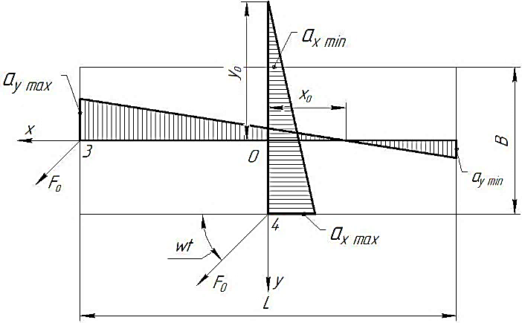

**Figure 1 – Nature of vibration amplitude distribution of the movable frame at** **B/L=0.5**

The generalized coordinates are taken:

 – coordinates of the system center of gravity;

 – rotation angle of the system in the plane near the center of gravity.

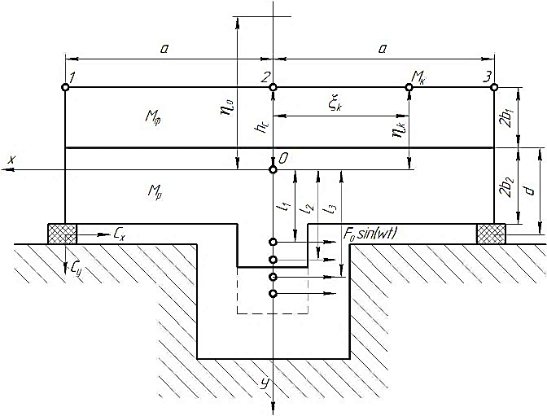

**Figure 2 – Scheme of options for applying forced vibrations, relative to the center of mass of the oscillatory system**

Neglecting the dissipation of energy in supports and concrete, the differential equations of oscillations of the system are obtained in the form:

, (1)

, (2)

where  – mass of the entire system;

– mass of form;

 – weight of movable frame;

 – rigidity of point supports in directions of corresponding axes;

 – different distances of the point of application of the disturbing force to the center of gravity of the system;

 – design parameters.

A partial solution of this system, describing forced vibrations in the resonance constant mode, is:

 (3)

 (4)

where amplitudes of vibration movements are determined by formulas:

 (5)

 (6)

 ,(7)

, (8)

 (9)

From the ratios of the values of the main parameters (,,,) of the vibration machine of this type, it follows that in the obtained expressions for the amplitudes of vibration movements, their components are determining their value: , , .

An approximate estimate of amplitude values allows us to conclude that with the removal of the vibration exciter from the center of gravity, the amplitude of the rotary vibration movements increases noticeably, but the amplitude of the horizontal vibration movements slightly decreases.

The increase in coordinates, that characterize the vibrational movements of system points, are determined by equations:

 (10)

 (11)

where  and  – constant coordinates, which determine the position of the -th point in the system, is rigidly connected with the vibrating mechanism. For characteristic points 1, 2 and 3 on the open surface of the form (Fig. 2) are defined as:

 (12)

 (13)

 (14)

where  – distance to the center of gravity of the system from the open surface of the form and accordingly:

 (15)

 (16)

 (17)

The magnification of coordinate  is zero, that is, horizontal vibration movements are absent at a point that we call "zero" and the coordinate of which we denote . Find the position of this point by putting , from where:

, (18)

As previously called, the magnitude and sign of expressions for  and  are determined by the first components, and therefore it is obvious from equation 18, that $<$  0 and with increasing  decreases, that is, with the vibration exciter moving down from the center of gravity, the "zero" point approaches the center of gravity and horizontal vibration movements on the upper surface of the form decrease.

The resulting dependencies can be reduced to a form convenient for calculations. We introduce the following dimensionless coefficients:

 (19)

. (20)

We present  and express the main characteristics of the vibration machine through these coefficients.

The position of the center of gravity of the machine in relation to the open surface of the form is determined by the distance:

 (21)

Moment of inertia of the system correlate with the center of gravity.

 (22)

(23)

Limited to approximate values of vibration movement amplitudes  and :

 (24)

 (25)

Find the increase in coordinates:

 (26)

 (27)

The position of the "zero" point is determined by equality:

 (28)

Amplitudes of vibration movements of points on the open surface of the mold:

, (29)

 (30)

The obtained dependencies (Fig. 3) for the vibration system with the following data:

 

 

 

 

The results found by the above formulas have good correspondence to natural measurements on several vibration machines with a width of a movable frame .

Finally, it should be noted that when the vibration exciter is buried under the working surface of the movable frame, it increases the vertical component of vibration displacements near the longitudinal sides of the rigid non-removable frame, increasing the intensity of vibration compaction of the concrete mixture. However, calculations and analytical studies show that the penetration of the vibration exciter by more than 0.6 m under the working surface of a movable formwork with a width of less than 3 m is impractical, since the metal consumption of the vibration machine increases, and the excess vertical component leads to formwork collisions and increased production noise [14].

Selection of the best structural scheme of the vibration machine depending on the specific production conditions and dimensions of the formed reinforced concrete products (Fig. 3).

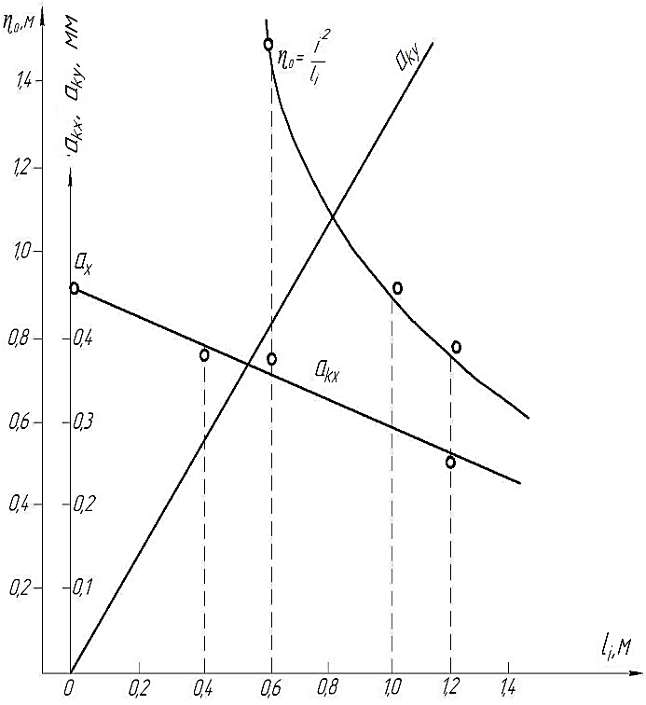

**Figure 3 - Dependence of vibration displacement amplitudes at characteristic points 1-3 and position of "zero" point on location of vibration exciter**

**Conclusions**

In this paper, the most rational design schemes of small-sized vibration machines and their optimal dynamic parameters were outlined:

1. When the vibration exciter is located on the vibration machine in the central window of the movable frame and below its working surface, the vibration pattern of the movable frame will be uniform and symmetrical distribution of the displacement amplitudes of the peripheral points of the shape. The vertical component of displacements of the movable frame is noticeable. In this design, the vibration exciter does not protrude above the working surface of the movable frame, which is convenient for conveyor lines. In this case, the central window weakens the cross section of the movable frame, and makes it difficult to access the vibration exciter. It can be recommended for the formation of hollow floor slabs from inactive mixtures.

2. When the vibration exciter is located on the vibration machine at the end of the movable elongated frame and at 100...300 mm above its working surface there is an uneven distribution of displacement amplitudes along the length of the form. Transverse and vertical components are unequal at the ends and smaller in the middle part. Therefor, there is good access to the vibration exciter. Simple and reliable vibration machine design, convenient for open polygons. Recommended for vibration sites and vibration forms that are used for forming long structures from moving mixtures.

3. If the vibration exciter is located on the side and in the middle of the long side of the movable frame, a more even distribution of displacement amplitudes occurs above or below its working surface compared to other cases. Also, the movable frame retains a continuous section in the central part, which contributes to its strength. Good access to the vibration exciter. Asymmetric arrangement of the vibration drive relative to the axis of the vibration platform. Recommended for use on open polygons and for vibration forms.

4. When the vibration exciter is located at the end or at the corner of the equilateral movable frame and raised above its working surface on the calculated value of 400...1200 mm, it is the most distinct multicomponent nature of vibrations of the movable frame and shape with significant vertical components of vibration displacements. There is also good access to the vibration exciter. Conveniently placed in deep pits and open landfills. Simple and reliable vibration machine design. It is recommended for the formation of high volume elements, reinforced concrete pipes, etc.

**References**

|  |  |  |
| --- | --- | --- |
| 1. Онищенко О.Г., Онищенко В.О., Коробко Б.О., Вірченко В.В. (2017). *Будівельна техніка*. Київ: Кондор |  | 1. Onyshchenko O.H., Onyshchenko V.O., Korobko B.O., Virchenko V.V. (2017). *Building machinery*. Kyiv: Kondor |
| 2. Назаренко І.І. (2007). *Вібраційні машини і процеси будівельної індустрії*. Київ: КНУБА |  | 2. Nazarenko I.I. (2007). *Vibrating machines and construction industry processes.* Kyiv: KNUBA |
| 3. Сукач М.К. (2010) *Будівельна техніка*. Київ Сімферополь: КНУБА – НАПКС |  | 3. Sukach M.K. (2010) *Building machinery.* Kyiv Simferopol: KNUBA – NAPKS |
| 4. Повідайло В.О. (2004) *Вібраційні процеси та обладнання*. Львів: Нац. ун-ту «Львівська політехніка» |  | 4. Povidailo V.O. (2004) *Vibration processes and equipment.* Lviv: Nats. un-tu «Lvivska politekhnika» |
| 5. Nesterenko M.P. Maslov A.G., Salenko Ju.S. (2018). Investigation of vibration machine interaction with comlpacted concrete mixture. *Academic Journal.* *International Journal of Engineering & Technology*, 7(3.2), 260-264 |  | 5. Nesterenko M.P. Maslov A.G., Salenko Ju.S. (2018). Investigation of vibration machine interaction with comlpacted concrete mixture. *Academic Journal.* *International Journal of Engineering & Technology,* 7(3.2), 260-264 |
| 6. Нестеренко М.П. (2015). Прогресивний розвиток вібраційних установок з просторовими коливаннями для формування залізобетонних виробів. *Збірник наукових праць.* *Галузеве машинобудування, будівництво*,2(44), 16-23 |  | 6. Nesterenko M.P. (2015). Progressive development of vibration units with spatial oscillations for forming reinforced concrete products. *Academic Journal. Industrial Machine Building, Civil Engineering,* 2 (44), 16-23 |
| 7. Nesterenko M.P., Nesterenko M.M., Orysenko O.V., Sklyarenko T.O. (2019). Vibrating tables with the spatial os-cillations of the moving frame technological properties for forming reinforced concrete products. *Academic Journal. Industrial Machine Building, Civil Engineering*, 2(53), 13-18  <https://doi.org/10.26906/znp.2019.53.1881> |  | 7. Nesterenko M.P., Nesterenko M.M., Orysenko O.V., Sklyarenko T.O. (2019). Vibrating tables with the spatial os-cillations of the moving frame technological properties for forming reinforced concrete products. *Academic Journal. Industrial Machine Building, Civil Engineering,* 2(53),13-18  <https://doi.org/10.26906/znp.2019.53.1881> |
| 8. Kaplan, D. (1995) *Understanding Nonlinear Dynamics*. New York: Springer-Verlag |  | 8. Kaplan, D. (1995) *Understanding Nonlinear Dynamics.* New York: Springer-Verlag |
| 9. Нестеренко М.П., Білецький В.С., Семко О.В. (2015). Оцінка конструктивно-технологічних параметрів та експлуатаційних якостей вібраційних машин для формування залізобетонних виробів. *Збірник наукових праць.* *Галузеве машинобудування, будівництво*, 1(43), 231-237 |  | 9. Nesterenko M.P., Biletskyi V.S., Semko O.V. (2015). Evaluation the constructive and technological parameters and performance of vibration machines for forming concrete products. *Academic Journal. Industrial Machine Building, Civil Engineering,* 1(43), 231-237 |
| 10. Назаренко І.І., Нестеренко М.П. (2015). Методика досліджень загальної динамічної моделі «технологічна машина для будівельної індустрії – оброблюване середовище». *Техніка будівництва*, 34, 4- 11 |  | 10. Nazarenko I.I., Nesterenko M.P. (2015). Methods of research of the general dynamic model "technological machine for the construction industry - processed medium.". *Construction technique*, 34, 4-11 |
| 11. Назаренко І.І., Дєдов О.П., Дьяченко О.С. (2018) Огляд конструкцій існуючих навісних збудників коливань та дослідження ефективності їх використання для покращення ущільнення залізобетонних виробів на вібраційних установках. *Техніка будівництва*, 39, 46-55 |  | 11. Nazarenko I.I., Diedov O.P., Diachenko O.S. (2018) Review of the designs of existing mounted vibration exciters and study of the effectiveness of their use to improve the sealing of reinforced concrete products in vibration installations. *Construction technique,* 39, 46-55 |
| 12. Nazarenko I., Ruchynskyi M. & Delembovskyi M. (2018) The basic parameters of vibration settings for sealing horizontal surfaces. *International Journal of Engineering & Technology*, 7(3.2), 255-259  <http://dx.doi.org/10.14419/ijet.v7i3.2.14415> |  | 12. Nazarenko I., Ruchynskyi M. & Delembovskyi M. (2018) The basic parameters of vibration settings for sealing horizontal surfaces. *International Journal of Engineering & Technology,* 7(3.2), 255-259.  <http://dx.doi.org/10.14419/ijet.v7i3.2.14415> |
| 13. Сердюк Л.И. (1991) Основы теории, расчеты, конструирование управляемых вибрационных машин с дебалансными возбудителями: дис. .докт. техн. наук. Полтава |  | 13. Serdyuk L.Y. (1991) *Fundamentals of theory, calculations, construction of controlled vibration machines with unbalanced pathogens*. Poltava |
| 14. Ручинський М.М., Свідерський А.Т., Дьяченко О.С. (2019) *Огляд і аналіз існуючих режимів ущільнення бетонних сумішей.* ХХ Міжнародна науково-технічна конференція «Прогресивна техніка, технологія та інженерна освіта». Херсон, 398-399 |  | 14. Ruchynskyi M.M., Sviderskyi A.T., Diachenko O.S. (2019) *Review and analysis of existing concrete compaction modes.* ХХ International Scientific and Technical Conference "Progressive Technology, Technology and Engineering Education.". Kherson, 398-399 |