Збірник наукових праць. Галузеве машинобудування, будівництво
Academic journal. Industrial Machine Building, Civil Engineering
http://journals.nupp.edu.ua/znp
https://doi.org/10.26906/znp.2023.60.ХХХХ

УДК 621.97-868:666.97.033.16

Determination of generalized vibration table forces

Korotych Yuriy¹*

¹ Poltava National Technical Yuri Kondratyuk University https://orcid.org/0000-0002-1961-5318
*Corresponding author E-mail: korotitch.iury@ukr.net

The article determines the generalized forces of the technological set of equipment for concrete products production (vibrating table), in which the vibration exciter is fixed on the lever vertically in the center under the vibrating plate. This equipment is used for the manufacture of small-sized concrete products. Methods of mathematical physics and physical and mathematical modeling by methods of applied mechanics were used in the research. To determine the position and describe the free motions of the material bodies that make up the mechanical system under consideration, an orthogonal vibrational reference system of three coordinate systems was used. As a result, seven generalized forces acting on this mechanical system were determined. The obtained dependencies for the generalized forces will be used to compose a mathematical model of the above-mentioned equipment using the Lagrange equations of the second kind

Key words: vibrating table, lever, vibrator, unbalance, generalized force, mechanical system

Визначення узагальнених сил вібраційного столу

Коротич Ю. Ю¹*.

¹ Національний університет «Полтавська політехніка імені Юрія Кондратюка»
*Адреса для листування E-mail: korotitch.iury@ukr.net

В статті проводиться визначення узагальнених сил технологічного комплекту обладнання для виробництва бетонних виробів (вібростолу), у якого віброзбуджувач закріплюється на важелі вертикально по центру під віброплитою.
Дане обладнання використовується для виготовлення малогабаритних бетонних виробів. При виконанні досліджень були використанні методи математичної фізики та фізико-математичне моделювання методами прикладної механіки. Для визначення положення і опису вільних рухів матеріальних тіл, з яких складається розглядувана механічна система, була застосована ортогональна вібраційна система відліку з трьох систем координат. Аналізуючи кінематичну схему вібраційного столу, визначено, що положення в просторі усіх матеріальних тіл механічної системи, яка моделює зазначений вібростіл, можна однозначно задати такими незалежними параметрами: декартовими координатами, вібраційними кутами та кутом повороту дебалансу. Таким чином, розглядувана механічна система має сім ступенів вільності з сімома узагальненими координатами. Оскільки кожній узагальненій координаті відповідає узагальнена сила, то їх число дорівнює числу узагальнених координат системи, через що розглядувана механічна система має сім узагальнених сил. Беручи до уваги, що на дану механічну систему діють зовнішні сили у вигляді сили тяжіння, сили пружності чотирьох віброопор та механічного крутного моменту приводного двигуна, були визначені сім узагальнених сил,діючих на дану механічну систему. Отримані залежності для узагальнених сил будуть використані для складання в подальшому математичної моделі вищезгаданого обладнання за допомогою рівнянь Лагранжа другого роду

Ключові слова: вібростіл, важіль, вібратор, дебаланс, узагальнена сила, механічна система

Introduction.
Vibration is the most common method of compaction of concrete composites [1,2]. More than 90% of all concrete and reinforced concrete building products are made using this method of concrete mix compaction [3]. This is due to the fact that in the process of vibration action on concrete mixtures, favorable conditions are created for thixotropic dilution and the most compact placement of aggregate particles [4,5].
Modern development of construction requires the introduction of the latest technologies and the installation of engineering equipment for various purposes according to the criteria of minimizing energy and high efficiency of the technological process. There is a huge variety of vibration machines used in construction, which differ in design and purpose. And, first of all, great attention should be paid to the development and implementation of energy-saving technologies and equipment.
A review of various designs of vibration equipment shows that in the production of a wide range of concrete products, equipment with the necessary operating parameters is used, with the help of which high-quality vibration compaction of the concrete mixture is achieved. In order to find out the individual parameters influence of the technological set of equipment for concrete products production developed by us [6] on the movement of its working body and energy consumption, it is necessary to make a mathematical model of this mechanical system.

Review of the research sources and publications.
In modern production, vibration machines with harmonic (circular oscillations in the vertical plane, vertically and horizontally directional oscillations, spatial oscillations) and with shock-vibration (on elastic pads, dual-mass with horizontal or vertical directional oscillations) movements of the working body are used to form concrete products. Such technologies for forming concrete products as vibration compression, vibration vacuum and pulse compaction method are increasingly being developed and implemented [7].
The widespread use of vibration technology, numerous theoretical and experimental studies of the dynamics of vibration machines have made it possible to identify the features of their operation, to explain and apply in practice the peculiar effects that occur during the action of vibration on mechanical systems [8,9,10]. Therefore, a lot of research and development is devoted to this issue [11,12], which reveals such advantages of vibration equipment as high compaction efficiency, simplicity of design, high reliability and relatively low metal and energy consumption.
One of the priority areas for the development of construction vibration equipment is to reduce energy costs in production. Energy-saving technologies, along with increasing productivity and improving product quality, are at the forefront of modern construction. The direction of energy saving is developing due to the optimization of technological parameters of equipment and the use of modern technologies.

Definition of unsolved aspects of the problem.
In our case, it is necessary to create a vibrating table, which, by placing a vibrating exciter on a vertical lever under the vibrating plate, would save energy costs in the manufacture of concrete products by reducing the power of the vibrator while maintaining the required vibration compaction parameters.

Problem statement.
The purpose of this work is to determine the generalized forces of a mechanical system that simulates a vibrating table with a vibrating exciter placed on a vertical lever under a vibrating plate. The data of the dependence of generalized forces are necessary for the analysis of technological factors, in particular the length of the lever, which have an impact on the energy intensity of this mechanical system, as well as for the subsequent compilation of a mathematical model of the technological set of equipment for the production of concrete products (vibrating table) using the Lagrange equations of the second kind.
This work is an integral part and continuation of the results obtained in the work [13].

Basic material and results.
The general view of the technological set of equipment for the production of concrete products (vibrating table) is shown in Fig. 1.

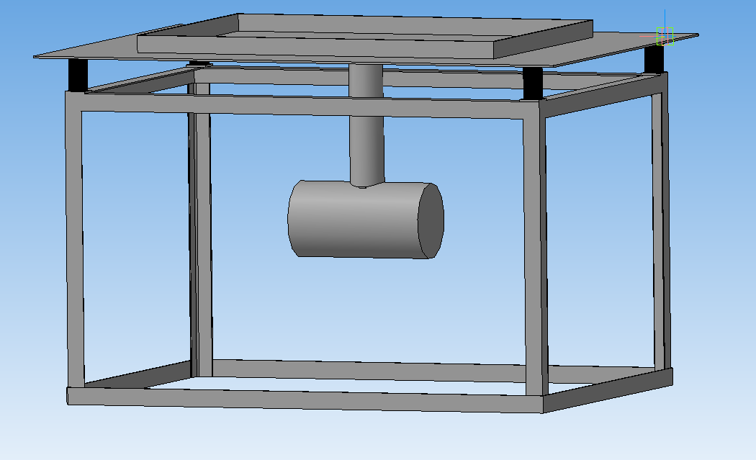

Fig. 1. General view of the technological set of equipment for the manufacture of concrete products

Mathematical model of a vibrating table for the manufacture of small-sized concrete products in the form of Lagrange equations of the second kind [14]
$\frac{d}{dt}\left(\frac{∂T}{∂{\dot{q}}_{i}}\right)-\frac{∂T}{∂q_{i}}=Q_{i}$ $\left(i=1, 2, . . .,i, . . ., s\right)$ (1)
contains generalized forces $Q_{1}$, $Q_{2}$, …,$Q_{i}$ , …, $Q_{s}$, where $Q_{i}$ – the generalized force corresponding to the generalized coordinate $q_{i}$. In the system (1) of differential equations, the coordinates are generalized $q_{1}=q_{1}\left(t\right)$, $q_{2}=q_{2}\left(t\right)$, …, $q_{i}=q_{i}\left(t\right)$, …, $q_{s}=q_{s}\left(t\right)$ – these are independent parameters that uniquely define the position of a mechanical system in space, the number of which determines the number of $s$ degrees of this system freedom, а${\dot{q}}_{1}=\frac{dq_{1}}{dt}={\dot{q}}_{1}\left(t\right)$, ${\dot{q}}_{2}=\frac{dq_{2}}{dt}={\dot{q}}_{2}\left(t\right)$, …, ${\dot{q}}_{i}=\frac{dq_{i}}{dt}={\dot{q}}_{i}\left(t\right)$, …, ${\dot{q}}_{s}=\frac{dq_{s}}{dt}={\dot{q}}_{s}\left(t\right)$ – corresponding generalized velocities.
From the analysis of the kinematic scheme of the vibrating table [13], it is obvious that the position in space of all material bodies of the mechanical system that simulates the specified vibrating table can be uniquely given by the following independent parameters:
- Cartesian coordinates $x_{C}=x_{C}\left(t\right)$, $y_{C}=y_{C}\left(t\right)$ і $z_{C}=z_{C}\left(t\right)$, which determine the position of the center $С$ inertia of plate 1 in a fixed coordinate system $Oxyz$;
- vibrating angles $α=α\left(t\right)$, $β=β\left(t\right)$ і $ψ=ψ\left(t\right)$, which define the position of plate 1 with respect to the moving coordinate system $Cx^{'}y^{'}z^{'}$;
- angle $ϕ=ϕ\left(t\right)$ unbalance rotation 5 around the axis $ϕ$ rotation of an unbalanced shaft 4 that passes through a point $С_{3}$ and coincides (coincides) with the central longitudinal axis of the housing 3 of the vibration exciter.
Thus, the mechanical system in question has $s=7$ degrees of freedom, the generalized coordinates are $q_{1}=x_{C}$, $q_{2}=y_{C}$, $q_{3}=z_{C}$, $q_{4}=α$, $q_{5}=β$, $q_{6}=ψ$ і $q_{7}=ϕ$, and generalized speeds – ${\dot{q}}_{1}=\frac{dx_{C}}{dt}={\dot{x}}_{C}$, ${\dot{q}}_{2}=\frac{dy_{C}}{dt}={\dot{y}}_{C}$, ${\dot{q}}_{3}=\frac{dz_{C}}{dt}={\dot{z}}_{C}$, ${\dot{q}}_{4}=\frac{dα}{dt}=\dot{α}$, ${\dot{q}}_{5}=\frac{dβ}{dt}=\dot{β}$, ${\dot{q}}_{6}=\frac{dψ}{dt}=\dot{ψ}$ і ${\dot{q}}_{7}=\frac{dϕ}{dt}=\dot{ϕ}$.
For the sake of clarity and for further considerations, let us imagine and depict in Figures 2 ÷ 4 a mechanical system in its three projections at an arbitrary moment in time so that all the generalized coordinates are positive, and assuming that at that moment each generalized coordinate is increasing (of course, in this case, all time derivatives of the generalized coordinates will also be only positive).

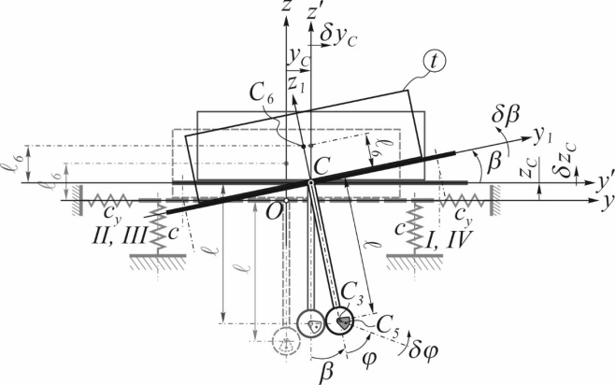

Fig. 2. Mechanical system in projection on the frontal plane
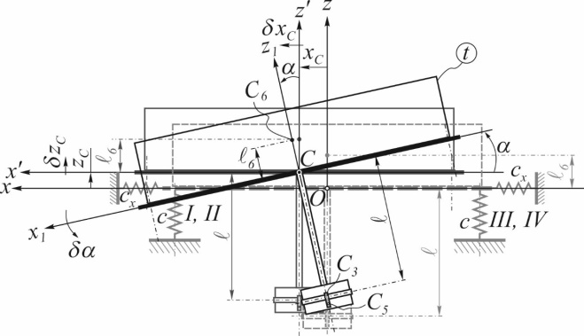

Fig. 3. Mechanical system in projection on the profile plane

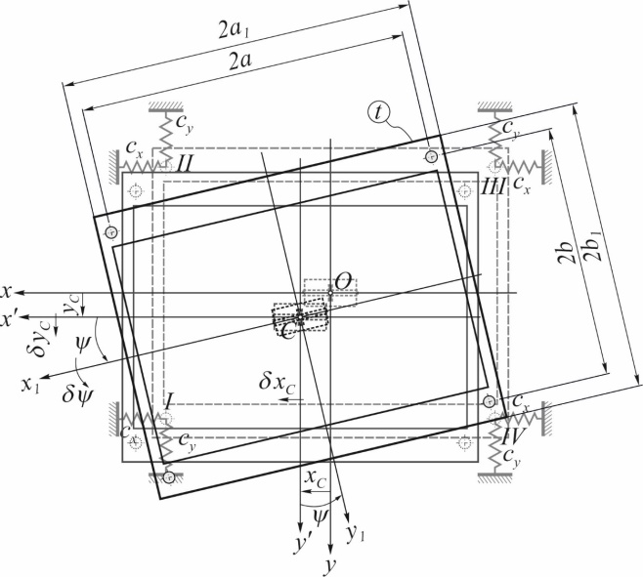

Fig. 4. Mechanical system in projection on the horizontal plane

Since each generalized coordinate corresponds to a generalized force, their number is equal to the number of generalized coordinates of the system, which is why the mechanical system in question has seven generalized forces. The significance of these forces directly depends on external forces ${\vec{P}}_{1}$, ${\vec{P}}_{2}$, …, ${\vec{P}}_{j}$, …, ${\vec{P}}_{n}$, acting on certain points of the system.
To determine the generalized force, for example, $Q_{i}$ corresponding generalized coordinate $q_{i}$ give an infinitesimal increment $δq_{i}$, leaving the other generalized coordinates unchanged. As a result, the infinitesimal increases $δq_{i}$ all points of the mechanical system will receive infinitesimal displacements $δs_{1}$, $δs_{2}$, …, $δs_{j}$, …,$δs_{n}$, which are possible point movements. Next, the sum of the elementary work of all external forces on these possible displacements is calculated, which is equal to
$\sum_{j=1}^{n}{\left[P_{j}⋅δs_{j}⋅cos\left({\vec{P}}_{j}; δ{\vec{s}}_{j}\right)\right]}=δA_{i}$,
and believe that
$δA_{i}=Q_{i}⋅δq_{i}$.
Value$Q_{i}$, what is determined from this equation,
$Q_{i}=\frac{δA_{i}}{δq_{i}}$ (2)
and is a generalized force that corresponds to a generalized coordinate$q_{i}$, defined through possible work $δA_{i}$.
As is known [15], the elementary work of an arbitrary force ${\vec{P}}_{j}$ on a certain possible displacement in the coordinate form of the notation, determines the dependence
$δA\left({\vec{P}}_{j}\right)=P_{jx}⋅δx+P_{jy}⋅δy+P_{jz}⋅δz$, (3)
where $P_{jx}$, $P_{jy}$ і $P_{jz}$ – projections of this arbitrary force ${\vec{P}}_{j}$ on the appropriate axes;$δx$, $δy$ і $δz$ – projections of possible displacement of the point of force application ${\vec{P}}_{j}$ on the same axes.
Any resistance to the movements of the material bodies of the mechanical system in question shall be neglected. In this case, it is affected by the following external forces:
a) gravity
${\vec{G}}_{1}=m_{1}⋅\vec{g}$, ${\vec{G}}_{3}=m_{3}⋅\vec{g}$, ${\vec{G}}_{6}=m_{6}⋅\vec{g}$ і ${\vec{G}}_{5}=m⋅\vec{g}$
corresponding material bodies, which are attached in points $C$, $C_{3}$, $C_{6}$ і $C_{5}$ (see Fig. 5);
б) elastic forces of the four elastic elements on which the plate rests 1 (see Fig. 7);
в) mechanical torque (or rotational) $M_{дв.}$ Of an engine (see Fig. 8, а).

a) b)
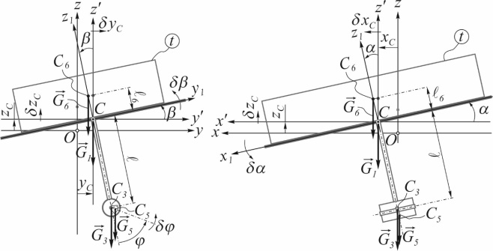

Fig. 5. On the of gravitational forces elementary works definition

As is known [16], according to Hooke's law, the linear elastic force $F_{пр.}$, that occurs in linear deformation$Δ l$, proportional to said deformation
$F_{пр.}=с⋅Δ l$,
where $c$ – proportionality coefficient, for an elastic element – stiffness coefficient.
Due to the fact that during the direct formation of concrete products, slab 1 is in free motion, the vertical elastic elements on which it rests undergo not only linear deformations along the vertical axis$Oz$. To take into account the stiffness of each elastic element in the direction of the horizontal axes $Ox$ and $Oy$ let's introduce virtual elastic elements with stiffnesses $c_{x}$ and $c_{Y}$ respectively (see Fig. 4). In this case, three orthogonal elastic forces will act on plate 1 from each elastic element
$F_{пр.x}=с_{x}⋅Δ l_{x}$, $F_{пр.y}=с_{y}⋅Δ l_{y}$ і
$F_{пр.z}=с⋅Δ l$, (4)
where$Δ l_{x}$, $Δ l_{y}$ and $Δ l$ – deformations of the corresponding elastic elements.
Since for the working body of the vibrating table, its angular displacements determine the vibration angles$α$, $β$ and $ψ$, which acquire only small values, then we neglect the torsional rigidity of each elastic element.
Consider in Figure 6 a mechanical system in its position of static equilibrium (PSE), where $l_{нед.}$ – length of each elastic element in the undeformed state.

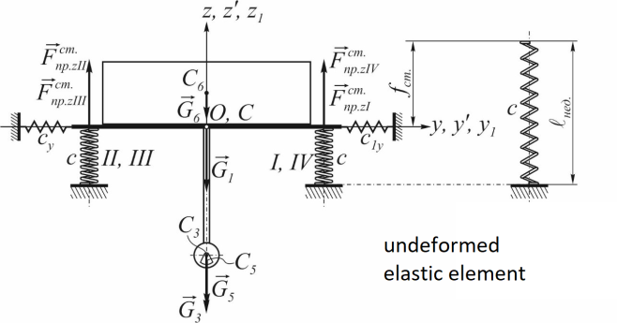

Fig. 6. Mechanical system in static equilibrium position

From the equilibrium condition $∑Z=0$ getting the corresponding equilibrium equation
$-m_{1}⋅g-m_{3}⋅g-m⋅g-m_{6}⋅g+c⋅f_{ст.}+c⋅f_{ст.}+c⋅f_{ст.}+c⋅f_{ст.}=0$,
from where
$-M⋅g+c_{е}⋅f_{ст.}=0$, (5)
where $M=m_{1}+m_{3}+m_{6}+m$, $c_{е}=c+c+c+c=4⋅c$– equivalent stiffness of elastic elements or stiffness of equivalent elastic support [13], $f_{ст.}$– static vertical deformation of equivalent elastic support (of course, in the static equilibrium position of a mechanical system, each of the elastic elements on which plate 1 rests has the same vertical static deformation, and all the introduced virtual elastic elements are undeformed).
To find the generalized force $Q_{3}=Q_{z_{C}}$:
- will give to a generalized coordinate $q_{3}=z_{C}$ infinitesimal linear increment $δq_{3}=δz_{C}$ (see Fig. 1 and 2), and leaving other generalized coordinates unchanged;
- will establish what possible displacements were made by the points of application of all external forces acting on the mechanical system, as a result of the increase provided $δq_{3}=δz_{C}$;
- will calculate the possible work $δA_{3}$ of all external forces at the indicated possible displacements of points.
Will look for a possible work $δA_{3}$ according to the formula
$δA_{3}=δA_{3}\left(\vec{G}\right)+δA_{3}\left({\vec{F}}_{пр.}\right)$, (6)
where $δA_{3}\left(\vec{G}\right)$ і $δA_{3}\left({\vec{F}}_{пр.}\right)$ – Accordingly, the possible work of gravity forces and elastic forces of elastic elements.
As the increasing $δq_{3}=δz_{C}$ directed vertically, then the possible works of the elastic forces of horizontally arranged virtual elastic elements at such a possible displacement are equal to zero and therefore
$δA_{3}\left({\vec{F}}_{пр.}\right)=δA_{3}\left({\vec{F}}_{пр. z}\right)$,
where $δA_{3}\left({\vec{F}}_{пр. z}\right)$ – possible works of elastic forces of real elastic elements.
For sure,
$δA_{3}\left(\vec{G}\right)=δA_{3}\left({\vec{G}}_{1}\right)+δA_{3}\left({\vec{G}}_{3}\right)+δA_{3}\left({\vec{G}}_{6}\right)+δA_{3}\left({\vec{G}}_{5}\right)$,
where $δA_{3}\left({\vec{G}}_{1}\right)$, $δA_{3}\left({\vec{G}}_{3}\right)$, $δA_{3}\left({\vec{G}}_{6}\right)$ і $δA_{3}\left({\vec{G}}_{5}\right)$ – elementary works of the corresponding gravitational forces, which are determined by the formula (3).
Directly from Figure 4 we can see that the corresponding projections of forces
$G_{1x}=0$, $G_{1y}=0$, $G_{1z}=-G_{1}=-m_{1}⋅g$, $G_{3x}=0$, $G_{3y}=0$,
$G_{3z}=-G_{3}=-m_{3}⋅g$, $G_{6x}=0$, $G_{6y}=0$, $G_{6z}=-G_{6}=-m_{6}⋅g$,
$G_{5x}=0$, $G_{5y}=0$, $G_{5z}=-G_{5}=-m⋅g$
and projections of possible point displacements $C$, $C_{3}$, $C_{6}$ and $C_{5}$ on the same axes
$δx_{C}=δx_{C_{3}}=δx_{C_{6}}=δx_{C_{5}}=δy_{C}=δy_{C_{3}}=δy_{C_{6}}=δy_{C_{5}}=0$,
$δz_{C_{3}}=δz_{C_{6}}=δz_{C_{5}}=δz_{C}$.
Then
$$δA_{3}\left(\vec{G}\right)=-m_{1}⋅g⋅δz_{C}-m_{3}⋅g⋅δz_{C}-m_{6}⋅g⋅δz_{C}-m⋅g⋅δz_{C}=$$
$$=-\left(m_{1}+m_{3}+m_{6}+m\right)⋅g⋅δz_{C}=$$$=-M⋅g⋅δz_{C}$. (7)
Now let's find in formula (6) the component $δA_{3}\left({\vec{F}}_{пр.}\right)=δA_{3}\left({\vec{F}}_{пр. z}\right)$ as the sum of the elementary works of the real elastic elements elastic forces $I$, $II$, $III$ і $IV$:
$δA_{3}\left({\vec{F}}_{пр.}\right)=δA_{3}\left({\vec{F}}_{пр.zI}\right)+δA_{3}\left({\vec{F}}_{пр.zII}\right)+δA_{3}\left({\vec{F}}_{пр.zIII}\right)+δA_{3}\left({\vec{F}}_{пр.zIV}\right)$,
where $δA_{3}\left({\vec{F}}_{пр.zI}\right)$, $δA_{3}\left({\vec{F}}_{пр.zII}\right)$, $δA_{3}\left({\vec{F}}_{пр.zIII}\right)$ and $δA_{3}\left({\vec{F}}_{пр.zIV}\right)$ determined by the formula (3), and the elastic forces themselves by the formula (4).
Calculating for each of the elastic elements the elementary work of its elastic force at a specific displacement of the point of its application, we will take into account the fact that the specified work is positive when the elastic force contributes to the reduction of the deformation of the elastic support, and negative if the elastic force increases the deformation of the elastic support.
When finding deformations of elastic elements at the considered moment of time t Let us take into account the fact that the movement of their anchoring points to plate 1 from its rotations to vibration angles $α$, $β$ and $ψ$ in reality, they are carried out along the arcs of the corresponding circles, but because of the smallness of these displacements, we neglect their curvature, assuming that the points move in straight lines along the corresponding coordinate axes at a distance equal to the lengths of the indicated arcs. Then, from the cumulative analysis of Figures 6 and 7, we establish that
$Δ l_{I}=f_{ст.}-z_{C}+a⋅α-b⋅β$, $Δ l_{II}=f_{ст.}-z_{C}+a⋅α+b⋅β$,
$Δ l_{III}=f_{ст.}-z_{C}-a⋅α+b⋅β$, $Δ l_{IV}=f_{ст.}-z_{C}-a⋅α-b⋅β$,
Because of what
$\left.\begin{aligned}F_{пр.z I}=с⋅Δ l_{I}=c⋅\left(f_{ст.}-z_{C}+a⋅α-b⋅β\right) , \\ F_{пр.z II}=с⋅Δ l_{II}=c⋅\left(f_{ст.}-z_{C}+a⋅α+b⋅β\right) , \\ F_{пр.z III}=с⋅Δ l_{III}=c⋅\left(f_{ст.}-z_{C}-a⋅α+b⋅β\right) , \\ F_{пр.z IV}=с⋅Δ l_{IV}=c⋅\left(f_{ст.}-z_{C}-a⋅α-b⋅β\right) .\end{aligned}\right\}$ (8)

a) b)
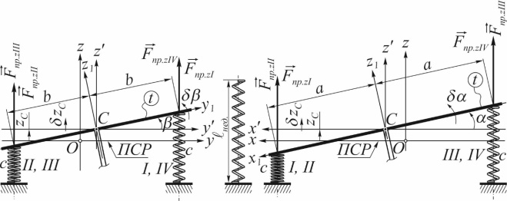

Fig. 7. On the Elastic Forces Elementary Works Determination

Since in Figure 7 all the elastic forces ${\vec{F}}_{пр.z I}$, ${\vec{F}}_{пр.z II}$, ${\vec{F}}_{пр.z III}$ і ${\vec{F}}_{пр.z IV}$ vertically upwards, then, of course, they are all projected on the axis $Oz$ life-size with a positive sign, and are not projected on other axes. It is also evident that projections on the axis $Oz$ possible displacements of the points of attachment of elastic elements to plate 1 are positive and are equal to the given infinitesimal increment $δz_{C}$, and the projections on the other axes are zero.
Then, according to the formula (3)
$δA_{3}\left({\vec{F}}_{пр. zI}\right)=F_{пр.z I}⋅δz_{C}=c⋅\left(f_{ст.}-z_{C}+a⋅α-b⋅β\right)⋅δz_{C}$,
$δA_{3}\left({\vec{F}}_{пр. zII}\right)=F_{пр.z II}⋅δz_{C}=c⋅\left(f_{ст.}-z_{C}+a⋅α+b⋅β\right)⋅δz_{C}$,
$δA_{3}\left({\vec{F}}_{пр. zIII}\right)=F_{пр.z III}⋅δz_{C}=c⋅\left(f_{ст.}-z_{C}-a⋅α+b⋅β\right)⋅δz_{C}$,
$$δA_{3}\left({\vec{F}}_{пр. zIV}\right)=F_{пр.z IV}⋅δz_{C}=c⋅\left(f_{ст.}-z_{C}-a⋅α-b⋅β\right)⋅δz_{C}$$
and
$$δA_{3}\left({\vec{F}}_{пр.}\right)=c\left(f_{ст.}-z_{C}+a⋅α-b⋅β\right)⋅δz_{C}+c\left(f_{ст.}-z_{C}+a⋅α+b⋅β\right)⋅δz_{C}+$$
$$+c⋅\left(f_{ст.}-z_{C}-a⋅α+b⋅β\right)⋅δz_{C}+c⋅\left(f_{ст.}-z_{C}-a⋅α-b⋅β\right)⋅δz_{C}$$
or (after conversions)
$$δA_{3}\left({\vec{F}}_{пр.}\right)=c⋅\left(f_{ст.}-z_{C}+a⋅α-b⋅β+f_{ст.}-z_{C}+a⋅α+b⋅β+\right.$$
$$+\left.f_{ст.}-z_{C}-a⋅α+b⋅β+f_{ст.}-z_{C}-a⋅α-b⋅β\right)⋅δz_{C}=$$
$=с⋅\left(4⋅f_{ст.}-4⋅z_{C}\right)⋅δz_{C}=4⋅с⋅\left(f_{ст.}-z_{C}\right)⋅δz_{C}$.
Since the same $4⋅c=c_{е}$, then
$δA_{3}\left({\vec{F}}_{пр.}\right)=с_{е}⋅f_{ст.}⋅δz_{C}-с_{е}⋅z_{C}⋅δz_{C}$. (9)
By substituting the values (7) and (9) into formula (6), we have
$$δA_{3}=-M⋅g⋅δz_{C}-m_{5}⋅g⋅δz_{C}+с_{е}⋅f_{ст.}⋅δz_{C}-с_{е}⋅z_{C}⋅δz_{C}=$$
$=\left(-M⋅g-m_{5}⋅g+с_{е}⋅f_{ст.}-с_{е}⋅z_{C}\right)⋅δz_{C}$,
whence we get the equality (5)
$δA_{3}=-с_{е}⋅z_{C}⋅δz_{C}$;
then, according to formula (2), the generalized force corresponding to the generalized coordinate $q_{3}=z_{C}$,
$$Q_{3}=\frac{δA_{3}}{δq_{3}}=\frac{δA_{3}}{δz_{C}}=\frac{-с_{е}⋅z_{C}⋅δz_{C}}{δz_{C}}$$
and, after the reduction of $δz_{C}$, finally
$Q_{3}=-с_{е}⋅z_{C}$.

Computing the other generalized forces of our mechanical system in the same way, we get
$Q_{1}=-c_{ex}⋅x_{C}+c_{ex}⋅δ⋅α$.
$Q_{2}=-c_{ey}⋅y_{C}-c_{ey}⋅δ⋅β$.

.
$Q_{6}=-c_{ex}⋅b^{2}⋅ψ-c_{ey}⋅a^{2}⋅ψ$.
$Q_{7}=M_{дв.}-m⋅g⋅e⋅sinϕ$.
Conclusions
To obtain a mathematical model of the developed vibrating table design, we propose to use the Lagrange equation of the second kind. This method is the most common method used in solving problems concerning the motion of mechanical systems.
The vibrating table in question was modeled by a mechanical system consisting of several material bodies - a plate, a vibration exciter body, an imbalance and a container with a concrete mixture. To determine the position and describe the free motions of the above-mentioned material bodies of the mechanical system under consideration, an orthogonal vibrational reference system of three coordinate systems was used.
Having depicted and considered the mechanical system of the developed design of the vibrating table, seven generalized forces acting on it were determined.
The defined generalized forces of this mechanical system will be further used to compile a mathematical model of the vibration table in the Lagrange equations of the second kind, with the help of which it will be possible to analyze the influence of its constituent parameters - geometric and kinematic - on the process of compaction of the concrete mixture to reduce energy consumption during vibration compaction of products.

References
1. Назаренко І.І. (2007). Вібраційні машини і процеси будівельної індустрії. – К.: КНУБА |  | 1. Nazarenko I.I. (2007). Vibration machines and processes of the construction industry. – Kyiv, KNUBA
2. Дудар І.Н. (2006).Теоретичні основи технології виробів із пресованих бетонів. Вінниця: УНІВЕРСУМ-Вінниця |  | 2. Dudar I.N. (2006).Theoretical foundations of the technology of products from pressed concrete. Vinnytsia: UNIVERSUM-Vunnytsia
3. Гусев Б.В., Зазимко В.Г. (1991). Вібраційна технологія бетону. Київ: Будівельник |  | 3. Gusev B.V., Zazimko V.G. (1991). Concrete Vibration Technology. Kyiv: Budivelnyk
4. Ручинський М.М., Свідерський А.Г., Дяченко О.С. (2019). Огляд і аналіз існуючих режимів ущільнення бетонних сумішей. МНТК «Прогресивна техніка, технологія та інженерна освіта» |  | 4. Ruchinsky M.M., Svidersky A.G., Dyachenko O.S. (2019). Review and analysis of existing modes of compaction of concrete mixtures. MNTK "Progressive technique, technology and engineering education"
5. Назаренко І.І., Ручинський М.М. (2002). Фізичні основи механіки будівельних матеріалів. Львів: Афіша |  | 5. Nazarenko I.I., Ruchinsky M.M. (2002). Physical foundations of the mechanics of building materials. Lviv: Afisha
6. Коробко Б.О., Коротич Ю.Ю., Васильєв Є.А. (2021). Пат. України 146691. Вібростіл з важільним закріпленням віброзбуджувача. Київ: Державне патентне відомство України |  | 6. Korobko B.O., Korotych Y.Y., Vasilyev E.A. (2021). Pat. Ukraine 146691. Vibrating table with lever fastening of the vibrating exciter. Kyiv: State Patent Office of Ukraine
7. Загреба В.П., Дудар І.Н., Коваленко А.О. (2012).  Технологія роздільного віброімпульсного формування каменебетонних виробів. Вінниця: ВНТУ |  | 7. Zagreba V.P., Dudar I.N., Kovalenko A.O. (2012). Technology of Separate Vibro-Pulse Molding of Stone-Concrete Products. Vinnytsia: VNTU
8. Дворкін Л.Й., Двокін О. Л., Гарніцький Ю.В. (2000). Проектування складів бетону із заданими властивостями. Рівне: Вид-во РДТУ |  | 8. Dvorkin L.Y. Dvorkin O.L., Harnitsky Y.V. (2000). Design of concrete compositions with specified properties. Rivne: RDTU Publ.
9. Nesterenko M.P., Molchanov P.O. (2014). Study of vibrations of plate of oscillation cassette setting as active working organ. Conference reports materials «Problems of energ and nature use 2013». Budapest, 146-151 |  | 9. Nesterenko M.P., Molchanov P.O. (2014). Study of vibrations of plate of oscillation cassette setting as active working organ. Conference reports materials «Problems of energ and nature use 2013». Budapest, 146-151
10. Рунова Р.Ф., Братчун В.І., Гоц В.І. та ін. (2008). Конструкційні матеріали нового покоління та технології їх впровадження у будівництво. Київ: УВПК ЕксОб |  | 10. Runova R.F., Bratchun V.I., Gots V.I.et al. (2008). Structural materials of the new generation and technologies of their implementation in construction. Kyiv: UVPK EksOb
11. Нестеренко М.П. (2007). Класифікація та оцінка споживчих якостей сучасних вібраційних машин для формування залізобетонних виробів. Збірник наукових праць. Галузеве машинобудування, будівництво, 20, 20-25 |  | 11. Nesterenko M.P. (2007). Classification and Evaluation of Consumer Qualities of Modern Vibration Machines for the Formation of Reinforced Concrete Products. Academic journal. Industrial Machine Building, Civil Engineering, 20, 20-25
12. Загреба В.П., Дудар І.Н., Коваленко А.О. (2012). Технологія роздільного віброімпульсного формування каменебетонних виробів. Вінниця: ВНТУ |  | 12. Zagreba V.P., Dudar I.N., Kovalenko A.O. (2012). Technology of Separate Vibro-Pulse Molding of Stone-Concrete Products. Vinnytsia: VNTU
13. Korobko B., Zhyhylii S., Korotych Yu. (2022). Determination of the vibrating table kinetic energy. Academic journal. Industrial Machine Building, Civil Engineering, 2(59), 17-26 |  | 13. Korobko B., Zhyhylii S., Korotych Yu. (2022). Determination of the vibrating table kinetic energy. Academic journal. Industrial Machine Building, Civil Engineering, 2(59), 17-26
14. Morin D. (2008). Introduction to Classical Mechanics: With Problems and Solutions. Cambridge University Press |  | 14. Morin D. (2008). Introduction to Classical Mechanics: With Problems and Solutions. Cambridge University Press
15. Павловський М.А. (2002). Теоретична механіка: підручник. Київ: Техніка |  | 15. Pavlovskyі M.A. (2002). Theoretical mechanics: Kyiv: Technika
16. Seely F.В., Ensign N.E. (1941). Analytical mechanics for engineers. Chapman & Hall, Limited, New York, London |  | 16. Seely F.В., Ensign N.E. (1941). Analytical mechanics for engineers. Chapman & Hall, Limited, New York, London

