Збірник наукових праць. Галузеве машинобудування, будівництво
Academic journal. Industrial Machine Building, Civil Engineering
http://journals.nupp.edu.ua/znp
https://doi.org/10.26906/znp.2022.59.ХХХХ

UDC 332.83

Organizational and technological aspects
of applying ecological criteria in innovative low-rise construction

Perehinets Ivan¹, Nazarenko Ivan², Nesterenko Mykola^{3*}, Nesterenko Tetiana⁴

¹Kyiv National University of Construction and Architecture https://orcid.org/0000-0002-1888-3687
²Kyiv National University of Construction and Architecture https://orcid.org/0000-0003-3812-6509
³National University «Yuri Kondratyuk Poltava Polytechnic» https://orcid.org/0000-0002-4073-1233
⁴National University «Yuri Kondratyuk Poltava Polytechnic» https://orcid.org/0000-0002-2387-8575
*Corresponding author E-mail: nesterenkonikola@gmail.com

At the current stage of society's development, more and more attention is paid to the search for constructive solutions to facilitate a healthy lifestyle. The work presents a cluster approach to the formation of the project of an innovative low-rise building under the conditions of ensuring environmental criteria, the principles of green construction by the flow method of raising buildings from ecological materials and quickly assembled modular elements. Such houses have low energy costs and make the most of the circle of quality and comfortable living. The solution of the specified approach and the adoption of relevant decisions were carried out using classical parametric system analysis and structural synthesis.

Keywords: flow construction method, energy efficiency, cluster construction, digitalization of the construction industry, low-rise construction

Організаційно-технологічні аспекти застосування екологічних
критеріїв в інноваційному малоповерховому будівництві

Перегінець І.І.¹, Назаренко І.І.², Нестеренко М.М.³*, Нестеренко Т.М.⁴

¹Київський національний університет будівництва та архітектури
²Київський національний університет будівництва та архітектури
³Національний університет «Полтавська політехніка імені Юрія Кондратюка»
⁴ Національний університет «Полтавська політехніка імені Юрія Кондратюка»
*Адреса для листування E-mail: nesterenkonikola@gmail.com

У роботі запропоновано комплексний підхід на основі кластерного аналізу для розробки інноваційних рішень для малоповерхової забудови з акцентом на екологічні критерії та принципи «зеленого будівництва». Проведено аналіз, який підкреслює актуальну потребу у більш енергоефективному та сталому житловому фонді України та показує значну різницю в споживанні енергії між Україною та країнами-членами Європейського Союзу. Виділено неефективність існуючого житлового фонду та необхідність використання енергоефективних технологій протягом усього життєвого циклу будівництва. Доведено, що інтеграція моделей кластерів у будівельний процес дає різноманітні переваги, включаючи скорочення часу виведення інноваційних продуктів на ринок інновацій будівельних процесів, підвищення стабільності логістичних зв'язків, зменшення фінансових ризиків та розширення ринку збуту. Дослідження розглядає ключові аспекти організації будівництва, планування, управління та контролю якості в контексті кластерів. Досліджено метод потокового будівництва, який поєднує послідовний та паралельний методи, мінімізуючи їхні недоліки. Цей підхід ілюструється на прикладі проекту Bucha Techno Garden та показує, як даний метод може призвести до зниження витрат і зміцнення співпраці між учасниками кластера. Крім того, досліджено використання технології Building Information Modeling (BIM) як інструменту для ефективного управління інформацією, моніторингу процесів та оптимізації витрат протягом життєвого циклу будівництва. Цей підхід відповідає загальній тенденції цифровізації у будівельній галузі. Запропоновано підходи, що сприяють створенню житла, яке не лише відповідає сучасним екологічним та енергоефективним стандартам, але й направлені на підвищення комфорту і якості життя для мешканців.

Ключові слова: потоковий метод будівництва, енергоефективність, кластерне будівництво, цифровізація будівельної галузі, малоповерхова забудова

Introduction
The work analyzes the suitability of residential and public buildings, which must be comfortable and safe, which are the initial environmental criteria. As you know, these criteria must be ensured in the design of one or another building, according to the purpose. To a large extent, this refers to the comfort conditions of living in low-rise buildings, since in such buildings the number of apartments and the number of residents are important. This is determined by the criterion that defines functional comfort, as the ability of people to live and communicate with each other in such a limited space. An important aspect of ensuring environmental sustainability is the constructive and planning solutions of architectural objects in such a space [1].
At the current stage of society's development, more and more attention is paid to the search for constructive solutions to ensure a healthy lifestyle. The cluster approach of forming the project of an innovative low-rise building under the conditions of ensuring ecological criteria, the principles of green construction by the flow method of raising buildings from ecological materials and quickly assembled modular elements is substantiated and developed [2, 3].
The main positive aspects of the cluster approach are:
- permanent participation of scientific and research and development sectors in the activities of the cluster;
- shortening the period of bringing innovative product units to the market;
- the formation of more stable logistic connections between enterprises;
- increasing predictability and predictability of cash flows;
- significant reduction of financial and credit risks;
- expansion of the sales market;
- growth of incentives to increase labor productivity;
- determination of the enterprise's share in the final innovative product and the integrated economic effect.

Research results
The housing fund of Ukraine is in an unsatisfactory state from the point of view of fuel and energy efficiency. According to energy surveys, in residential buildings of mass construction of the past years, heat losses through the walls are 42%, through the windows - 16%, through the roof - 7%, through the basement - 5%, in the process of air exchange - 30%. (Table 1).
In fact, the efficiency of thermal energy use in Ukrainian buildings is 3-5 times lower than in Western countries. Thus, according to experts' estimates, the specific consumption of heat and hot water in Ukraine is two times higher than that of EU member states with similar climatic conditions. The average specific energy consumption for heating per year in Ukraine is 264 kWh per square meter, while in EU countries - 130 kWh per square meter [7].
Construction of new community territories should be carried out exclusively using energy-efficient technologies during the life cycle [5].

Table 1 – Heat losses through the enclosing structures of buildings
Walls | Windows | Roof | Basement | Air exchange
% | % | % | % | %
42 | 16 | 7 | 5 | 30

Innovations in the organizational and production process during the construction of urban planning objects are a necessary condition for the transformation of the company's activities, which are accompanied by significant financial and time costs. Clusters make it possible to reduce such costs both at the stage of changing the structure of organizational and production processes and at the cost of current financial, organizational, technological and infrastructural transactions when producing a joint construction product by the flow method of construction. [4]
The organization of construction production based on cluster models provides for the following areas of scientific and production activity:
1. Construction organization - a system of formation or selection of a production enterprise (complex of enterprises) included in a cluster designed to fulfill the assigned task.
2. Planning – development of a system of linking construction and installation works, providing the construction process with material and technical resources.
3. Management – a system of compliance with design and estimate indicators and operational management of changes.
4. Quality control of construction and assembly, engineering and finishing works - a system of quality control of the supply of construction materials, structures and equipment, as well as the performance of the respective types of work.
Construction theory and practice distinguishes three main methods of construction of buildings and structures: sequential, parallel and flow [6].
With the sequential method of construction, each object of urban planning is erected after the completion of all works on the previous object. This method of work performance by crews carrying out various construction processes is accompanied by forced interruptions in work.
It is possible to start and finish construction processes on all objects at the same time. In this case, the construction time of all objects will be equal to the construction time of one object, but significant material and technical resources will be required. This method of conducting construction and assembly works is called a parallel method of construction.
The flow method of construction and assembly works in the development of territories according to the Comprehensive Spatial Development Plans (Fig. 1) combines sequential and parallel methods, preserving the advantages of both methods and eliminating the disadvantages.
Reducing the cost of the final construction product gives competitive advantages to cluster formations. The frequency of mutual contacts between the subjects of the cluster with the flow method of construction is so dense that their interaction goes from a purely production to a social-cooperative aspect, strengthening moral and ethical obligations and joint responsibility for the quality of the final result.
The cluster approach allows small and medium-sized construction firms to consolidate without losing their legal and financial autonomy, promotes the development of the middle class, gives clusters greater flexibility and speed of decision-making, which is not characteristic of larger bureaucratized companies. [2] Multiplication of cluster participants in production and geographical aspects integrally forms the most optimal composition of the material, technical and executive resource base for the construction of a building object as a separate commodity unit with specified operational parameters, at a fixed price, in a specific UTC of Ukraine, at a specific time [1].
The cluster method of territory development involves the use of BIM technologies, as a new approach to digital information management, which is used in construction and urban planning and involves the collection and complex processing of all architectural, design, technological, economic and other information about the object. Thanks to their application, it is possible to virtually reproduce the object even before its construction begins, to monitor the life cycle processes of the construction object - from design to its construction, operation and dismantling. This approach makes it possible to increase the safety and reliability of buildings and structures, implement operational management of construction processes and control the quality of construction works, significantly reduce the probability of errors in projects, reduce the cost of construction and optimize costs at the operational stage.

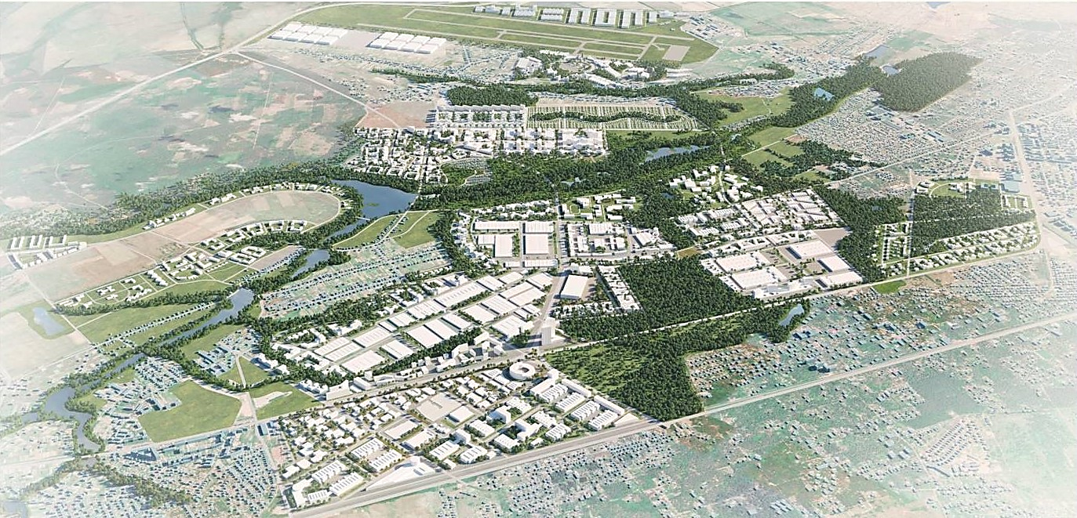

Figure 1 - Bucha Techno Garden project for the development
of the territory of Bucha united territorial community, Kyiv region

An example of the organization of innovative construction production is the cluster form (Fig. 2) of the branch of the Academy of Construction of Ukraine "Intersectoral Scientific and Production Cluster of Innovative Construction".
The important aspects of ensuring environmental sustainability are the constructive and planning solutions of architectural objects in a given space. The following requirements are put forward to the main volume-planning and constructive means of greening buildings:
- application of rational planning and construction solutions (in accordance with specific climatic conditions);
- maximum use of underground space;
- using the protective properties of the terrain;
- construction of "ecohouse" and "intelligent building" houses;
- landscaping of all surfaces of the building (walls, roof) and the surrounding area.
To ensure these conditions, an analysis of the suitability of residential and public buildings was carried out with the use of classical parametric system analysis and structural synthesis. Those buildings must be comfortable and safe, which are the original ecological criteria. As you know, these criteria must be ensured in the design decisions according to the purpose of the building. To a large extent, this refers to the comfort conditions of living in low-rise buildings, since in such buildings the number of apartments and the number of residents are important. This is determined by the criterion that defines functional comfort, as the ability of people to live and communicate with each other in such a limited space. Such a house should have low energy costs, making the most of the circle of quality and comfortable living (Fig. 3) [1].

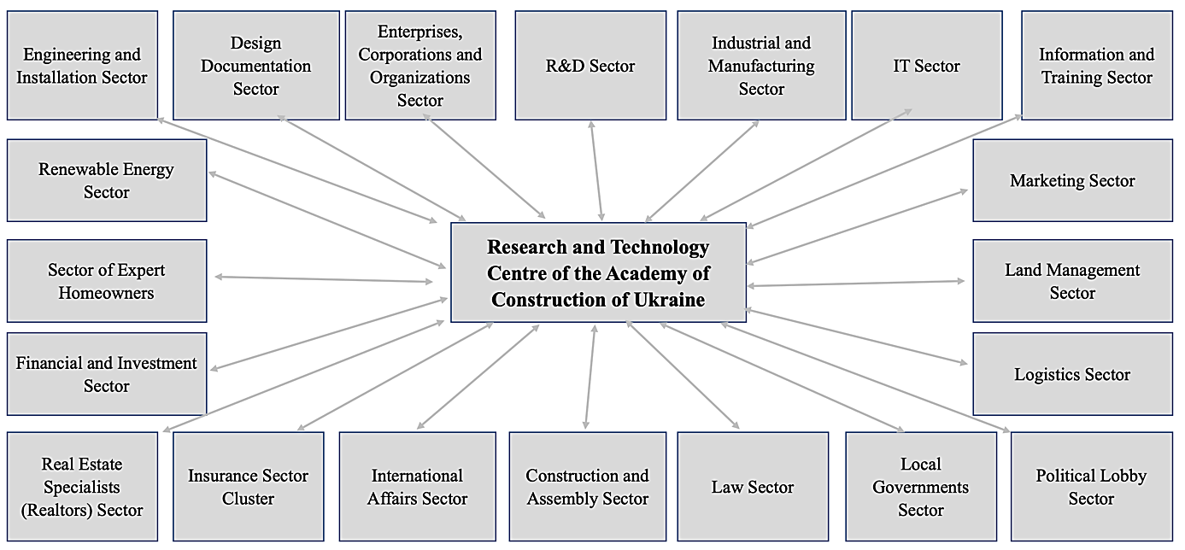
Figure 2 – Graphic structure of the cluster of the Academy of Construction of Ukraine

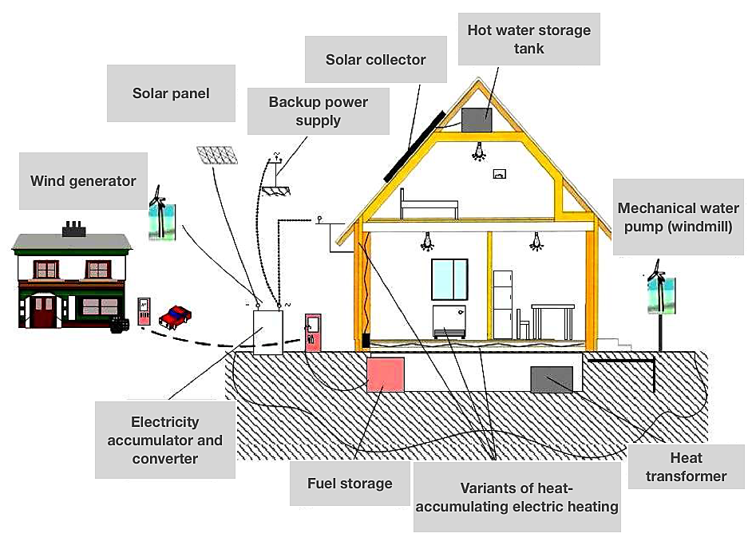

Figure 3 – Schematic diagram of creating an ecological and energy-efficient house

Effective and rational means in the field of energy-saving architectural and planning solutions include:
- simplification of the configuration of buildings (reduction of the area of enclosure structures relative to the total area);
- construction of attic floors in existing buildings;
- optimization of architectural forms in accordance with climatic features;
- optimal orientation of buildings to wind and sun.
Simplifying the configuration of buildings is relevant because it allows to reduce heat exchange with the environment due to the reduction of the area of contact surfaces. Hence, priorities shift towards greater values of life, the search for ways and means of survival of humanity under the conditions of progressive deterioration of the ecological and social situation. In this regard, they are actively revising the traditional attitude to both man and nature, searching for new spiritual foundations for further civilizational development, forming new ideals of human activity and a new understanding of the human perspective. The solution of the mentioned approach and the adoption of appropriate decisions are implemented in the proposed comfortable and energy-saving eight-apartment building with the symbolic name "BIDEN", including the rationally considered aspects of anthropometry and psychology of human behavior in such a space (Fig. 4).
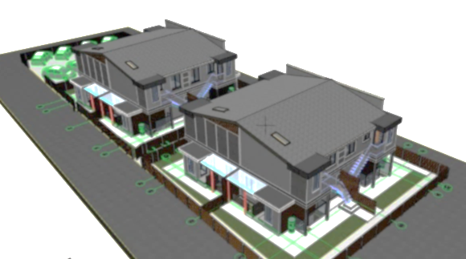
Figure 4 – General view of an ecological
and energy-efficient building with
the symbolic name "BIDEN"

Special attention is paid to the psychological aspect, which is demonstrated in specific constructive solutions. The accepted condition is the well-known statement that the psychological aspect is related to the fact that space is evaluated by a person in terms of distances and orientation: large spaces can "separate" people, and small rooms cause a feeling of discomfort. Figure 5 shows the spatial model of the house of the "Biden" project.
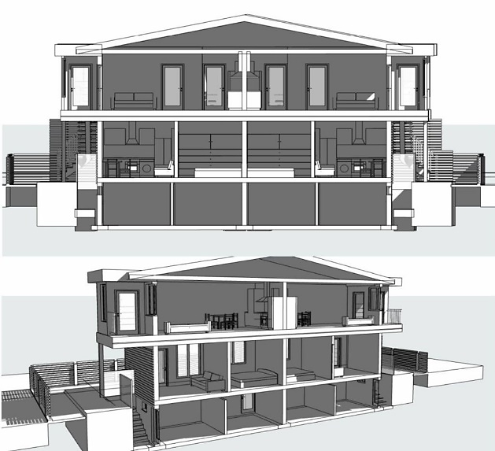 Figure 5 – Spatial model of the house
of the BIDEN project

In the proposed innovative project, for the first time in a low-rise building, the maximum use of the underground space, which can actually be attributed to the elements of underground urbanism, is realized. The presence of a reinforced concrete shelter under the house against possible artillery, rocket or small arms attacks is essential to preserving people's lives and health. That is why the basement of the "Biden" house is made as a monolithic reinforced concrete structure of the floor and walls with a reinforced monolithic floor of the basement part of the house, which is 80% submerged below the ground level. This makes it possible to save basement structures from shock waves or ruptures. An important parameter of quality shelter is also the presence of an additional exit, so as not to get trapped under the debris of construction structures.
The BIDEN project provides for an exit through an adjacent room located at 90° from the first one. Finishing of the basement is at the residential level: polymer seamless floor coverings; high-quality painting of the walls and ceiling, ceramic heating panels with digital temperature control; LED lighting; the possibility of installing bathrooms. In peacetime, the premises can be used as an office, gym, dressing room, food pantry, etc. Entrance to the shelter/basement from one's own plot of land. All 8 basement rooms of the house are equipped with ventilation systems with recuperation, fire extinguishers, axes and long-lasting battery lights.
Plants are an important means of greening buildings and the architectural environment as a whole. It is generally known about the ability of plants to absorb carbon dioxide and produce oxygen, to protect buildings from wind and noise, that is, to improve the quality of the ecological parameters of the environment. In addition, plants have a positive effect on the psycho-emotional state of people, mitigating the aggressive effect of the urbanized environment. Because of this, a tendency to green all surfaces of the building arose and is actively developing in the world. Buildings and structures organically connected with living nature (with a green roof, walls, etc.) are called biopositive.
During the reconstruction of the existing building and the construction of new biopositive structures, it is advisable to provide archophytomelioration measures: landscaping of basement floors (biopositive constructions of extensions and plinths, creation of phytoscreening wall coverings, etc.); landscaping of all free areas of the territory and above-ground territories above the objects of underground urbanism; vertical landscaping of walls (verandahs, terraces, ampelous coverings, hanging systems); winter gardens inside the buildings [9].
Ecological architecture involves energy saving, the use of ecologically compatible building materials and structures, the use of alternative energy sources and the correct disposal of waste.

Conclusions
The research presents a cluster-based approach to innovative low-rise building projects with a strong emphasis on environmental sustainability and green construction principles. The study underscores the urgent need for energy-efficient housing solutions in Ukraine, given the significant energy consumption gap with EU member states. The integration of cluster models into construction processes offers numerous advantages, including shorter time-to-market for innovative products and enhanced logistic connections. The flow method of construction, combining sequential and parallel methods, proves to be a viable approach for cost reduction and cooperative synergy within cluster formations.
Additionally, the utilization of Building Information Modeling (BIM) technology emerges as a pivotal tool for efficient project management and cost optimization. This study contributes valuable insights into sustainable building practices, aligning them with the evolving societal needs for healthier, greener, and more energy-efficient living spaces.

References
1. Перегінець І.І. (2017). Кластерні форми організації будівельного виробництва в умовах розвитку соціально-економічних трансформацій сучасної України. Містобудування та територіальне планування, 64, 560-569 |  | 1. Pereghinets I.I. (2017). Cluster forms of construction production organization in the conditions of development of socio-economic transformations of modern Ukraine. Urban planning and territorial planning, 64, 560-569
2. Маляр С.А. (2022). Формування організаційно-економічного механізму розвитку житлового фонду.  Вісник Хмельницького національного університету. Економічна науки, 1, 305-309 |  | 2. Malyar,S.A. (2022). Formation of the organizational and economic mechanism for the development of the housing stock. Bulletin of the Khmelnytskyi National University. Economic sciences, 1, 305-309
3. Заяць В.С. (2019). Розвиток житлового будівництва як фактор формування житлових умов населення. Демографія та соціальна економіка, 2(3), 137-151 |  | 3. Zayats V.S. (2019). The development of housing construction as a factor in the formation of housing conditions of the population. Demography and social economy, 2(3), 137-151
4. Білошицька Н.І., Білошицький М.В., Татарченко З.С., Медвідь І.І. (2019). Аналіз комфортності прибудинкових територій різних типів забудови у м. Сєвєродо-нецьку. Вісник Східноукраїнського національного університету імені Володимира Даля, 8(256), 23-29  https://doi.org/10.33216/1998-7927-2019-256-8-23-29 |  | 4. Biloshytska N.I., Biloshytskyi M.V., Tatarchenko Z.S. & Medvid І.І. (2019). Analysis оf Comfortability оf House Territories оf Different Building Types In Severodonetsk Town. Visnik of Volodymyr Dahl East Ukrainian National University, 8(256), 23-29  https://doi.org/10.33216/1998-7927-2019-256-8-23-29
5. Yurin O., Avramenko Y., Leshchenko M., Rozdabara O. (2020) Research of Possible Methods of Increasing the Duration of the Insolation of Rooms in Residential Buildings. Lecture Notes in Civil Engineering, 73, 312-323  https://doi.org/10.1007/978-3-030-42939-3_32 |  | 5. Yurin O., Avramenko Y., Leshchenko M., Rozdabara O. (2020) Research of Possible Methods of Increasing the Duration of the Insolation of Rooms in Residential Buildings. Lecture Notes in Civil Engineering, 73, 312-323  https://doi.org/10.1007/978-3-030-42939-3_32
6. ДБН В.2.1-10: 2018 (2018). Основи і фундаменти будівель та споруд. Основні положення. Київ: Міністерство регіонального розвитку, будівництва та житлово- комунального господарства України |  | 6. DBN V.2.1-10: 2018. (2018). Bases and foundations of buildings and structures. Main principles. Kyiv: Ministry of Regional Development, Construction, and Housing of Ukraine
7. Kariuk A., Mishchenko R., Pents V., Shchepak V. (2019). Енергоефективність будівель у країнах Євросоюзу та Україні. Academic Journal. Industrial Machine Building, Civil Engineering, 1(52), 185-190  https://doi.org/10.26906/znp.2019.52.1695 |  | 7. Kariuk A., Mishchenko R., Pents V., Shchepak V. (2019). Energy performance of buildings in European Union countries and Ukraine. Academic Journal. Industrial Machine Building, Civil Engineering, 1(52), 185-190  https://doi.org/10.26906/znp.2019.52.1695
8. ДБН В.2.2-15-2015 (2015). Житлові будинки. Основні положення. Київ: Мінбуд України |  | 8. DBN B.2.2-15-2015. (2015). Residential buildings. Funda-mentals principles. Kyiv: Ministry of Construction of Ukraine
9. Koshlaty O., Kariuk A. & Mischenko R. (2015). The development and prospects analysis of buildings thermal protection standardization in Ukraine. Intern. Scientific Journal «Theoretical & Applied Science», 09(29), 21-23 |  | 9. Koshlaty O., Kariuk A. & Mischenko R. (2015). The development and prospects analysis of buildings thermal protection standardization in Ukraine. Intern. Scientific Journal «Theoretical & Applied Science», 09(29), 21-23

