Збірник наукових праць. Галузеве машинобудування, будівництво
Academic journal. Industrial Machine Building, Civil Engineering
http://journals.nupp.edu.ua/znp
https://doi.org/10.26906/znp.2022.59.ХХХХ

UDC 666.97.033

The analytical investigation of the concrete mixture
deposition process by the concrete 3d printer extruder

Orysenko Olexandr¹*, Nesterenko Mykola², Shokalo Artem³

¹ National University «Yuri Kondratyuk Poltava Polytechnic» https://orcid.org/0000-0003-3103-0096
² National University «Yuri Kondratyuk Poltava Polytechnic» https://orcid.org/0000-0002-4073-1233
³ National University «Yuri Kondratyuk Poltava Polytechnic» https://orcid.org/0000-0001-6013-9969
* Адреса для листування E-mail: oleksandr.orysenko@gmail.com

The construction of buildings using 3D printing is becoming increasingly popular. However, this technology, despite its numerous advantages, also has its drawbacks. To minimize the impact of these drawbacks on the quality of construction work, scientifically substantiated approaches can be applied to improve both the technology itself and the machines used in the process. One of the factors that affect the quality of material deposition on the printing surface is the alignment of the extruder's productivity of the construction 3D printer with the speed of its movement above the surface. This can be achieved by considering the physicomechanical properties of the concrete mixture and the method of its delivery to the application area. To describe the mixture's delivery through a narrow channel between the nozzle end of the extruder and the printing surface, the Poiseuille method is proposed, modeling the mixture with the Herschel-Bulkley rheological model. Analytical dependencies have been derived to determine the extruder's productivity and the speed of the mixture extrusion through the nozzle.

Keywords: 3D construction, extruder, Herschel-Bulkley model, Poiseuille method, integral average velocity.

Аналітичне дослідження процесу подачі бетонної суміші
екструдером будівельного 3D-принтера

Орисенко О.В.¹*, Нестеренко М.М.², Шокало А.В.³

^{1, 2, 3} Національний університет «Полтавська політехніка імені Юрія Кондратюка»
*Corresponding author E-mail: oleksandr.orysenko@gmail.com

Спорудження об’єктів будівництва способом 3D-друку набуває все більшого поширення. Дана технологія має
ряд переваг перед традиційними способами виконання будівельних робіт. Проте, поряд з перевагами 3D-бетонування має також і недоліки, мінімізувати вплив яких на якість виконання будівельних робіт можна застосувавши науково обґрунтовані підходи до вдосконалення як самої технології так і машин, які при цьому використовуються. Одним із факторів, які впливають на якість нанесення матеріалу на поверхню друку є узгодження продуктивності екструдера будівельного 3D-принтера та швидкості його пересування понад поверхнею. Цього можна досягти урахувавши реологічні властивості бетонної суміші та спосіб її подачі у зону нанесення. Пропонується суміш для 3D-принтера моделювати реологічною моделлю Гершеля-Балклі, яка дозволяє врахувати зміну дотичних напружень зсуву залежно від в’язкісних властивостей суміші та індексу її течії. Для опису подачі суміші через щілинний канал між торцем сопла екструдера та поверхнею друку застосовано методику Пуазейля. Виведено аналітичні залежності для визначення продуктивності екструдера та швидкості витискання суміші через сопло. Передбачається, що швидкість пересування екструдера над поверхнею друку повинна дорівнювати середньоінтегральній швидкості витискання суміші через щілинний канал між торцем сопла екструдера та поверхнею друку. В подальшому намічено проведення експериментальних досліджень з метою підтвердження запропонованої гіпотези. Для проведення експериментальних досліджень створено лабораторний 3D-принтер, який конструктивно являє собою робот-маніпулятор зі встановленим на ньому екструдером. Пересуванням екструдера по просторовій траєкторії, швидкість обертання лопатей та шнека екструдера здійснюється індивідуальними механізмами, керування якими забезпечується апаратно-програмним забезпеченням на платформі Arduino.

Ключові слова: 3D-будівництво, екструдер, модель Гершеля-Балклі, методика Пуазейля, середньоінтегральна швидкість.

Introduction
In recent times, there has been a rapid development of additive technologies in all sectors of manufacturing, and the construction industry is no exception. The number of structures fabricated using 3D printing has increased significantly in recent years [1-3]. The equipment used for this purpose is construction 3D printers. The main advantages of using construction 3D printers compared to traditional construction technologies are as follows [4]:
- Reduction in construction timelines
- Improved quality of construction work
- Decreased labor costs
- Possibility of implementing modular production
- Reduction in costs associated with construction and tooling
- Increased safety in production and improved working conditions
- Enhanced environmental performance of construction activities through waste reduction
- Ability to construct buildings with diverse architectural designs.
Additionally, several economic factors also support the adoption of 3D printing [5]. However, as researchers point out [4], this technology is not without its drawbacks. The following disadvantages should be considered:
- Relatively high initial investments due to the high cost of 3D printing equipment.
- Frequent breakdowns of 3D printers, especially during continuous usage.
- The need for improvement and development of new construction materials for use in 3D printers.
- Comparatively rough appearance of the constructed structure, requiring finishing works.
Considering the mentioned advantages and disadvantages of using 3D printing in the construction industry, we can conclude that this technology currently requires further improvement, which can be achieved through the application of scientifically grounded technical solutions. Therefore, scientific research in the field of improving and developing 3D printing equipment remains relevant.

Review of the research sources and publications
A significant number of publications by both domestic and international researchers are dedicated to improving equipment for 3D printing. In works [6, 7], an analysis of existing types of construction 3D printers was conducted, and their shortcomings that require improvement were identified. Promising designs of 3D printers and their components were also proposed, aiming to expand the technological capabilities of the equipment and increase work productivity.
Another direction for improving the quality of construction works using 3D printing is the improvement and development of construction mixtures. The results of a critical review of methods for investigating interlayer regions of 3D-printed concrete are presented in work [8]. Testing methods used to assess the strength of interfacial bonding, the influence of printing parameters, material composition, and other factors on the strength of interfacial connections are discussed. Relevant modification methods are considered, and ideas for future research are proposed.
The rheological properties of the concrete mixture used in 3D printers are the subject of study in work [9]. Two contrasting strategies that can be applied in the construction of concrete structures using extrusion are discussed: using concrete with high and low workability. The behavior of fresh cement paste and construction mortar under various influences (shear, compression, tension) is investigated for different water-to-cement ratios.

Definition of unsolved aspects of the problem
The construction of a structure using a construction 3D printer involves layer-by-layer deposition of a concrete mixture onto the printing surface. At the beginning of the construction, this surface may be a specially prepared platform, and subsequently, it becomes the lower layers of the already printed structure.
It is evident that to ensure quality printing with this method of application for each subsequent layer, it is necessary to coordinate the amount of concrete mixture supplied to the printing zone and the speed of movement of the extruder over the surface. If the amount of supplied mixture exceeds the required amount, an excess will be extruded not only behind the extruder in the direction of its movement but also from the sides and in the area ahead, leading to a deterioration in the appearance of the structure, excessive material consumption, and additional resistance to movement.
On the other hand, if the feed rate of the mixture is lower than the speed of the extruder's movement, the required layer thickness will not be achieved, resulting in poor print quality.
This problem can be addressed through a theoretically justified coordination of the properties of the mixture used for 3D printing and the parameters and operating principles of the machine that deposits this mixture. However, the scientific literature provides insufficient coverage of these issues.

Problem statement
Thus, the objective of this research is to develop a scientifically justified methodology that allows for the coordination of the amount of mixture supplied to the printing zone and the speed of movement of the extruder. At the initial stage of the investigation, it is necessary to develop a mathematical model of the process of mixture deposition in the printing zone.

Basic material and results
To conduct scientific research at the Yuri Kondratyuk Poltava National Technical University, a laboratory 3D printer has been created (Figure 1), which is a robotic manipulator with an installed extruder. The deposition of mixture layers onto the printing surface is carried out by the extruder as it moves above this surface. The robotic manipulator enables the movement of the extruder along a spatial trajectory through individually controlled mechanisms.

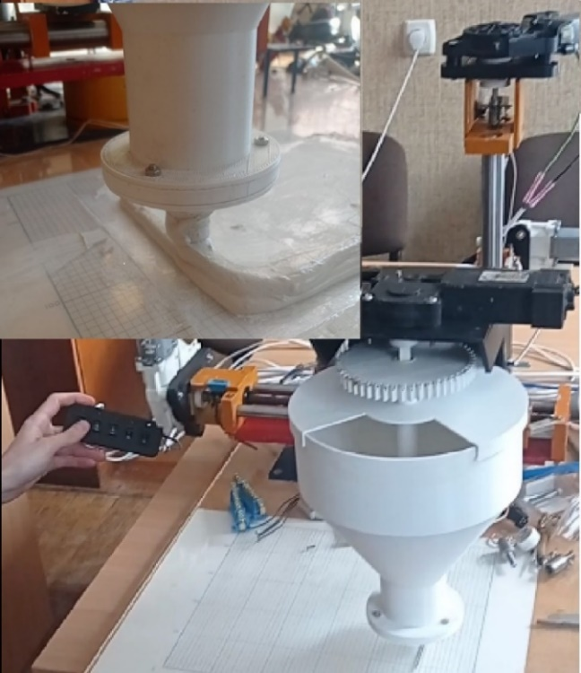

Figure 1 – 3D Printer in our laboratory

Structurally, the extruder consists of a container with individual shafts on which blades and an auger are installed (Figure 2). One of the shafts is hollow, allowing the other shaft to pass through it. The blades are used to mix the concrete mixture, preventing it from solidifying and keeping it in a fluid state. The auger is responsible for feeding the concrete mixture to the nozzle, which is located at the bottom of the extruder and has a cylindrical shape. The loading of the mixture is carried out cyclically through a loading opening as it is consumed.
The spatial trajectory of the extruder's movement is defined (Figure 3) by the hardware and software provided on the Arduino platform. This hardware and software also determine the necessary rotational speed of the blades and auger. This allows for various operating modes to be set and enables the deposition of the mixture along the specified trajectory.
The adjustment of the mixture layer thickness H (Figure 3) using the specified extruder design is achieved by setting the desired height of the nozzle above the printing surface. In this case, the mixture, under the pressure generated by the auger, will be extruded through the narrow channel formed between the nozzle tip and the printing surface. In the case of a cylindrical nozzle, the extruded material will form a ring-shaped cross-section of length B (Figure 4). Unfolding this ring on a plane, we obtain a narrow channel through which the mixture is supplied in the form of a parallelepiped with width B, height H, and length L. The geometric dimensions of this channel remain constant during the operation of the 3D printer.
Therefore, the amount of mixture delivered to the printing zone will depend on the speed at which it passes through the specified channel.

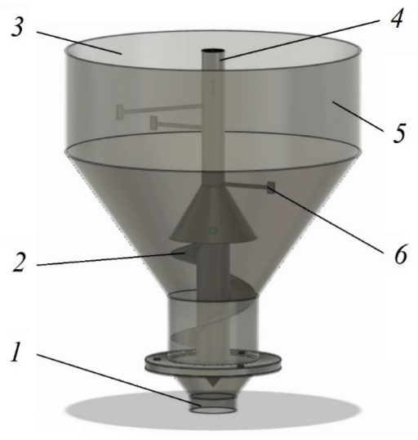

Figure 2 – The structure of the extruder of the laboratory 3D printer is as follows:
1 – extruder nozzle; 2 – concrete mixture feeding auger; 3 – loading window; 4 – shaft for driving the auger
and blades; 5 – container for the concrete mixture;
6 – blades for mixing the mixture

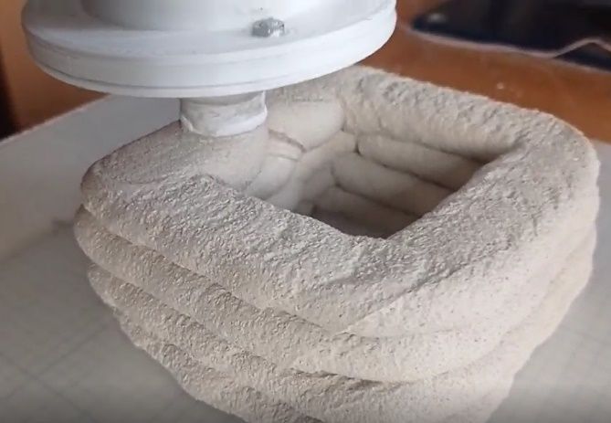

Figure 3 – The application of a layer
of the concrete mixture onto the printing
surface along a specified trajectory

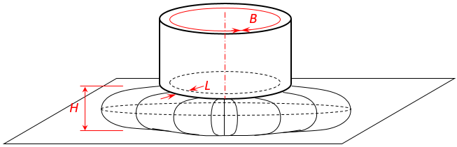

Figure 4 – The diagram of material
flow through a slotted circular channel

Considering the characteristics of the structure and operation principle of the proposed construction 3D printer extruder, the following requirements can be additionally formulated for the concrete mixture:
- Taking into account the vertical positioning of the extruder and the location of the feeding opening at its lower part, the mixture should possess certain viscosity properties that prevent it from self-advancing through the feeding opening under the influence of gravity.
- The consistency of the mixture should be such that it exhibits plastic properties and can be extruded through the nozzle opening when the screw is rotating.
- After being deposited onto the printing surface, the plasticity of the mixture should rapidly diminish, and it should not exhibit excessive flow or spreading behaviour.
Based on the existing scientific research on the rheological properties of concrete mixtures, it can be concluded that a mixture with specific strength characteristics in a quiescent state that acquires fluid-like properties when subjected to external loading best satisfies these requirements. Such a mixture is considered a viscoelastic material that exhibits its maximum strength under the influence of external loading.
Typically, the physico-mechanical properties of such materials are described by the Shvedov-Bingham rheological model, which takes the following form:
τ = τ₀+μ_{р} ⋅ γ , | (1)
where τ₀ – shear yield stress, Pa;
μ_{р} – plastic viscosity, Pa·s;
γ – velocity gradient, 1/s.
However, this relationship does not account for the change in tangential stresses with varying shear rates, and in this case, inaccurately reflects the behavior of concrete at different rates of applied loading.
A more accurate description of concrete behavior during extrusion is provided by the stepped rheological models, such as the Herschel-Bulkley model [13], which has the following analytical expression:
τ = τ_{s}+μ ⋅ γ^{ϕ} , | (2)
where τ_{s} – shear yield stress, Pa;
μ – a coefficient proportional to the viscosity at a unit velocity gradient;
γ – velocity gradient, 1/s;
ϕ – flow index.
Therefore, the objective of this research is to adapt the mentioned rheological model to describe the material flow process through the slit channel between the nozzle face of the extruder and the printing surface. Since the nozzle of the proposed construction 3D printer has a circular shape, the slit channel will also be circular. The width of the channel will be equal to the circumference length B, and the length will be the thickness of the nozzle face L. When the concrete mixture is fed, a layer of thickness H is formed.
To derive an analytical expression for the material flows through the slit channel, we apply Poiseuille's method [14], which describes the flow rates of a viscoelastic fluid through a cylindrical channel.
Further calculations are carried out using the scheme depicted in Figure 5. The diagram shows the forces acting on an elementary layer of material with a thickness, which is assumed to be undeformed. We assume positive shear stresses occur on the lower and upper surfaces of the elementary layer. Then the external force creating pressure will have a negative sign, and the equation of force equilibrium will take the form:
2⋅ B⋅ L⋅ τ = – 2⋅ h⋅ B⋅ q , | (3)
where h, B, L – length, and width of the slit, respectively (in the case of a circular channel, the length of the channel is equal to the circumference);
q – pressure at the inlet of the channel.

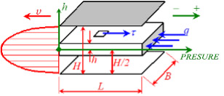

Figure 5 – Computational scheme
of material flow through the slit channel

From equation (3), we determine the dependence of shear stresses in a material layer with height on the pressure of the material at the inlet of the slit channel:
. | (4)
We transform formula (1) into the following form:
, | (5)
where n – is the reciprocal of the flow index, n = 1/ϕ.
The minus sign before the velocity gradient symbol indicates that the directions of velocity and shear stresses are opposite. Since the velocity gradient is , formula (5) can be written as:
, | (6)
By integrating both sides of equation (6), we obtain:
. | (7)
Assuming that the flow velocity near the wall is zero [14] (υ = 0 when h = H/2), we find the constant of integration C as:
. | (8)
By substituting the constant of integration into the velocity equation (7), we find the velocity distribution equation along the channel height:
(9)
Formula (9) allows us to calculate the velocity of the concrete mixture layers as they advance through the height of the slit channel. Since the velocity of individual layers of the mixture will vary with height, to determine the extruder's movement speed above the printing surface, we need to use the average integral value of velocity, which we find as:
(10)
Taking into account that:
ΔH = 0.5H – 0 = 0.5H | (11)
the expression (10) takes the form:
(12)
Equation (12) enables the adjustment of the material feed rate through the extruder channel with the movement of the 3D printer extruder, ensuring a uniform cross-section of the applied mixture layer on the printing surface.
To determine the productivity of the extruder Q, m³/s, we evaluate the definite integral of the obtained function (9) and multiply it by 2, since formula (9) describes only half of the channel height. Additionally, we multiply the resulting equation by - the channel width. For convenience, we express the channel width in terms of the average nozzle diameter , that is:
B = π ⋅ D | (13)
Then the expression for calculating the extruder's productivity takes the form:
(14)

Conclusions
The conducted research allows us to state the following:
1. The application of additive technologies is currently a promising direction in the development of the construction industry.
2. The equipment used for 3D printing of building products and structures has several disadvantages, which can be avoided by applying scientifically substantiated technical solutions.
3. Ensuring high-quality 3D printing is possible by coordinating the amount of mixture supplied to the printing zone and the extruder's movement speed along the printing surface.
4. The scientific novelty of the obtained results lies in the derivation of analytical dependencies that relate the technical parameters of the construction 3D printer to the rheological properties of the extrusion material used.

References
1. Заяць Є., Богданов І., Невгомонний Г., Мерилова І., Речиц О. (2021). Особливості використання технологій 3D-друку в будівництві. Містобудування та територіальне планування, (76), 83-93  https://doi.org/10.32347/2076-815x.2021.76.83-93 |  | 1. Zayats Y., Bohdanov I., Nevhomonnyi H., Merilova I., Rechits O. (2021). Features of Using 3D Printing Technologies in Construction. Urban Planning and Spatial Planning, (76), 83-93  https://doi.org/10.32347/2076-815x.2021.76.83-93
2. Hamidreza Gh.S., Corker J., Fan M. (2018). Additive manufacturing technology and its implementation in construction as an eco-innovative solution. Automation in Construction, 93, 1-11  https://doi.org/10.1016/j.autcon.2018.05.005 |  | 2. Hamidreza Gh.S., Corker J., Fan M. (2018). Additive manufacturing technology and its implementation in construction as an eco-innovative solution. Automation in Construction, 93, 1-11  https://doi.org/10.1016/j.autcon.2018.05.005
3. Андрійчук О.В., Оласюк П.Я. (2015). Застосування технології 3D-друку в будівництві. Сучасні технології та методи розрахунків у будівництві, 3, 11-18  https://doi.org/10.1016/j.autcon.2018.05.005 |  | 3. Andriychuk O.V., Olasiuk P.Ya. (2015). Application of 3D Printing Technology in Construction. Modern Technologies and Calculation Methods in Construction, 3, 11-18  https://doi.org/10.1016/j.autcon.2018.05.005
4. Лаухін Д.В., Дадіверіна Л.М., Твердохліб О.М., Мацюк І.М. (2020). Аналіз застосування в будівельному виробництві адитивних технологій 3D-друку. Збірник наукових праць національного гірничого університету, 61, 163-177  https://doi.org/10.33271/crpnmu/61.163 |  | 4. Laukhin D.V., Dadyverina L.M., Tverdokhlib O.M., Matsyuk I.M. (2020). Analysis of the Application of Additive Manufacturing Technologies in Construction Production. Collection of Scientific Papers of the National Mining University, 61, 163-177  https://doi.org/10.33271/crpnmu/61.163
5. Згалат-Лозинська Л., Згалат-Лозинський О. (2020). Розвиток та впровадження інноваційних технологій 3D-друку у будівництві. Вчені записки Таврійського національного університету імені В.І. Вернадського. Серія : Економіка і управління, 31(70), 45-51  https://doi.org/10.32838/2523-4803/70-5-7 |  | 5. Zgalat-Lozinska L., Згалат-Лозинський О. (2020). Development and Implementation of Innovative 3D Printing Technologies in Construction. Scientific Notes of V.I. Vernadsky Tavria National University. Series: Economics and Management, 31(70), 45-51  https://doi.org/10.32838/2523-4803/70-5-7
6. Шатов С.В., Савицький М.В., Марченко І.О. (2019). Удосконалення обладнання 3D-друку об’єктів. Вісник Придніпровської державної академії будівництва та архітектури, 6(259-260), 90-101  https://doi.org/10.30838/J.BPSACEA.2312.261119.91.593 |  | 6. Shatov S.V., Savitsky M.V., Marchenko I.O. (2019). Improvement of Equipment for 3D Printing of Objects. Bulletin of the Pridneprovsk State Academy of Civil Engineering and Architecture, 6(259-260), 90-101  https://doi.org/10.30838/J.BPSACEA.2312.261119.91.593
7. Lipson Н., Kurman Melba (2013). Fabricated. The New World of 3D Printing. Wiley |  | 7. Lipson Н., Kurman Melba (2013). Fabricated. The New World of 3D Printing. Wiley
8. Ding T., Xiao J., Mechtcherine V. (2023). Microstructure and mechanical properties of interlayer regions in extrusion-based 3D printed concrete: A critical review. Cement and Concrete Composites, 141  https://doi.org/10.1016/j.cemconcomp.2023.105154 |  | 8. Ding T., Xiao J., Mechtcherine V. (2023). Microstructure and mechanical properties of interlayer regions in extrusion-based 3D printed concrete: A critical review. Cement and Concrete Composites, 141  https://doi.org/10.1016/j.cemconcomp.2023.105154
9. Jacquet Y., Perrot A., Picandet V. (2021). Assessment of asymmetrical rheological behavior of cementitious material for 3D printing application. Cement and Concrete Composites, 140  https://doi.org/10.1016/j.cemconres.2020.106305 |  | 9. Jacquet Y., Perrot A., Picandet V. (2021). Assessment of asymmetrical rheological behavior of cementitious material for 3D printing application. Cement and Concrete Composites, 140  https://doi.org/10.1016/j.cemconres.2020.106305
10. Дворкін Л., Житковський В., Степасюк Ю., Марчук В. (2020). Ефективні будівельні розчини для 3D-принтера. Будівельні матеріали та вироби, 1-2(101), 16-21  https://doi.org/10.48076/2413-9890.2020-101-03 |  | 10. Dvorkin L., Zhytkovskiy V., Stepasyuk Y., Marchuk V. (2020). Efficient Construction Mixtures for 3D Printing. Construction Materials and Products, 1-2(101), 16-21  https://doi.org/10.48076/2413-9890.2020-101-03
11. Дворкін Л., Марчук В., Зятюк Ю. (2021). Цементно-шлакові суміші для 3D-принтеру. Будівельні матеріали та вироби, 1-2(102), 14-19  https://doi.org/10.48076/2413-9890.2021-102-02 |  | 11. Dvorkin L., Marchuk V., Ziatyuk Y. (2021). Cement-Slag Mixtures for 3D Printing. Construction Materials and Products, 1-2(102), 14-19  https://doi.org/10.48076/2413-9890.2021-102-02
12. Теліцина Н. Є., Скіданова Г. М., Суруп І. В. (2010). Алгоритм підбору СБС на повітряних в’яжучих із заданими реологічними показниками. Східно-Європейський журнал передових технологій, 2/10(44), 71-74  http://journals.uran.ua/eejet/article/view/2785/2591 |  | 12. Telitsina N.Ye., Skidanova G.M., Surup I.V. (2010). Algorithm for Selecting Fine-Grained Air-Binding Compositions with Given Rheological Indicators. Eastern-European Journal of Advanced Technologies, 2/10(44), 71-74  http://journals.uran.ua/eejet/article/view/2785/2591
13. Крих Г.Б. (2007). Особливості застосування реологічних моделей неньютонівських рідин. Вісник Національного університету «Львівська політехніка», 581,  71-82 |  | 13. Krykh H.B. (2007). Features of Applying Rheological Models of Non-Newtonian Fluids. Bulletin of Lviv Polytechnic National University, 581, 71-82
14. Колчунов В.І. (2004). Теоретична та прикладна гідромеханіка. Київ: НАУ |  | 14. Kolchunov V.I. (2004). Теоретична та прикладна гідромеханіка. Kyiv: NAU

