УДК 681.3.06
G.V. Sokol к.т.н., доц., O.S. Shkurupii аспірант, O. Y. Sribna
Department of Computer Engineering,
Poltava National Technical University
Chongyang Shi
School of Computer Science and Technology, Beijing Institute of Technology

MATHEMATICAL MODEL OF THE DIGITAL FILTER KALMAN-BUCY
IN THE APPLICATION OF NON-STATIONARY TRAFFIC
Имитационная модель дискретного фильтра Калмана-Бьюси

New automatic methods of TMN, TINA types make it possible to complete necessary changes and updating of network elements modes and networks structure, to perform network resources remapping according to the rerouting control in telecommunication systems. Provided changes offer random probabilities which transiency emerges at the lowest operation hours. It is obviously that nonstationarity generates a need for the indicated updating and network restructuring realization. There is not necessary to update the network during the hypothesized stationary operation in the condition if the system operates without failings.
In this work conduct a research of nonstationarity effect both by observation and by state. For this purpose, we will first present the results of theoretical study, allowing to investigate the responsivity of the procedure and obtain general representation on the effect of filter parameter deviations upward and downward. As for practical implementation of the filter, these deviations are imposed upon various realization restrictions associated primarily with the appearance of instability at high correlation of signal and noise and different rate of the observed nonstationarity process digitalization.
Parameter, elements and current characteristics of the traffic $\hat{x}(k)$ estimation is to be quite a difficult task, especially in practice, taking into the account random and nonstationarity traffic character of TN and other benchmarked network parameters [1].
In the capacity of evaluation procedure it is reasonable to use Kalman-Bucy recursive algorithm (1) for the local search optimization. Optimal evaluation according to the integral square error criterion is determined from the recursion equation solution also known as Kalman-Bucy method:
$\hat{x}(k+1)=F(k+1,k)\hat{x}(k)+K(k)\left[H(k)F(k+1,k)\hat{x}(k)−y(k)\right]$, (1)
where$K(k)=V(k)H^{T}(k)N_{ν}^{−1}$ is a coefficient, which provides evaluation optimality and procedure convergence degree.
The template that includes observation, evaluation and processing models reflects distinct FKB deviations influence of the chosen model. Block diagram of the simulant is shown on Figure 1 [1, 2].

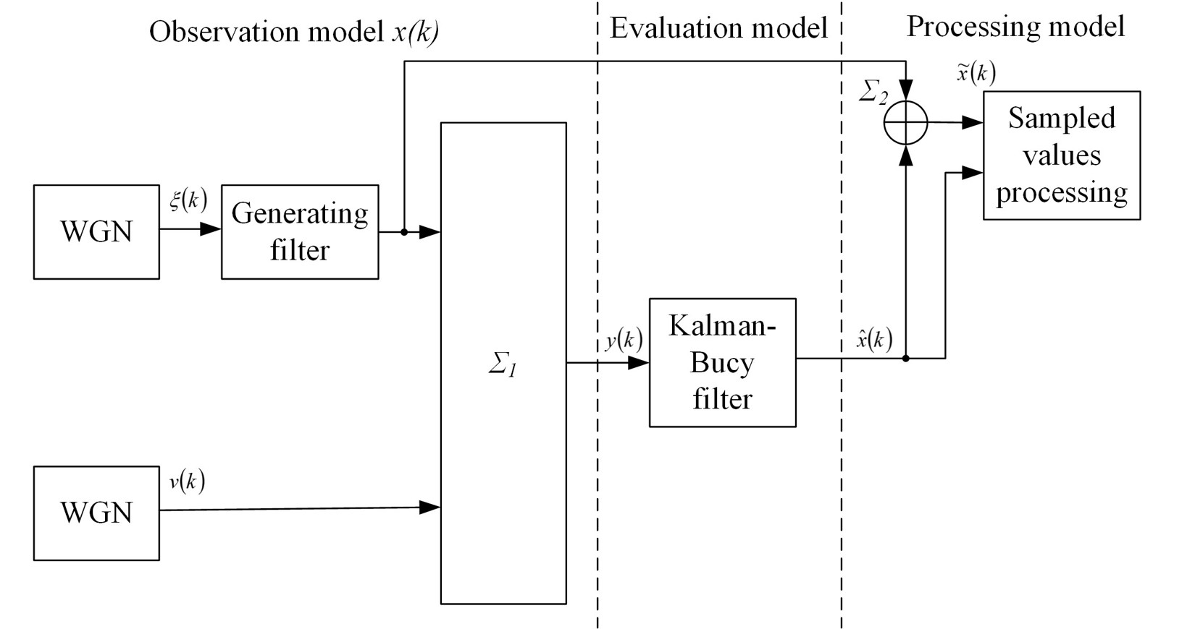
Figure 1: Block diagram model of the distinct FKB stimulant
Proposed computer test model gives an opportunity to select options of the evaluated process model (k) and inspection noise model N_{v}(k) as to the stationary state and transient state [3, 4]. Individual noise ξ(k) and v(k) generators are to be standardized formation procedures with the choice of corresponding spectral power density N_{v}(k) and N_{ξ}(k) values. Models chosen parameters consistency is proved by receiving sample estimations of these parameters.
The effect of nonstationarities is evident from the moment of emitting useful signal to the filter input. Thus, different filters react on nonstationary signal differently. This response appears in the form of the transition process from the emitting until setting a stationary filter mode.
The analysis of filter efficiency at the nonstationary conditions has been held under the advanced observation model. Additive identity that reflects level and speed changes of the nonstationarity has been comprehended to the watch equation. Sinuous nonstationarity model has been chosen to be primary taking into the consideration the fact that traffic change is a result of multiple actions on the network load:
$y(k)=H(k)x(k)+C\text{sin}(l k T/{τ_{\text{кор}}})+v(k)$, (2)
where l is a multiplication factor that changes nonstationary actions period, C changes nonstationarity value, T /τ_{cor} changes intervals rate between sample spacings T and correlation intertissue τ_{cor}.
In this work examine the situation for different cases of T periods, nonstationary changes. When provided changes become commensurable to the time of the process transition T_{s} = 5∆t (Figure 2) at low-speed nonstationary change T /τ_{cor} = 25∆t (Figure 3) and T/τ_{cor} = 500∆t (Figure 4).
The intent of the nonstationary entry influence is that evaluation stationary process has not approached yet but in the observation results there have already occurred the changes that the filter shall obtain as re-emerged information. Thus, the filter functions persistently as if in the transient mode.
Sampled values of posteriori variances are little different from functioning results of basic stationary process at the low-speed change [3]. Thus, evaluation accuracy can be obtained at sample spacing shorthand in the condition of static entry changes.
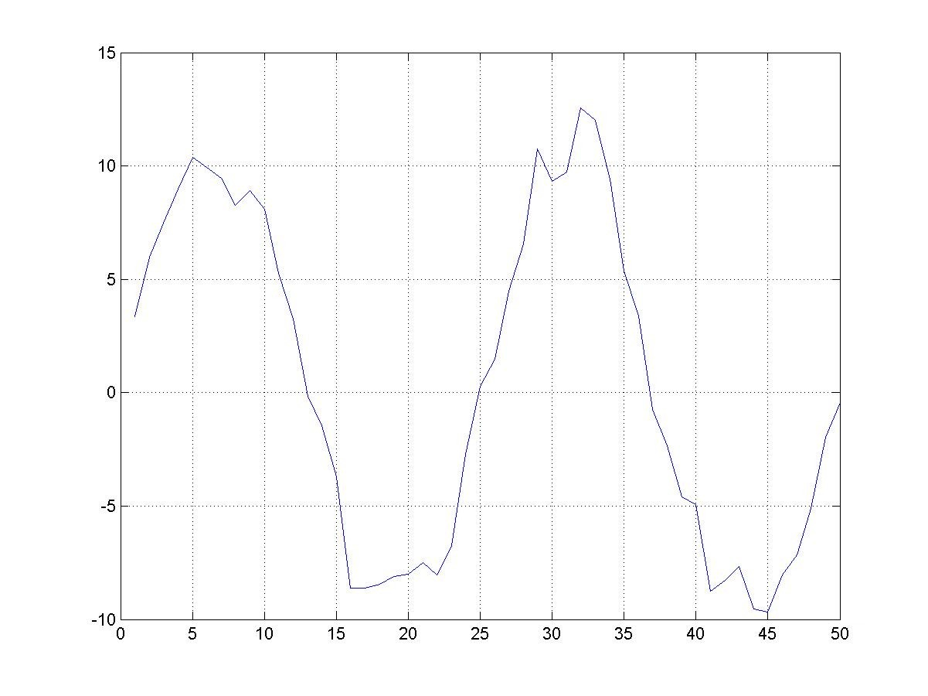  Figure 2: Realization segment of nonstationary signal at fast changes of nonstationary Function | 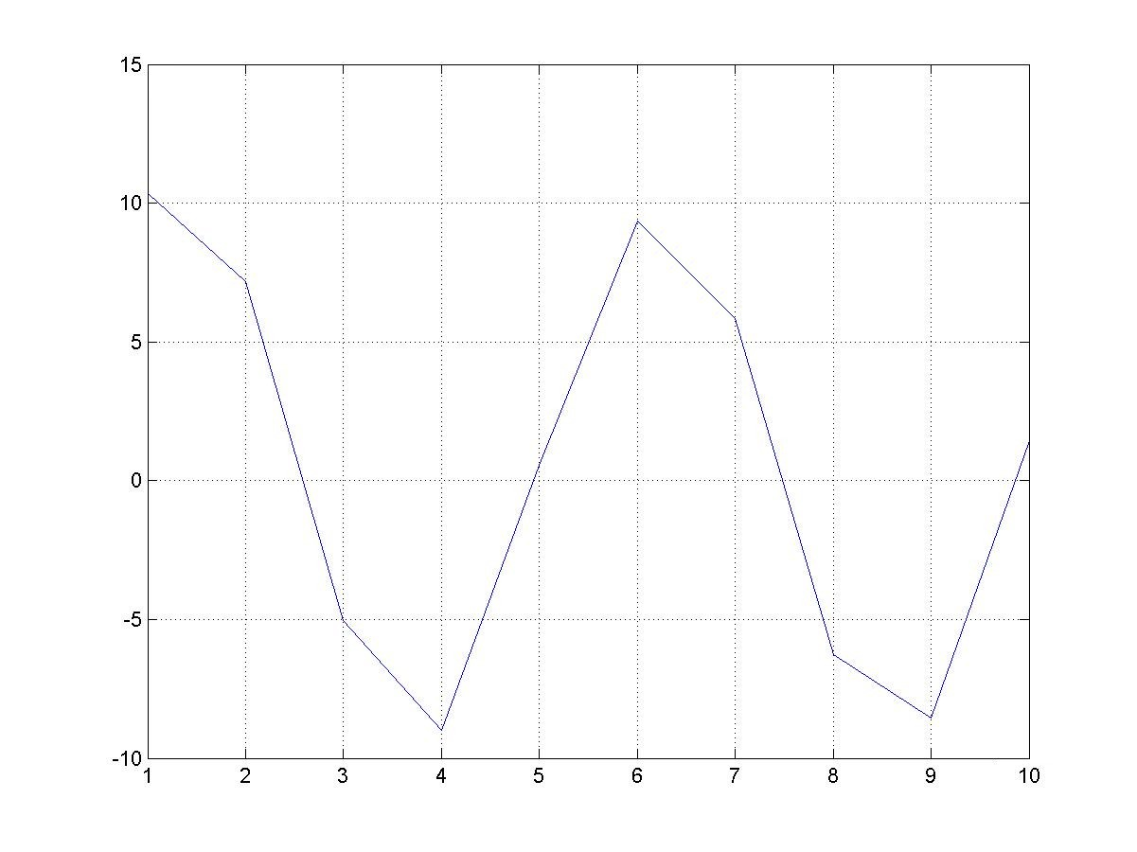  Figure 3: Realization segment of nonstationary signal at mean changes of nonstationary Function
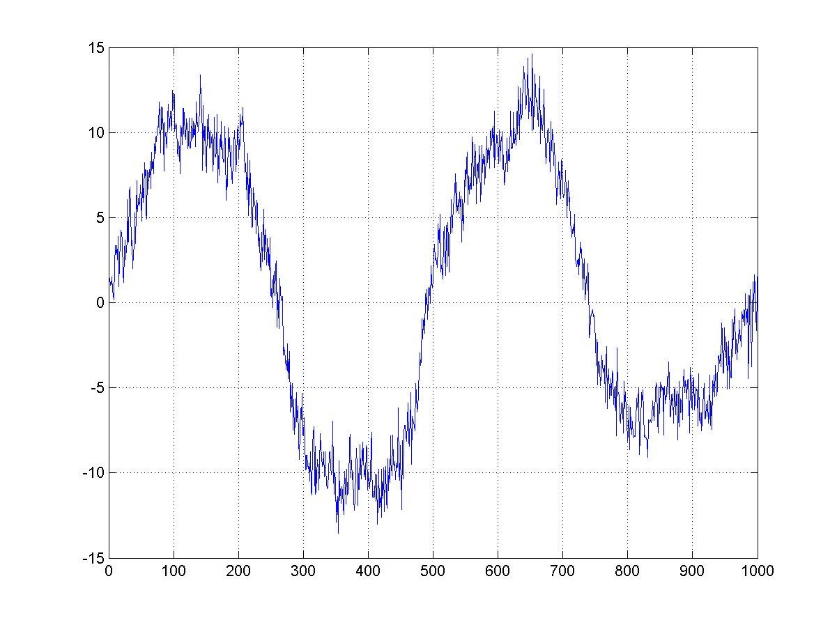
Figure 4: Realization segment of nonstationary signal at low-speed changes of nonstationary function

Conclusions
Actual traffic of telecommunicative networks has both random and seasonal character that generates a need to investigate nonstationary influence on evaluation procedure.
The analysis of nonstationary influence has reflected that evaluation value decreases and posteriori variance of error evaluation increases at nonstationary entries availability. The amount of evaluation errors increasers in the condition of changes level and speed increase of these nonstationary influences. It is possible to bring about the decrease of evaluation errors increasing the procedure productivity that is to decrease sample spacing. Almost the same accuracy can be achieved as in the stationary case decreasing the sample spacing.

References
1. Zviagolskaia G. V., S. N. Selevko, A. Zugbr, State evaluation of Non-Stationary telecommunication system, Telecommunication and radio engineering. 3 (2007) 209–222.
2. Popovskii V. V., Zviagolskaia G. V., Quality evaluation of optimized network elements and networks control procedures at nonstationary conditions. Radioengineering: Ukrainian Interagency Technological Reference Collection. 151 (2007) 124–129.
3. Zviagolskaia G. V., Procedure response investigation of the model parameter defection, 2nd International radioelectronics forum Modern Information Systems. Problems and trends of development, Kharkov-Tuapse: NURE, 2009, pp. 137–138.
4. Popovskii V. V., Oleinik V. F., Mathematical backgrounds of control and adaptation in the telecommunication systems, Smyth, Kharkov, 2011.

