economics and business administration
(according to the economic activity types)

UDC 338.48 10.26906/EiR.2020.3(78).1991
JEL L 83

AN ANIMATION AS A FACTOR IN THE FORMATION OF COMPETITIVE ADVANTAGES OF ORGANIZED TOURISM SERVICES

Iryna Chernysh*, Doctor of Sciences (Economics), Associate Professor
Viktoriia Makhovka**, PhD (Economics)
National University «Yuri Kondratyuk Poltava Polytechnic»

* ORCID 0000-0001-6565-5292
** ORCID 0000-0001-7985-7792
_____________________
© Chernysh І., 2020.
© Makhovka V., 2020.

Стаття отримана редакцією 30.08.2020 р.
The article was received by editorial board on 30.08.2020

Introduction. An animation as a socio-cultural phenomenon and as a type of activity is the object of attention of both practitioners of socio-cultural activities and scientists of various branches of science: recreationalists, sociologists, teachers, culturologists, psychologists. The attractiveness of this phenomenon is explained by the innovative content, objectively inherent in animation, a variety of technological qualities and approaches, as well as the wide possibilities of using and implementing animation in various spheres of socio-cultural activity, including tourism. A new direction of tourist activity - animation - today is gaining active development all over the world as an adequate means in the competition between hotels and tourist complexes of similar level of service and interior furnishing. In modern conditions, animation is one way to form the competitive advantages of an integrated tourism product.
An overview of the latest sources of research and publications. The problems of essence and value of the animation research in the field of tourism devoted to the works by many domestic and foreign scholars, including: A. Beidyk, A.N. Kravets, M.P. Malska, I.T. Skrypchenko, Yu.V. Fedotova, A.Yu. Davydova, S.I. Bailyk, etc.
Problem statement. An organization of animation activities is an integral part of the range of tourist services offered by tourism enterprises. The importance of animation activities in the structure of complex tourist services at the present stage of development of the tourism and hotel and restaurant business can hardly be overestimated, since the use of animation technologies has significant socio-economic and educational value, contributes to the popularization, preservation and development of the country's national and cultural heritage and tourist destination. Considering this, the organization of animation activities is very important in the field of tourism. Therefore, there is a growing focus on the role of animation in the field of organized tourism.
Main material and investigation results. Animation as a special component of the organization of leisure is reaching a new level of application, which makes it possible to use it in various aspects of social activity.
The development of new technologies, the acceleration of the pace of life has led to the emergence of a tendency to increase the need of a modern person for high-quality and varied rest and recreation. However, the choice of a certain type of rest is limited by a group of factors. They can be classified as internal and external [1, 9].
Internal factors include: limitation of free time in certain categories of the population; underdeveloped infrastructure and lack of qualified specialists; low level of motivation of the population to socially productive leisure; insufficient awareness of citizens about the functioning of the sphere of leisure, etc. External factors take into account: social tension; loss of traditions and spiritual unity of generations; value instability; consumer preference in social and cultural life [4, 8, 2].
In Fig. 1. the main components of animation are determined, which characterize its content as a type of organized tourist leisure. The preservation and restoration of human health (somatic, physical, mental, moral) during tourist leisure is achieved through the organization of hotel animation. Note that animation is a direction of tourist and resort activity, providing for both visual (passive) and personal participation of vacationers in theatrical and game programs, cultural, entertainment and sports events. The international experience of the tourist hotel business considers animation activity as an integral process of interaction between an animator and tourists, in the process of which the educational, cultural, recreational, recreational, creative needs and interests of the participants are satisfied [15].
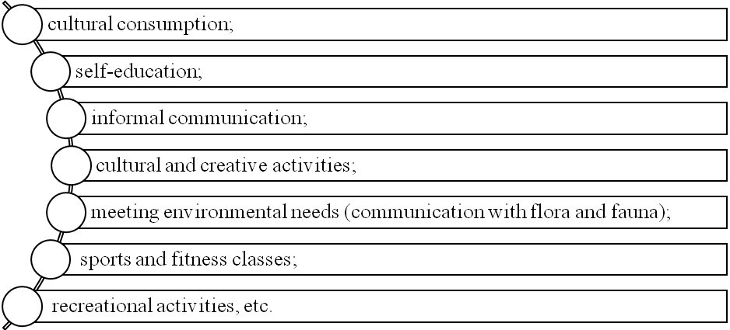
Fig. 1. Maintenance of tourist leisure [15]

The combination of active and passive recreation of tourists, regardless of age category and social status, presupposes the presence of entertainment activities, which are characterized by emotional switching, unusualness, conviviality, dissimilarity to what they do in their daily life.
In foreign hospitality practice, the term "amusements" (entertainment) is used, which combines a complex of types of recreational activities of a person during the rest period, in addition to purely entertainment: cognitive, sports and health, socio-cultural, etc. Holistic (eng. holism from the gr. holos – whole, all) the nature of recreational activities manifested in the ability of tourism brings variety and joy to the daily life of a person, creating a holiday atmosphere has led to the emergence of the term "animation" (animation) [15].
The term "animation" comes from the Latin animation - to inspire, animate. This term was first used in France at the beginning of the twentieth century and is interpreted as an activity aimed at reviving interest in cultural and artistic creativity [5].
Modern scientists understand animation as a process of organizing leisure time in recreation and recreation facilities, at corporate events and MICE events, in children's camps and children's parties, which provides for the personal participation of vacationers in animation events. According to V. Zorin, animation in tourism is an activity on the development and presentation of special programs for spending free time. Animation programs include sports games and competitions, dance evenings, carnivals, games, hobbies, etc. [9, 11].
Tourist animation is a complex, holistic interaction of an animator and a tourist using planned means of influence and stimulation of their activity and restoration of vitality in the process of this interaction [5].
In Fig. 2. the essence of the animation process is determined.
ANIMATOR
TOURIST
RESULT
Means of influence
Stimulation of activity, recovery, inspiration and restoration of human vitality

Fig. 2. Animation process [6]

Also, note that the concept of "animation" has a Latin origin (anim – wind, air, soul; animatus – animation) and means inspiration, inspiration, stimulation of vitality, involvement in outdoor activities.
Table 1 the essence of the concepts "animation" is defined and generalized.
Table 1
The definition of "animation"
The concept | The essence
Animation | a kind of service aimed at improving the quality of service;
Animation | a peculiar form of advertising, re-attracting guests and their friends, and promoting a tourist product to the market to increase the profitability and profitability of the tourist business. [12]
Animation | it is the revitalization of relaxation and the organization of direct impressions  from personal participation in events [16]
Animation | stimulating a full-fledged recreational, social and cultural leisure activity of a person by influencing his vitality [15]
Animation | a type of tourist activity carried out in a tourist complex, on a vehicle (train, bus, etc.) or at the place of stay of tourists (in a city square, in a theater or city park, etc.), which attracts tourists to various events through participation in specially designed leisure programs. [13]
Animation | as a complex for the development and provision of special programs for spending free time, organizing entertainment and sports leisure activities [5]
Hotel animation | these are a kind of additional services to the client, the purpose of which is to awaken positive emotions in him, to feel the pleasure of rest and the desire to come to this hotel again [14];
Hotel animation | one of the most effective ways to attract guests to the hotel. It also affects the positive assessment of the hotel as a whole;
Hotel animation | is a hotel service, which is based on the personal contacts of the animator with the hotel guests, on their joint participation in the entertainment offered by the animation program of the hotel company. It aims to implement a new philosophy of hotel service – improving the quality of services and the level of guest satisfaction with rest, etc. [8].
Touristic animation | it is a tourist service in the provision of which the tourist is involved in active action. Based on the personal contacts of the animator with tourists, on their joint participation in the entertainment offered by the animation program of the tourist complex [7]
Touristic animation | this is a kind of tourist activity carried out in a tourist complex, hotel, through boat or train, attracts tourists to a variety of activities through participation in specially designed leisure programs [7]

Thus, tourist animation is the most important part of the total activity of a tourist enterprise, an expression of a high degree of its professionalism, the most important component of a tourist product. Therefore, like any other activity at a tourist enterprise, animation should be planned, clearly regulated, organizationally controlled and provided with material, financial and human resources.
The ultimate goal of tourist animation is the tourist's satisfaction with the rest – his good mood, positive impressions, restoration of moral and physical strength. This is the most important recreational function of animation.
The research carried out allows us to detail the value of tourist animation:
in improving the quality, variety and attractiveness of the tourist product;
an increase in the number of regular customers and demand for a tourist product;
increasing the load on the material base of the tourist enterprise, increasing the efficiency of its use,
profitability and profitability of tourist activities [17].
Summarizing the results of a theoretical study of the essence of animation, we note that its characteristic features are:
1) exercise in free time;
2) the presence of freedom of choice, voluntariness, activity, initiative of both one person and various social groups;
3) conditioning by national-ethical, regional characteristics and traditions;
4) a variety of species based on the difference in interests of adults, youth and children;
5) deep personality;
6) humanistic, cultural, developmental, health-improving and educational character [13].
The following directions of development of animation in tourism can be distinguished:
1. Creation of special museums and parks, organization of costume balls, shows, holidays and other actions according to specific scenarios (creation of a specialized tourism product).
2. Animation – revitalizing leisure programs for tourists in long-term recreational areas – resort hotel complexes, tourist centers, holiday villages (HV-1) and bases, on cruise ships, and the like.
Both of these areas provide for the uniqueness and variety of events, the direct attraction of tourists to action, requires leisure organizers to have certain creative abilities to create special programs and scenarios, the ability to stimulate the tourist's interest, make him, despite the embarrassment, inertia, take part in animation programs. The animation uses active types of recreation, which include outdoor sports, swimming, running, skiing, hiking, aerobics, rock climbing, hiking, and passive – reading, fishing, music lessons, gardening, computer games, visiting stadiums, concerts, exhibitions, museums, viewing monuments of architecture, history and culture [13].
Travel animation is a holistic process of interaction between an animator and tourists using planned means of influence and stimulation of their activity and inspiration, healing and restoration of vitality in the process of interaction. Animation as a component of leisure is a way of initiating a person's creative needs and social activity; optimization of interpersonal and intergroup relations, socio-cultural integration, self-awareness and self-determination of the individual in the context of building a civil society.
As a result of the animation influence, the relaxation, health-improving, cultural, educational, creative needs and interests of the subjects of leisure activities are satisfied, conditions are created for the social activity of a person capable of transforming the surrounding reality. In Fig. 3 types of animation in tourism are defined.
TYPES OF ANIMATION
By industry basis:
hotel
recreational
transfer
tourist
By age:
for preschool children
for school children
youthfully
youth
for middle-aged people
for pensioners and the disabled
According to the needs and motivation of tourists:
animation in motion;
animation through experience;
animation through communication;
animation through calming;
cultural animation;
creative animation
According to the purpose and focus of animation programs:
sports;
sports and recreation
sports and entertainment
sports and educational
excursion
cultural and educational
adventure-play
creative
spectacular and entertaining
On national grounds:
national;
international;
ethnographic
Fig. 3. Types of animation [6]

Thus, based on internal needs, interests, the level of culture and existing capabilities, a person can participate in various types of animation activities during rest. Possible directions of animation activities are shown in table. 2.
Table 2
The main directions of animation in tourism [17]
Animation programs of tourism | Theatrical performances | Animation in theme parks | Sports animation | Hotel animation
festive events;  carnivals;  festivals;  competitions;  fairs | national holidays;  role games;  knightly tournaments;  costume balls;  performances in historic interiors | attractions;  visiting;  meeting with  fairy-tale heroes;  travel to the past and future | mountaineering;  aquaplaning;  badminton;  baseball;  skittles;  bowling;  water sports and others | discos;  concerts;  aerobics;  restaurant, bars;  darts

Studies show that animation is used more precisely in recreational and tourist activities, in particular in accommodation, health improvement and recreation establishments.
In Fig. 4 the main types of animation that are used during organized tourism have been determined.
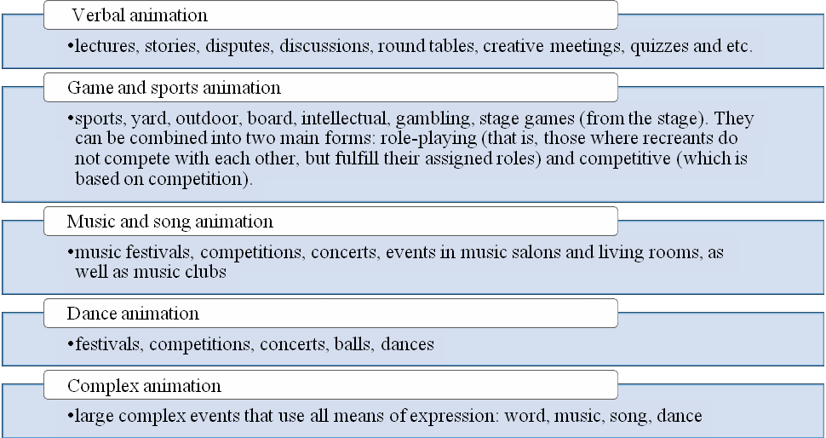
Fig.4. Types of tourist animation [10]

The component of animation activity in the socio-cultural life of a person is expressed in the experience, impression, emotion, state that assimilates the tourist during the rest. On the basis of these reactions, the tourist re-imagines, feels, comprehends the perception of the event, evaluates the quality of rest and the services provided. Forms of animation events: entertaining, exciting, spectacular events, relaxing procedures, active outdoor games, family and calendar holidays, anniversaries with friends, communicating with pleasant people in an unusual atmosphere, communicating with animals, traveling, etc.
Conclusions. So, on the basis of the above, it is advisable to conclude that tourist leisure is a kind of tourist activity in free from the time regulated by the tour program, motivated by the individual needs of the tourist, chosen at his own request in the place of his location and aimed at meeting the recreational, cultural, educational and entertainment needs of the traveler. The development of animation as an important component of organized tourism has significant prospects for development, since it is able to perform tasks such as upbringing, education, recreation, the development of human culture, the formation of an optimistic mood, in general, has an impact on the formation and development of a personality.

REFERENCES:
- Canak, N., Prentović, S. 2007. Communication and animation in sport and tourism. Faculty of Sport and Tourism, EDUCONS University of Novi Sad, Novi Sad [In Serbian].
- Cordes, Kathleen A. Applications in recreation & leisure: for today and the future / Kathleen A. Cordes, Hilmi M. Ibrahim. 2nd ed. WCB/McGraw-Hill, 1999. 350 p.
- Djordjevic, S. (2017). Benefits of sport-recreational animation programs in tourism [Benefiti sportsko-rekreativih sadržaja u programima turističke animacije]. Novi Sad: Faculty of Sport and Tourism/ Dumazedier J. Vers une civilisation du loisir? Paris, 1962. 319 p.
- Fedotova Yu.V. Animatsiina diialnist: sutnist, osoblyvosti ta sotsialno-ekonomichna efektyvnist / O.M. Kravets, Yu.V. Fedotova // Hlobalni ta natsionalni problemy ekonomiky, 2016. № 11.
- Garanin N.I. Menedzhment turistskoi i gostinichnoi animatsii: [ucheb. posob.] / N.I. Garanin, I.N. Bulygina. Moscow: Sovetskii sport, 2004. 128 p.
- Harbera O.Ye. Orhanizatsiia animatsiinoi diialnosti v strukturi kompleksnoho turystychnoho obsluhovuvannia / Olha Yevhenivna Harbera // Ekonomika XXI storichchia: problemy ta shliakhy yikh vyrishennia. kol.mon. Kharkiv, 2014.
- Hutkevych S. O. Orhanizatsiia animatsiinoho turyzmu u silskii mistsevosti [Elektronnyi resurs] / S. O. Hutkevych, M. I. Haba // Visnyk Chernivetskoho torhovelno-ekonomichnoho instytutu. Ekonomichni nauky. 2010. Vyp. 1. Р. 205–210.
- Ilto T.I. Rozvytok ta vprovadzhennia animatsiinoi diialnosti v hotelnomu hospodarstvi na ukrainskomu i svitovomu rynkakh // Hlobalni ta natsionalni problemy ekonomiky. 2015. Vyp.6. P.174–178.
- Kravets O. M. Orhanizatsiia animatsiinykh posluh v turyzmi : navch. posibnyk / O. M. Kravets, S. I. Bailyk ; Kharkiv. nats. Un-t misk. Hosp-va im. O. M. Beketova. 2-he vyd., pererob. i dop. Kharkiv: KhNUMH im. O. M. Beketova, 2017. 335 p.
- Kylymystyi S.M. Klasyfikatsiia vydiv animatsiinoi diialnosti v turyzmi [Elektronnyi resurs] / S.M. Kylymystyi // Mizhnarodnyi visnyk: Kulturolohiia. Filolohiia. Muzykoznavstvo. 2015. Vyp. 2. P. 77–83.
- Mikulic, J., & Prebezac, D. (2011). Assessing hotel recreational and entertainment activities programs at Mediterranean sun-and-sea resorts: An impact-asymmetry analysis. Tourism Management, 32, 688-696.
- Petrova I.V. Dozvillia v zarubizhnykh krainakh : pidruchnyk / I. V. Petrova. Kyiv : Kondor, 2005. 408 p.
- Rokicka-Hebel, M., Ziolkowska, J., & Patyna, A. (2016). The professional profile of a leisure time animator in tourism and recreation services. Gdansk, Poland: University of Physical Education and Sport.
- Shivers J. S. Leisure and recreation concepts: a critical analysis. London: Allyn and Bacon, 1981. 216 p.
- Skrypchenko I.T. Turystska animatsiia yak skladova profesiinoi pidhotovky fakhivtsiv do roboty u sferi dytiacho-yunatskoho turyzmu// «Zdorove, sport, reabylytatsyia». Kharkiv: KhNPU imeni H.S. Skovorody, 2016. №4. P. 57–62.
- Vedmid N.I., Melnychenko S.V. Orhanizatsiia dozvillia turystiv : navch. posib. K. : KNTEU, 2008. 85 p.
- Wartecka-Ważyńska, A. (2014). Professional competencies on the labour market of tourism and recreation graduates from the Academy of Physical Education in Poznan. Zeszyty Naukowe Uniwersytetu Szczecińskiego. Ekonomiczne Problemy Turystyki, 1, 231–248.
- Zivkovic, A., & Stamenkovic, I. 2008a. Ethno-gastronomic pleasure in tourist animation. Proceedings of the Department of Geography, Tourism and Hotel Management 37, 74-83 [In Serbian].
- Zorin V., Kvartalnov S. Tlumachnyi slovnyk turystskykh terminiv. Turyzm. Turystska industriia. Turystskyi biznes / V. Zorin, S. Kvartalnov. Moskva-Afiny : INFOGROUP, 1994. 408 p.

УДК 338.48
JEL L 83
Черниш Ірина Володимирівна, доктор економічних наук, доцент, директор Навчально-наукового інституту фінансів, економіки та менеджменту. Маховка Вікторія Михайлівна, кандидат економічних наук, доцент. Національний університет «Полтавська політехніка імені Юрія Кондратюка». Анімація як фактор формування конкурентних переваг послуг організованого туризму. Мета статті полягає у дослідженні особливостей анімації як фактора формування конкурентних переваг послуг організованого туризму. Визначено, що анімація використовується у багатьох сферах туризму та дозвілля, зокрема у формі анімаційних програм, театралізованих вистав, анімації в тематичних парках, спортивної та готельної анімації. Досліджено основні підходи до визначення сутності поняття «анімація». Зазначено, що анімацію необхідно розуміти як процес організації дозвілля в закладах відпочинку та оздоровлення, на корпоративних заходах та МІСЕ заходах, у дитячих таборах і на дитячих святах, яка передбачає особисту участь відпочивальників в анімаційних заходах. У результаті дослідження було визначено основні складові анімації, котрі характеризують її як вид організованого туристичного дозвілля: культурне споживання; самоосвіта; неформальне спілкування; культурно-творчі заняття; задоволення екологічних потреб (спілкування з флорою та фауною); фізкультурно-оздоровчі заняття; розважальна діяльність тощо. Проаналізовано основі види туристичної анімації за різними класифікаційними ознаками. Складова анімаційної діяльності в соціокультурному житті людини виражається у переживанні, враженні, емоції, стані, що охоплюють туриста під час відпочинку. На основі цих реакцій він переусвідомлює, відчуває, осмислює сприйняття події, дає оцінку якості відпочинку і наданих послуг. Форми анімаційних заходів: розважальні, захоплюючі, видовищні заходи, релаксуючі процедури, активні ігри на свіжому повітрі, сімейні та календарні свята, ювілеї в колі друзів, спілкування з приємними людьми в незвичайній атмосфері, спілкування з тваринами, подорожі й ін. Таким чином, анімація як складова дозвілля є способом ініціації творчих потреб людини та її соціальної активності; оптимізації міжособистісних і міжгрупових відносин, соціально-культурної інтеграції, самосвідомості та самовизначення особи в контексті побудови громадянського суспільства. Перспективами подальших досліджень є визначення потенційних напрямів розвитку анімації у сфері туризму, підвищення її якості й сервісу з урахуванням потреб сучасних споживачів туристичного продукту.
Ключові слова: туризм, анімація, анімаційна програма, готельна анімація, дозвілля, відпочинок.

UDC 338.48
JEL L 83
Iryna Chernysh, Doctor of Sciences (Economics), Associate Professor. Viktoriia Makhovka, PhD (Economics). National University «Yuri Kondratyuk Poltava Polytechnic». An Animation as a Factor in the Formation of Competitive Advantages of Organized Tourism Services. The purpose of the article is to study the features of animation as a factor in the formation of the competitive advantages of organized tourism services. The authors determined that animation is used in many areas of tourism and organized leisure, including in the form of animation programs, theatrical performances, animation in theme parks, sports and hotel animation. The article explores the main approaches to defining the essence of the concept of "animation". It is noted that animation is the process of organizing leisure time in recreation and recreation establishments, at corporate events and MICE events, in children's camps and children's parties, which provides for the personal participation of vacationers in animation activities. As a result of the research, the main components of animation were identified, which characterize its content as a type of organized tourist leisure: the culture of consumption; self-education; informal communication; cultural and creative activities; meeting environmental needs (communication with flora and fauna); health and fitness classes; entertainment activities and the like. The types of tourist animation based on various classification criteria are analyzed. The component of animation activity in the socio-cultural life of a person is expressed in the experience, impression, emotion, state, covering the tourist during the rest. Based on these reactions, the tourist feels, comprehends the perception of the event, evaluates the quality of rest and services provided. Forms of animation events: entertaining, exciting, spectacular events, relaxing procedures, active outdoor games, family and calendar holidays, anniversaries with friends, communicating with pleasant people in an unusual atmosphere, communicating with animals, traveling, etc. Thus, animation as a component of leisure is a way of initiating a person's creative needs and social activity; optimization of interpersonal and intergroup relations, socio-cultural integration, self-awareness and self-determination of the individual in the context of building a civil society. Prospects for further research are the identification of potential directions for the development of animation in the field of tourism, improving its quality and service, taking into account the needs of modern consumers of a tourist product.
Key words: tourism, animation, animation program, hotel animation, leisure, rest.

