UDC 336.117 DOI 10.26906/еір.2019.4(75).1818

FINANCIAL INCLUSION OF THE REGION: ANALYSIS OF THE STATE AND WAYS OF ENSURING

Andrii Matkovskyi, PhD (Economics)
Vitaliia Skryl, PhD (Economics)
Ruslana Shtanko, student
National University «Yuri Kondratyuk Poltava Polytechnic»
_____________________
© Matkovskyi A., 2019.
© Skryl V., 2019.
© Shtanko R., 2019.

Стаття отримана редакцією 25.11.2019 р.
The article was received by editorial board on 25.11.2019

Introduction. Financial inclusion of the region is a means of making full use of the financial services industry's tools, which ultimately contributes to the long-term economic growth of the region, as it stimulates innovation, mobilizes savings and supports investment. Scientific and technological progress has made the provision of financial services a simpler, safer and more cost-effective process for ordinary citizens.
At the same time, embracing technology in all sectors of the financial market contributes to solving financial inclusion problems for all types of low-income developing economies, including Ukraine. All these factors make relevant research concerning the definition of effective ways of development of financial inclusion of Poltava region.
An overview of the latest sources of researches and publications. Foreign scientists have been active since the early 1990s discussing issues of financial inclusion, now their publications are most often analyzed regional aspects of this issue or opportunities and obstacles to the use of modern information technology to increase access to financial services. However, in domestic financial science they are indicated problems became the subject of study only in recent years.
Setting objectives. The purpose of this study is to deepening the theoretical foundations and practical recommendations for ensuring regional financial inclusion.
The main material and the results of the study. In recent decades, financial inclusion, along with financial stability, financial integrity and protection of the rights of consumers of financial services, has been one of the main goals of both the state and regional regulation of the financial sector in many countries of the world. Involvement of a wide range of economic entities, especially individuals, in the active financial life, contributes to the increase of the financial institutions resource base, and thus their positive impact on the economic development of the region and the well-being of the population, optimization of the money supply structure, enhancement of transparency of financial flows, which creates conditions for shrinking the shadow economy [1].
The idea of financial inclusion of the region is based on the elimination of barriers that impede or prevent the use of financial services by certain categories of the population. According to the latest financial services research, it is plausible that many of the region's population do not use them. This is especially true of innovative methods of providing financial services, such as internet banking or other financial services. The introduction of financial inclusion of the region implies the involvement of as many people of the region as possible in the financial services market. It is about all segments of the population of the region, individuals and legal entities. Increasing the level of financial inclusion of the region contributes to the prosperity of the banking sector and sustainable economic growth in the country as a whole and in the region [2].
Today, financial inclusion of the region is considered one of the drivers of stimulating the economic development of the country and its regions and reducing social inequality in society. It provides equal access for citizens and businesses of the region to the use of affordable financial services and products; meet their needs; are accessible to all segments of the population of the region, regardless of age, income, education, place of residence or type of activity; made available to the financial sector at an appropriate level by all parties involved. Thus, financial inclusion of the region is a way of overcoming poverty, and inclusive growth is a way to the common welfare of the region's population.
This concept was first introduced in 1994 and has been used by UNESCO to address inclusive learning. Subsequently, this concept spread to the macroeconomic level, when many financial institutions began to move from offering solely micro-credit services to offering basic financial services such as insurance and opening savings accounts. Today, the development of this concept has already crossed the horizon. It has become clear that in order to provide access to financial services, it is worth implementing it from local and territorial communities, districts, and only then at the level of individual regions. Researchers are still most often analyzing regional aspects of this issue in their publications or the opportunities and barriers to using modern information technologies to increase access to financial services [4, 5]. Worldwide history of financial inclusion shows that this process is quite lengthy and constantly evolving by involving everyone in the use of basic financial services. Finally, the annual increase in the number of people actively using financial institution services indicates the progress of financial inclusion [2].
Therefore, it can be noted that the term "financial inclusion of the region" is still not fully understood. But the vast majority of international organizations is paying more attention to it and, in carrying out their activities, is focused on putting the region's financial inclusion into practice.
The National Financial Inclusion Strategy (NSFI) identifies four components of financial inclusion, namely: 1) access; 2) quality; 3) use; 4) welfare (fig. 1.), it can be noted that it also extends to the regional level [6].

Ability to use financial technologies:  - physical  access quality  use welfare  proximity;  - digitization  fin.logist.;  Financial inclusivity  - digitization  fin.logist.;  - accessibility. | - Product attributes match  customer requirements;  - when designing  product  taken into account  customer needs.
Impact on lifestyle  consumers:  - welfare / consumption;  - personal business / productivity. | Factors of use  financial  services / products:  - regularity;  - frequency;  - length of time used.

Fig 1. Components of financial inclusivity of the region
Developed based on source [7]

That is, the main purpose of financial inclusion of the region is to maximize the involvement of all segments of the population in the use of financial products / services through various financial technologies. According to official statistics, about one third of the world's population, as well as Ukraine, do not have access to any financial services / products today. World Bank data indicate that more than 100 countries already have or are in the process of developing national and regional financial inclusion strategies, or have embedded components of financial inclusion into broader national strategies [8].
Speaking of Ukraine, over the last 20 years, it has made significant strides in raising financial inclusion at both national and regional levels, but today it remains at a relatively low level compared to the leading countries in the world. So raising the level of financial inclusion of the region is important for different stakeholders (fig. 2).
Achieving a sufficient level of financial inclusion in the region will contribute to the profitability of foreign investment; development of export-import operations; improving food security; development of tourism industry; increasing the level of profitability of the population of the region; the growth of the small and medium business layer; reducing corruption and fraud.

Financial service providers

State
Citizens of the country

Stakeholders of financial inclusion

Fig. 2. Stakeholders of financial inclusion

Major regulators of the financial sector of Ukraine such as the National Bank of Ukraine, the National Securities and Stock Market Commission, the National Commission for State Regulation of Financial Services Markets (hereinafter referred to as regulators), the Ministry of Finance of Ukraine and the Deposit Guarantee Fund have approved the Strategy development of the Ukrainian financial sector by 2025 [9].
This strategy defines the implementation of the international practices and measures envisaged by the EU-Ukraine Association Agreement and other international commitments of Ukraine regarding the further reform and development of Ukraine's financial sector. This strategy will take the place of the Comprehensive Financial Sector Development Program by 2020, which has prioritized regulatory reform over the past five years. Based on this strategy, regional financial sector development programs are developed at the regional level and its main components are identified as priority areas for development.
So, there are five key priorities for regional financial inclusion development:
- Changing the financial culture of the society of the region. The region's financial culture is the knowledge, skills and attitudes needed to ensure responsible financial behavior and enhance the financial inclusion of Ukrainians. The components of the region's financial culture are a whole range of cultures – insurance, savings, entrepreneurship, investing, tax, credit, retirement, community life, credit histories, and more.
- Financial literacy and European outlook of Ukrainians. Citizens of both the country and the region must share European values and be prepared to live up to European standards, form their own budget, be responsible in their financial decisions, engage in long-term financial planning, save, control their financial accounts, prudently use credit and manage debt.
- Youth as a driver of change. Young people aged 10 to 24 in the region (Generation Z and Generation Alpha) are the main target audience. Only young people can act as agents of change, able to teach their friends, parents, grandparents the financial knowledge and skills that citizens need to make informed decisions and to be responsible for their financial behavior.
- Formation of a single communication platform of the region. A unified, single brand communications platform brings together all stakeholders and activities, becomes recognizable and helps build trust.
- Creation of an educational and information center of the region. The educational and information center of the region is a center of financial education and communication that will combine: visitor center, money museum, youth education center, teacher competence center.
Working to increase the level of financial inclusion of the region and financial literacy is long-term and therefore requires the coordination and interaction of different stakeholders and partners to achieve the set goals. Thus, starting in 2019, a road map implementation process has started in Ukraine, which should result in the implementation of all developed roads in 2020. It should not only be based on the state level and determine the number of service financial institutions, but its main purpose is to disseminate and satisfy the regional level of financial services. They should be accessible, easy to understand, understandable and transparent. Today, one of the reasons for not using financial inclusion in the region is the lack of confidence and incomprehensibility of financial services to the population. It is worth building simpler mechanisms for providing these services (fig.3).
ordering goods
financial services
client
paymentt
paymentt
Fig.3. Scheme of the process of providing financial services for the population of Ukrainian regions is available

In order to enhance financial inclusion, financial institutions' market conduct standards and financial products disclosure will be implemented, targeted programs for increasing financial literacy of the population will be strengthened, consumer rights will be strengthened, incentives will be created for payment infrastructure for non-cash transactions, the system will be expanded and improved contributions, etc.
The level of financial inclusion at the marginal level (the inclusion of all segments of the population in the financial system) in countries such as Denmark, Sweden, Norway, as well as those that are consistently leading in the ratings of the richest and happiest countries in Europe reaches 100%. The Netherlands and almost 98% are Austria and Britain. With regard to Eastern Europe, financial services are also widely available here to the general public. More than 80% of the population in the Czech Republic and Belarus has a bank account. This figure is slightly lower in Hungary – 75%.
Today, the world's leading countries, including the United States, the United Kingdom, Canada, the Netherlands, Australia, and New Zealand, are making a lot of efforts to improve the financial literacy of the population of all regions of their countries. Best practices come together under the auspices of powerful international organizations: the World Bank, the Organization for Economic Co-operation and Development (OECD), the United States Agency for International Development (USAID), the IMF, the Basel Committee on Banking Supervision, etc.) collect statistics, calculations and analysis of financial inclusivity indicators.
Today, Ukraine has an indicator that more than 31% of Ukrainians are outside the financial system, i.e. they have no bank account. But the dynamics in recent years are very positive.
Regarding the level of financial inclusion in the Poltava region, it should first be noted that as of January 1, 2014, the population of Poltava region was 1458,2 thousand people, including urban population – 899,1 thousand people (61,7%), rural – 559,1 thousand people (38,3%).
The administrative map of districts of Poltava region includes 25 districts, 15 cities, of which 5 are of regional importance: Horishni Plavni, Kremenchuk, Lubny, Myrhorod, Poltava; 10 cities of district importance 5 districts in cities, 21 urban-type settlements, 467 village councils, 15 settlements and 1791 villages. The administrative center is the city of Poltava.
In order to determine the level of financial inclusion of the Poltava region, we conducted an online survey using the form developed by Google. 247 respondents took part in the study. Figure 4 shows the respondents who identified and participated in the online survey to determine their level of financial awareness. Respondents were asked to answer six questions that characterize their level of financial awareness. Among all respondents, 141 were identified as female and 106 were male.
When asked "Do you know what financial inclusion is?" we received the following data for only 15% of women and 7% of men gave a positive answer to this question.
When asked "Do you plan your own daily and / or regular expenses?", We received the following data – 50% of women and 47% of men gave a positive answer to this question. It is worth noting that residents of Poltava region plan their own daily expenses, which is already a very positive manifestation of the level of financial inclusion.

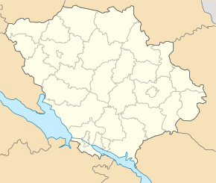
5
97
1
7
12
7
2
7
7
9
2
15
7
4
73
6
73
3
5
9
73
5
8
6
2

Fig. 4. Online survey chart on awareness of financial inclusion of residents of Poltava region

When asked "Do you use any electronic payment methods yourself?" We have received the following data that among all surveyed respondents only 43% of women and 35% of men of Poltava region use electronic means of payment.
To the question "Do you use any financial products in the region?", We received the following data, so 57% of women and 40% of men gave a positive answer.
When asked "Do you know what financial well-being is?", We received the following data on 53% of women and only 28% of men with an idea of financial well-being.
According to the results of the analysis, it can be noted that more than 40% of the respondents have a low level of financial inclusion. It is worth noting that almost 60% of respondents in the Poltava region came from rural areas. Therefore, it is worth dwelling on the dynamics of the ratio between urban to rural populations (fig.5).

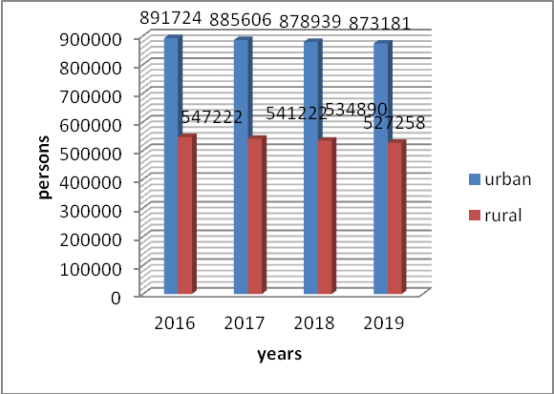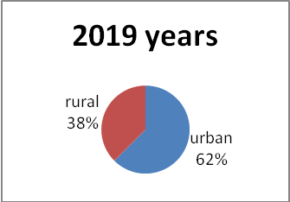
Fig.5. Dynamics of the number of existing urban and rural population of Poltava region in 2016-2019
Developed based on source [12]
As in most regions of Ukraine in the Poltava region, the main reasons for not actively developing the financial services market include the inability to use the service due to its physical inaccessibility for residents of certain territories.
For example, one of the indicators that characterize the level of access to customer accounts is the ratio of the number of terminals to the population living in the Poltava region (fig.6, 7).
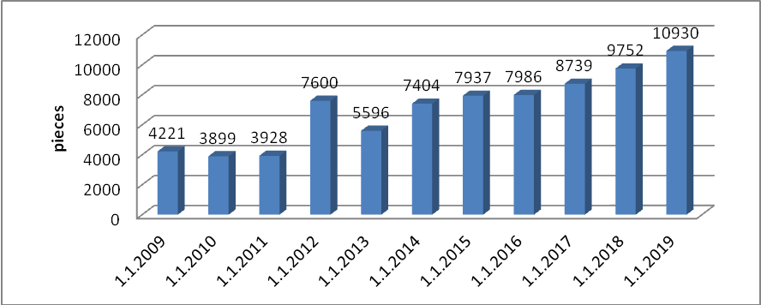
Fig.6. Number of payment terminals, including trade and banking per 1000 population in Poltava region in 2009-2019
Developed based on source [13]

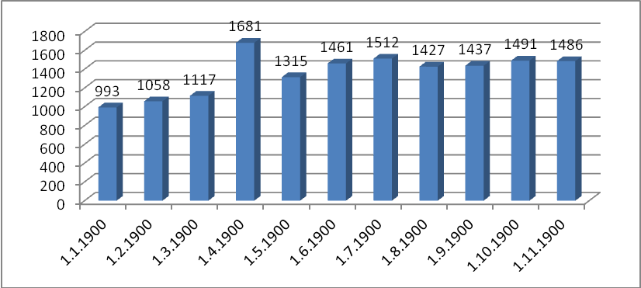
Fig.7. Number of self-service banking devices, including ATMs, deposit ATMs, PTCS per 1000 population in Poltava region in 2009-2019
Developed based on source [13]

As can be seen from the above data, the situation in the Poltava region has improved significantly since 2009. However, such a number of devices is not enough to serve both urban and rural population of Poltava region. It is also worth noting that the distributed infrastructure of payment devices is uneven, since most of its accumulation is observed in Horishni Plavni, Kremenchuk, Lubny, Myrhorod, Poltava, and rural areas may be absent altogether.
The main reason for this disparity is economic: to build the infrastructure to provide traditional banking services is expensive. Therefore, banks focus on focusing on the most active and most solvent demand, estimating the return on their investment.
However, for the development of financial inclusion, banking institutions need to remember that a large proportion of the regions of Ukraine have a significant proportion of rural residents in the permanent adult population (fig. 8, 9).
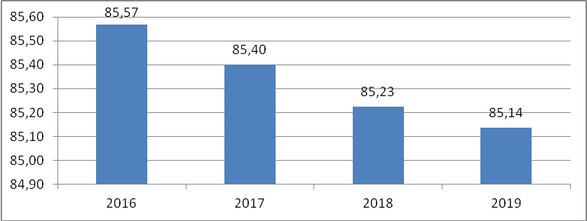
Fig.8. The share of permanent population of urban settlements 18 years and older in the total number of Poltava region in 2016-2019, %
Developed based on source [12]
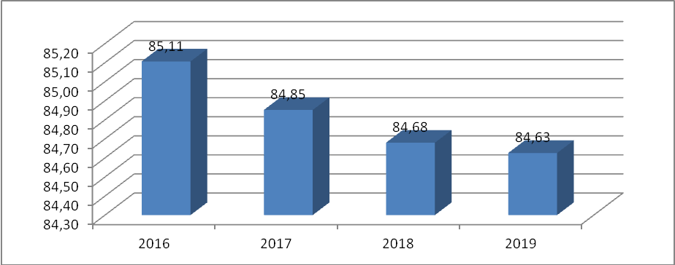
Fig.9. Percentage of permanent rural settlements 18 years and older in total number of Poltava region in 2016-2019, %
Developed based on source [12]

As we can see from the above data and our surveys, more than 38% of the adult rural population lives in the Poltava region, most of which are not involved in financial inclusion at all. However, this does not mean that residents of less populated or less economically active areas do not need access to financial services. It can be provided either directly by the financial institution or by remote access to financial services from a computer or mobile phone. Therefore, this provides a serious basis for the development of new financial technologies (FinTech).
Another reason for the low level of financial inclusion of the population of Poltava region is the lack of financial literacy of some groups of users of financial services. As a result, the consumer cannot make a rational and responsible decision regarding the placement and use of his own and borrowed funds:
а) because of the risks arising from the unconscious investing of own resources in a non-bank financial institution instead of the traditional bank deposit;
b) misunderstanding of risks in obtaining a foreign currency loan in the absence of income in the same currency.
It should be noted that in accordance with Art. 5 of the Law of Ukraine "On Financial Services and State Regulation of Financial Services Markets" financial services are provided to financial institutions, and, if expressly provided by law, to individuals – entrepreneurs [14].
The law stipulates that financial institutions include banks, credit unions, pawnshops, leasing companies, trust companies, insurance companies, savings-pension institutions, investment funds and companies and other legal entities, the sole activity of which is the provision of financial services, namely: trust management of financial assets; attraction of financial assets with their subsequent return; financial leasing; lending, in particular on the terms of a financial loan; providing guarantees and sureties; currency exchange and transfer of funds (control over compliance with the requirements of the legislation when providing these financial services is exercised by the National Bank of Ukraine); factoring; administration of financial assets for the purchase of goods in groups.
All the above financial institutions are to a certain extent sufficiently represented in Horishni Plavni, Kremenchuk, Lubny, Myrhorod and Poltava. Usually in rural areas the whole base of financial institutions is concentrated only by 2 national brands – JSC Ukrposhta and Coop Ukraine (before rebranding – Ukoopspilka). Recently UkrPoshta has also expanded its access to financial services, and Coop Ukraine is trying to make financial services available (payment for internet, mobile recharge, payment for goods using a card, receiving transfers, payment for utilities, etc.) (fig. 10).

Fig.10. Database of financial institutions in the countryside

But there are also a number of problems for urban populations. Typically, the average consumer who wants to get financial services from a non-bank financial institution is at risk of financial pyramids. The overall financial literacy index of Ukraine, calculated according to the OECD methodology, is 11.6 (out of 21). This index is based on points for financial knowledge, attitude and behavior. Only 43% of the adult population in Ukraine correctly answered at least five of the seven knowledge test questions (considered the minimum target) and confirms the correctness of the data we received when polling Poltava respondents against 56% in all participating countries in the OECD poll. This poll showed the following:
- Ukrainians are well aware of what inflation is and how to calculate discounts in stores.
- The level of knowledge of simple percentages is lower than in other countries (55% in Ukraine against the average of 65% for other OECD countries).
- A low level of understanding that the promise of a high income is likely to mean high risks makes Ukrainians vulnerable to fraudulent schemes and speculative investing.
- Only 21% of respondents were able to correctly choose from the short list of proposed options the amount of state-guaranteed bank deposit compensation (UAH 200,000).
But, it should be noted that Ukrainians show great interest in financial literacy and its support. They want children to learn how to manage their money. For example, 70% would like children to be taught in school how to manage their finances.
At the same time, about half of Ukrainians feel comfortable evading taxes. For example, 48% would agree to receive part of their paycheck in cash ("in an envelope" is a way of tax evasion for employers and employees). Citizens of Ukraine have a polarized attitude to talking about money. While 40% of those polled talk about money with relatives and friends, 41% say no. It is important, because it is difficult to increase the financial competence under such conditions when people consider that talking about money is inconvenient.
With respect to financial behavior, 61% of respondents have savings made in a certain way. However, for many respondents, the term savings is short-term. 52% said they saved money by keeping it in their wallet or cash at home. Only 12% of Ukrainians said they had saved money by transferring money to a bank deposit account. Of those who have savings in a deposit account, more than half also kept savings at home. This demonstrates a very strong culture of preferring cash and avoiding relationships with banks [15].
Protecting user rights. This problem is no less acute than the previous one. Its solution lies in the plane of development and compliance with appropriate legislative and regulatory support, both individually in the banking system and in the financial market as a whole. This will guarantee a safe and secure financial services market.
In Ukraine, the protection of the rights of consumers of financial services took place only in the general context of consumer protection and is not regulated by law. Specific disclosure requirements for financial products and liability for violations of consumer rights in the provision of financial services are undefined, and users of such services typically suffer.
To date, one of the main aspects of financial inclusion is the use of cash and non-cash. It is worth noting that in some countries at the legislative level it is stated that the calculation of the state with the population is carried out only by non-cash means, or wages are paid only by non-cash method. As we have already noted, these are countries in which the level of inclusion is 100%: Scandinavian countries, Sweden, Finland, Norway, Denmark, Canada, Holland, Australia. Here, there is a direct correlation of population involvement in all financial services, using a full list of banking services and insurance. Of course, all this happens honestly and transparently. For Ukraine and its regions, this is not yet possible. We can confidently say that some of the cash is still in the shadows, and thus significantly reduces the level of well-being of the residents of Poltava region.
Today we can observe the following dynamics of changes in the number of active electronic payment means in the Poltava region (fig.11).
The use of non-cash payments contributes to the economic well-being of the population, because cash is actually a shadow economy, and non-cash is something that can fill the budget and be an incentive for businesses to grow in the future, because there is an understanding of where cash flows go how they are controlled; the population has an understanding of how to manage their flows, there is a greater tendency to save.

Fig.11. Dynamics of Changes in the Number of Active Electronic Payment Instruments in the Poltava Region for 2009-2019

According to studies conducted in other countries, we see that when more consumers are involved in the financial sector in regions, so-called local or regional business activity is emerging, a business has a history of using financial services and more potential to attract financing for its development, and these are new jobs and more [17].
According to some analysts, with an increase in the number of non-cash transactions by at least 7%, we can observe the territorial economic growth of the population's well-being within 3-4%. Therefore, it is appropriate to consider the level of income of the population of Poltava region for 1 person. To generate forecast values for baselines, select the level of disposable income per person, according to statistics of the State Statistics Committee.
Table 1
Disposable income per person in Poltava region for 2013-2019
Region | Disposable income per person, UAH
Region | 2013 | 2014 | 2015 | 2016 | 2017 | 2018 | 2019
Poltava region | 25371 | 26196 | 31997 | 37938 | 48663 | 61649 | 82872
One by one, until the end of this year, one can clearly see the increase in income per person, with 7% of unbroken vacations. For the given tables, there is 1 indication of the lagging index of the indicators that is the trend for the linguistic formula.
It can be seen from the prompted diagrams, to show the linearity of the indicators, that is the trend for the linear formula.
$$у_{х}=а+b⋅х$$
where $у_{х}$ – UAH ratio a year;
х – time the years.
an+b Σ x = Σy
a Σx+b Σ = Σyx
The corresponding values are found in table 2.
Table 2
Baseline data to calculate the level of income per person from increasing the level of financial inclusion of residents of Poltava region
 | х, year | у, UAH |  | ху
1 | 1 | 25371 | 1 | 25371
2 | 2 | 26196 | 4 | 52392
3 | 3 | 31997 | 9 | 95991
4 | 4 | 37938 | 16 | 151752
5 | 5 | 48663 | 25 | 243315
6 | 6 | 61649 | 36 | 369894
7 | 7 | 82872 | 49 | 580104
Σ | 28 | 314686 | 140 | 1518819

Using Table 2 we calculate the coefficients of linear dependence:
a7+28x = 314686
28a+140x = 1518819
а = -157784 UAH., b = 42405 UAH.
Thus, if the number of non-cash transactions is increased, at least 7% revenue per person of the Poltava region is estimated at UAH 86758, which is 4,48%, as well as confirmation of our forecasts. Figure 12 clearly shows the dynamics of changes in incomes per person in the Poltava region, taking into account the increase in the level of financial inclusion of the population.
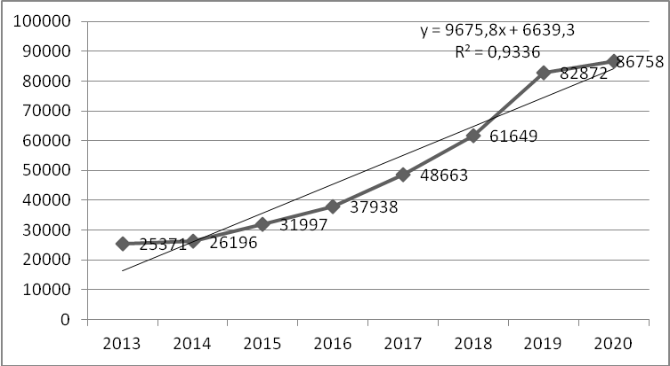
Fig.12. Dynamics of change of income 2013-2018 for one person of Poltava region from the level of financial inclusion and its forecast value in 2020
Thus, with the years studied, there is a tendency to increase incomes per person by years, we can confidently say that the increase of the level of financial inclusion directly influences the profitability of the population and contributes to its increase.
Table 3
SWOT-analysis of the level of financial inclusion of Poltava region
STRENGTHS | WEAK SIDES
1 | 2
1. High level of education of the population | 1. Imperfection of the legislative framework
2.Popularity of discussion of financial matters | 2.Low quality of promotional products
3. Use of banking products and services | 3. Inaccuracy of the information provided
4. Use of non-cash payments and Internet banking, access to banking infrastructure | 4. Inability to use financial services
5. Transition to international standards | 5. Low level of financial literacy
6. Increasing the level of welfare of citizens | 6. Imperfect financial knowledge
7. Reducing the level of shadowing of the economy and corruption | 7. Low level of financial well-being
8. Increasing the competitiveness of the Poltava region | 8. Imperfect financial behavior
9. Favorable geographical location | 9. Unformed financial goals
10. High level of industrial development | 10. No third party guarantee of secure, predictable and quality financial services
 | 11.Significant presence of financial services, cash turnover
 | 12. Restricted use of the Internet
1 | 2
OPPORTUNITIES | THREATS
1. Deepening integration with the EU | 1.Political instability and hostilities in the Donbas
2. Increasing the investment attractiveness of Poltava region | 2. Continuation of economic stagnation of the economy due to the political crisis in the East
3. Improvement of business climate in Poltava region, renewal of stimulation of development of small and medium business | 3. Accelerated depopulation of the region's population, especially in rural areas
4. Increasing transparency and productivity of the banking system, including through the introduction of digital technologies and paperless business processes, the use of the latest IT technologies, simplification and optimization of financial sector participants. | 4. Reducing household spending on goods and services
5. Reducing the share of cash payments and the share of cash in the money supply through the introduction of the latest technologies, attracting innovative payment service providers and creating favorable conditions for the use of electronic payment means
6. Creating a competitive environment for implementation and use of innovative payment services and services
7. Stimulating the development of the FinTech market

Based on the analysis of the world experience of financial inclusion and features of the Ukrainian financial market, the maximum effect in this area can be achieved by implementing a set of events in the Poltava region with four components, in the following directions:
1. Practical regulatory support for digital financial inclusion and implementation of responsible digital financial practices.
2. Promoting the development of digital financial services as a priority for the development of inclusive financial systems, balancing innovation and risk to achieve digital financial inclusion, simplifying and implementing consistent digital customer identification for digital financial services.
3. Expanding the ecosystem and infrastructure of digital functional services.
4. Strengthen digital and financial literacy and awareness.
Considering the Poltava region as a separate economic region of Ukraine, it is advisable to highlight the economically and physically strengths and weaknesses, opportunities and threats of development.
SWOT analysis begins with the identification of strengths and weaknesses - internal factors. Only after the internal factors have been thoroughly considered and evaluated do they proceed to the analysis of opportunities and threats that directly or indirectly affect the economy of the region. For the most part, their control is not possible, but their detection and accounting is required. Thus, having conducted the SWOT analysis we obtain the following results (table 3).
If the SWOT analysis is done correctly, it will reveal:
1) whether all the resources of the region are fully utilized;
2) what competitive advantages this particular region has; what strengths can be the benefits and what needs to be done;
3) which of the available opportunities will help the development of this region;
4) what threats are critical - now or in the future, how to avoid them.
Therefore, summarizing the SWOT analysis of the level of financial inclusion of the Poltava region, we can say that the strengths stand out less than the weaknesses, but in their importance strengths far outweigh the weaknesses. As a result, there are more development opportunities than threats.
Conclusions. The research has shown that the need to involve more people in the formal financial system cannot be overestimated. Financial inclusion of the region increases social stability, material well-being, directs savings in investments, which, after all, positively affects the level of profitability of each person in the Poltava region.
The principle of financial inclusion of the region is to increase the access of ordinary citizens to financial institutions; change of financial culture (tax culture, consumption culture, culture of savings, investments and entrepreneurship, retirement culture, community life culture, credit history culture, educational culture); formation of a European, financially aware Ukrainian (able to make responsible financial decisions, share European values, ready to live by European standards); reorientation of focus on youth (main target audience: 10-24 years, Generation Z and Alpha); to develop a single communication platform; set up an educational and information center for financial education and communications at the National Bank's mandate and functions. The study showed that the current level of financial inclusion of the Poltava region is low. Surveys of the respondents showed that there is a large disproportionate level of financial inclusion among urban and rural population. The rural population is limited in financial services. There is still a significant lack of confidence in financial institutions. All this slows down the processes of full involvement of the population in financial inclusion and creates a shadow sector.
However, remediation is observed in urgent action by both the state and local authorities and financial institutions. Continuous information in the media and social networks in the future will be able to restore confidence in financial institutions and thus increase not only the level of financial inclusion, but also every inhabitant of the Poltava region.

REFERENCES:
- Yehoricheva S.B.(2018). Finansova inkliuziia v ramkah systemy protydii lehalizatsii zlochynnykh dokhodiv ta finansuvanniu teroryzmu [Financial inclusion within the framework of combating criminal proceeds and terrorist financing]. Finansovyi prostir – Financial space, Vol. № 4 (32), 80-87. [in Ukrainian].
- Marushak A. V., Latkovskyi P.P. (2020). Finansova inklyuziia yak napriam rozvytku finansovoho sektoru Ukrainy [Financial inclusion as a direction of development of financial sector of Ukraine]. Mizhnarodna naukovo-praktychna konferentsiia «DIE WICHTIGSTEN VEKTOREN FÜR DIE ENTWICKLUNG DER WISSENSCHAFT IM JAHR 2020», LUX, URL: https://ojs.ukrlogos.in.ua/index. php/logos/index [in Luxembourg].
- Termin vykorystovuvavsia u konteksti toho, shcho shkoly povynni prystosovuvaty navchalnyi protses do vsikh ditei, nezalezhno vid yikhnikh fizychnykh, intelektualnykh ta inshykh osoblyvostei, a inkliuzyvne navchannia ye efektyvnym metodom borotby z dyskryminatsiieiu [The term was used in the context that schools should adapt the educational process to all children, regardless of their physical, intellectual and other characteristics, and inclusive education is an effective method of combating discrimination], URL: http://www.unesco.org/education/sne/
- Berwal R. (2017). Financial Inclusion in India: Role of RBI, International Journal of Scientific and Research Publications. Vol. 7., 463−468. [in English].
- Ozili P. K. (2018). Impact of digital finance on financial inclusion and stability, Borsa Istanbul Review, Vol. 18, 329−340. [in English].
- Dudynets L. A., Vernei O. Ye. (2018). Finansova inkliuzyvnist ta yiyi determinant [Financial inclusivity and its determinants]. Sotsialno-ekonomichni problemy suchasnoho periodu Ukrainy: zb. nauk. pr. – Socio-economic problems of the modern period of Ukraine: coll. of sciences. Issue 2(130). 8-13. [in Ukrainian].
- Center for Financial Inclusion (2018). Financial Inclusion. Retrieved from http://www.centerfor fi nancialinclusion [in English].
- Finansova inkliuziia [Financial inclusion], Ofitsiinyi veb-sait Natsionalnoho banku Ukrainy – The official website of the National Bank of Ukraine, URL: https://bank.gov.ua/control/uk/ publish/article?art_id=3961976 &cat_id=3115908 [in Ukrainian].
- Stratehiia rozvytku finansovoho sektoru Ukrainy do 2025 roku [Strategy for the development of the financial sector of Ukraine until 2025]. URL: https://bank.gov.ua/news/all/regulyatori-finansovogo-rinku-zatverdili-strategiyu-rozvitku-finansovogo-sektoru-ukrayini-do-2025-roku/ [in Ukrainian].
- Pakhnenko O. M. (2017). Analiz pidkhodiv do otsiniuvannia rivnia finansovoi inkliuzyvnosti [Analysis of approaches to assessing the level of financial inclusivity], Problemy i perspektyvy rozvytku finansovo-kredytnoi systemy Ukrainy: zbirnyk materialiv II Vseukrainskoi naukovo-praktychnoi konferetscii – Problems and Prospects for Development of the Ukrainian Financial and Credit System: Collection of Materials of the Second All-Ukrainian Scientific and Practical Conference 170–174. [in Ukrainian].
- Hlobalna baza danykh Global Findex [Global Findex Global Database], URL: https://globalfindex.worldbank.org/node [in Ukrainian].
- Derzhavna sluzhba statystyky [State Statistics Service], URL: http://www.ukrstat.gov.ua/ [in Ukrainian].
- Natsionalnyi bank Ukrainy [National Bank of Ukraine], URL: https://bank.gov.ua/markets/about [in Ukrainian].
- Pro finansovi posluhi ta derzhavne rehuliuvannia rynkiv finansovykh posluh: Zakon Ukrainy vid 12.07.2001 r. № 2664-III [On Financial Services and State Regulation of Financial Services Markets: Law of Ukraine of 26.07.2001 No. 2664-III], URL: https://zakon.rada.gov.ua/laws/show/2664-14. [in Ukrainian].
- Finansova hramotnist, finansova inkliuziia ta finansovyi dobrobut v Ukraini [Financial literacy, financial inclusion and financial well-being in Ukraine], URL: http://www.fst-ua.info/wp-content/uploads/2019/06/Financial-Literacy-Survey-Report_June2019_ua.pdf [in Ukrainian].
- Sutnist i znachennia SWOT-analizu [The essence and value of SWOT analysis], URL: https://pidruchniki.com/1577111551903/ marketing/swot-analiz [in Ukrainian].
- Hromadske radio. Fininkliuziia: shcho tse take i chomu tse tak vazhlyvo dlia vsikh ukrainok ta ukraintsiv? [Public radio. Fininclusion: what is it and why is it so important for all Ukrainian women?], URL: https://hromadske.radio/podcasts/rankova-hvylya/fininklyuziya-shcho-ce-take-i-chomu-ce-vazhlyvo-dlya-vsih-ukrayinok-ta-ukrayinciv [in Ukrainian].

УДК 336.117
Матковський Андрій Всеволодович, кандидат економічних наук, доцент. Скриль Віталія Вячеславівна, кандидат економічних наук, доцент. Штанько Руслана Володимирівна. Національний університет «Полтавська політехніка імені Юрія Кондратюка». Фінансова інклюзія регіону: аналіз стану та напрями забезпечення. Фінансова інклюзія регіону є засобом «повноцінного» використання інструментарію індустрії фінансових послуг, що зрештою сприяє досягненню довгострокового економічного зростання регіону, оскільки стимулює впровадження інновацій, мобілізацію заощаджень і підтримку інвестицій. Науково-технічний прогрес зробив надання фінансових послуг простішим, безпечнішим та економічно вигіднішим процесом для пересічних громадян. При цьому охоплення технологіями всіх секторів фінансового ринку сприяє рзв'язанню проблем фінансової інклюзії для всіх типів економік, у тому числі країн, що розвиваються, з низьким рівнем доходу, до яких належить Україна. Це робить актуальними дослідження, що стосуються визначення ефективних шляхів розвитку фінансової інклюзії Полтавського регіону. У зв’язку із цим було здійснено аналіз існуючого рівня фінансової інклюзії регіону. Дослідження показало, що сьогоднішній рівень його фінансової інклюзії є низьким. Проведене анкетування респондентів довело, що існує велика диспропорція рівня фінансової інклюзії серед міського й сільського населення. Сільське населення обмежено у фінансових послугах. І досі відчувається суттєвий низький рівень довіри до фінансово-кредитних установ. Це гальмує процеси повноцінного залучення населення до фінансової інклюзії та породжує тіньовий сектор. Однак виправлення ситуації вбачаємо у невідкладних діях з боку як держави, так і місцевих органів влади та фінансових установ. Постійне інформування у ЗМІ й соціальних мережах у майбутньому зможе відновити довіру до фінансових інституцій і тим самим підвищити не лише рівень фінансової інклюзії, а й кожного мешканця Полтавського регіону.
Ключові слова: фінансова інклюзія, фінансова грамотність, фінансовий добробут, фінансові цілі, регіон.

UDC 336.117
Matkovskyi Andrii, PhD (Economics), Associate Professor of the Department of Finance, Banking and Taxation, Skryl Vitaliia, PhD (Economics), Assistant Professor of the Department of Finance, Banking and Taxation, Shtanko Ruslana, National University “Yuri Kondratyuk Poltava Polytechnic”. Financial Inclusion of the Region: Analysis of the State and Ways of Ensuring. Financial inclusion of the region is a means of making full use of the financial services industry's tools, which ultimately contributes to the long-term economic growth of the region, as it stimulates innovation, mobilizes savings and supports investment. The paper analyzes the current level of financial inclusion of the Poltava region. The study showed that the current level of financial inclusion of the Poltava region is low. Surveys of the respondents showed that there is a large disproportionate level of financial inclusion among urban and rural population. The rural population is limited in financial services. There is still a significant lack of confidence in financial institutions. All this slows down the processes of full involvement of the population in financial inclusion and creates a shadow sector. However, remediation is observed in urgent action by both the state and local authorities and financial institutions. Continuous information in the media and social networks in the future will be able to restore confidence in financial institutions and thus increase not only the level of financial inclusion, but also every inhabitant of the Poltava region.
Keywords: financial inclusion, financial literacy, financial well-being, financial goals, region.
УДК 336.117
Матковский Андрей Всеволодович, кандидат экономических наук, доцент. Скрыль Виталия Вячеславовна. кандидат экономических наук, доцент. Штанько Руслана Владимировна. Национальный университет «Полтавская политехника имени Юрия Кондратюка». Финансовая инклюзия региона: анализ и направления обеспечения. Финансовая инклюзия региона является средством «полноценного» использования инструментария индустрии финансовых услуг, что в конечном итоге способствует достижению долгосрочного экономического роста региона, поскольку стимулирует внедрение инноваций, мобилизацию сбережений и поддержку инвестиций. Научно-технический прогресс сделал предоставление финансовых услуг проще, безопаснее и экономически более выгодным процессом для рядовых граждан. При этом охват технологиям всех секторов финансового рынка способствует решению проблем финансовой инклюзии для всех типов экономик, в том числе стран развивающихся, с низким уровнем дохода, к которым относится Украина. Это делает актуальными исследования, касающиеся определения эффективных путей развития финансовой инклюзии Полтавского региона. В связи с этим был осуществлен анализ существующего уровня финансовой инклюзии региона. Исследование показало, что сегодняшний уровень финансовой инклюзии является низким. Проведенное анкетирование респондентов показало, что существует большая диспропорция уровня финансовой инклюзии среди городского и сельского населения. Сельское население ограничено в финансовых услугах. До сих пор ощущается существенный низкий уровень доверия к финансово-кредитным учреждениям. Это тормозит процессы полноценного привлечения населения к финансовой инклюзии и порождает теневой сектор. Однако исправление ситуации усматриваем в неотложных действиях со стороны как государства, так и местных органов власти и финансовых учреждений. Постоянное информирование в СМИ и социальных сетях в будущем сможет восстановить доверие к финансовой институтам и тем самым повысить не только уровень финансовых инклюзии, но и каждого жителя Полтавского региона.
Ключевые слова: финансовая инклюзия, финансовая грамотность, финансовое благополучие, финансовые цели, регион.

