UDC 336.764.2 (477) DOI 10.26906/еір.2019.3(74).1767
JEL G13

DETERMINATION OF ESSENCE AND PRACTICAL MECHANISM FOR CONCLUSION OF FORWARD AGREEMENTS
(EXAMPLE OF PJSC «AGRICULTURAL FUND»)

Olena Mykhailova*, Ph.D. (Economics), Associate Professor
Denys Papirnyk **,
Poltava State Agrarian Academy
Myla Kozyk
Poltava National Technical Yuri Kondratyuk University

*ORCID: 0000-0003-2287-1467
**ORCID: 0000-0003-3752-0520
_____________________
© Mykhailova О., 2019.
© Papirnyk D., 2019.
© Kozyk M., 2019.

Стаття отримана редакцією 14.08.2019 р.
The article was received by editorial board on 14.08.2019

Introduction. The development of socio-economic relations and the introduction of market relations in Ukraine require radical reform of the legislation, which determines the principles of functioning of institutions of market infrastructure.
For the purpose of proper legal regulation of civil relations arising from the conclusion of forward contracts on commodity exchanges, it is necessary to carry out a significant reform of the stock exchange legislation in Ukraine. Adopted on December 10, 1991, the Law of Ukraine «On Commodity Exchange» for the first time in Ukraine defined the legal nature and regulated the process of entering into forward transactions. However, the application of this law showed its incompleteness and imperfection due to the lack of a clear definition of the concept of forward agreement and participants in the process of conclusion of forward agreements, the unsettled nature of the subject of these agreements and the particulars of the place of conclusion, etc.
These circumstances caused the need for a deep and detailed study of the problems associated with forward contracts and the preparation on this basis of scientifically substantiated recommendations for the improvement of the current legislation of Ukraine. In order to achieve the goal, it was necessary to take into account both world experience and national specificity, which was conditioned, first, by the peculiarities of the current economic situation in Ukraine.
Analysis of recent researches and publications. Such scholars carried out definition of the concept, bases of the provision, legal analysis and evaluation of the current mechanism of forward transactions: Khrystyna Hryhorieva, Viktoria Hmyria, Hanna Iliushchenko, Tetiana Kovalchuk, Olena Yatsukh, Olena Myniuk, Petro Sabluk etc., but the modern mechanism of forward transactions requires further study.
The purpose of the article. The purpose of the study is to identify the concept, the essence and scientific analysis of forward transactions, as well as analysis of the practical mechanism of activity and implementation of forward transactions on the example of PJSC «Agrarian Fund».
Presenting main material. Define the concept of «forward transaction»a document of the established form, which certifies the obligation of the person to purchase (to sell) securities, goods or currency at a certain time and under certain conditions in the future, with fixing the prices of such sales during the conclusion of the contract. Each party to a forward contract has the right to refuse to execute it only with the consent of the other party to the contract or in cases specified by civil law. The seller of the forward contract cannot transfer (sell) the obligation under this contract to other persons without the consent of the buyer of the forward contract. A buyer of a forward contract has the right, without the consent of the seller, to sell such contract to any other person at any time before the expiration (termination) of the forward contract, forward contract vendor [12].
The main provisions concerning the conduct and organization of forward agreements are regulated by the Law of Ukraine «On State Support to Agriculture» of June 24, 2004 [2], which provides that support for agricultural producers, regardless of the volume and type of products they produce, may be provided through the application state forward procurement of grain at the organized agricultural market of Ukraine and the Law of Ukraine «On Grain and Grain Market» dated July 4, 2002 [1], as well as the Commercial Code of Ukraine.
The Law of Ukraine «On Grain and Grain Market» defines the state policy regarding the development of the grain market; in this connection, it aims at creating economic, legal and organizational conditions for competitive production and the formation of the grain market to ensure the state's internal needs for grain, and to increase its export potential [15].
We will analyze the practical mechanism of activity and implementation of forward transactions on the example of the private joint stock company «Agrarian fund».
The purpose of PJSC «Agrarian Fund» activity is to create favorable conditions for the development of agriculture, functioning of the agricultural market, support of the domestic agricultural producer, as well as profit from the conduct of economic activity in accordance with the legislation. The founder of PJSC «Agrarian Fund» is the state represented by the Cabinet of Ministers of Ukraine. The only shareholder of PJSC «Agrarian Fund» is a state represented by the Ministry of Agrarian Policy.
One of the main instruments of PJSC «Agrarian Fund» is the conclusion of forward (prior) contracts. Each year, the fund buys about 1 million tons of grain precisely through the conclusion of forward contracts. The main objective of the joint financing program is to support small and medium-sized agricultural producers, to create a convenient system for obtaining funds from farmers.
Determine the main advantages of PJSC «Agrarian Fund»:
- is supported by a national producer;
- occupies 20% of the domestic market of food grain;
- included in the TOP 20 most profitable state-owned enterprises;
- is a key player in the national market of agricultural products and products for its processing;
- has an extensive network of regional representatives with full coverage of the whole territory of Ukraine;
- applies an individual approach to partners;
- has a professional team of experts;
- sells exclusively high-quality national production.
After the conclusion of a forward contract, agricultural producers will immediately receive 65% of the total cost of delivery under the contract. The final settlement takes place at the market prices that were formed at the time of delivery. The main difference of the forward contract from bank loans PJSC «Agrarian Fund» does not require additional collateral. The pledge is the grain of the future harvest, for which the contract is procured.
Identify the main advantages of the forward program for agricultural producers from PJSC «Agrarian Fund» (fig. 1).

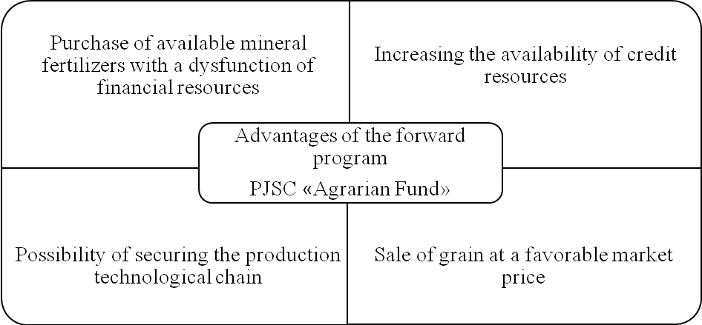
Fig. 1. Advantages of a forward program for agricultural producers from PJSC «Agrarian Fund»

Additional requirement of PJSC «Agrarian Fund» is compulsory insurance of the crop. Here is a list of insurance companies, with which PJSC «Agrarian Fund» co-operates as a beneficiary of voluntary insurance of agricultural products (fig. 2).

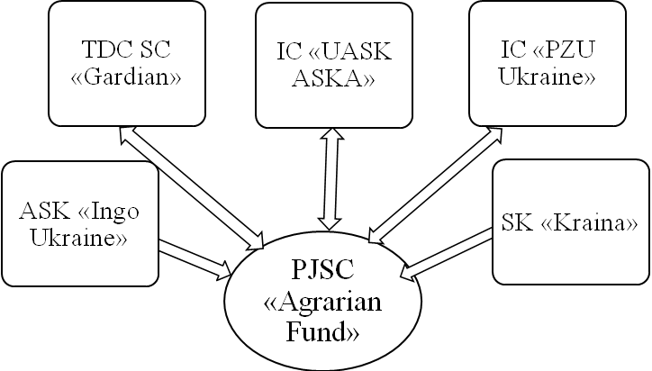
Fig. 2 Insurance companies with which PJSC «Agrarian Fund» cooperates in 2019

Companies that intend to cooperate with PJSC «Agrarian Fund» in the future may send the documents listed on the list.
The insurance contract is concluded between the producer and the insurance company, PJSC «Agrarian Fund» acts as the beneficiary.
The key terms for remuneration in PJSC «Agrarian Fund» are:
- Prepayment up to 65% of the cost of delivery;
- Interest rate 23-25%, non-consideration currency fluctuations or interest rate 15% taking into account exchange rate fluctuations.
It is also advisable to determine the minimum batches of grain deliveries in the conditions of a forward agreement at PJSC «Agrarian Fund» with the help of tab. 1
Based on table 1, we can conclude that the largest minimum supply of wheat and maize is 100 tons, while the smallest buckwheat and yellow peas are 30 tons.
Table 1
Minimum lots of grain deliveries at PJSC «Agrarian Fund» 2019
№ | Kind of culture | Minimum lot, tons
1. | Wheat | 100
2. | Maize | 100
3. | Barley | 50
4. | Rye | 50
5. | Buckwheat | 30
6. | Oat | 50
7. | Yellow peas | 30

Forward contracts cannot be described as publicly available derivatives, as the forward market has significant limitations, such as availability of a credit line, high credit rating, constant financial relationships between counterparties, etc. These conditions significantly reduce the number of participants in forward markets.
The scheme of conclusion of forward agreements in PJSC «Agrarian Fund» consists of two stages, we define stage 1 with the help of fig. 3.
Based on the data fig. 3, we can conclude that at the first stage, agricultural producers submit a package of documents to the Regional Branch of PJSC «Agrarian Fund», where the documents are inspected, followed by a meeting of the commission, which determines the discount rate and the percentage of the advance to be paid to the agrarian. Thereafter, an exchange contract, a collateral agreement and an insurance contract for the future yield are concluded. And at the last stage of the first stage, the farmer receives funds within 5 days.
In most cases, when concluding a contract, the parties agree that only the settlement of the difference between the contractual and spot price of the underlying instrument will be made on the date of payment, taking into account the amount of the contract, which in this case is called a conditional principal. This allows participants in the forward market to reduce the risk of supply disruption. In the case of an agreement on a conditional amount, the risk value is measured not by the principal amount, but by the cost of substituting a forward contract with another on identical terms.
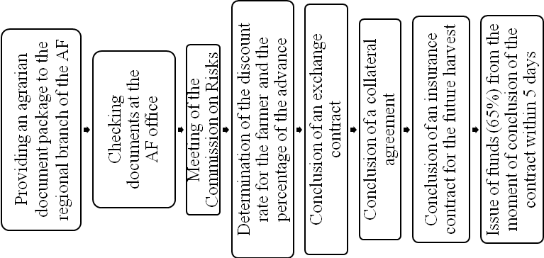
Fig. 3. Scheme of conclusion of forward agreements in PJSC «Agrarian Fund» 1 STAGE, 2019

Also, we will define the scheme of conclusion of forward agreements at PJSC «Agrarian Fund» in 2 stages (fig. 4).
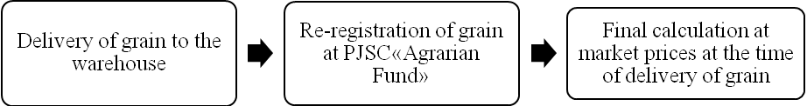
Fig. 4. Scheme of conclusion of forward agreements at PJSC «Agrarian Fund» 2 STAGE, 2019

Analyzing fig. 4, it can be noted that after the agrarian gathered a crop, he supplies the grain to the warehouse, after which the redistribution of grain delivery to PJSC «Agrarian Fund» takes place, and the last stage – the final settlement with the agrarian at market prices at the time of delivery of the grain.
Conclusions. Based on the above, we can note that the main difference of the forward transaction from bank loans – PJSC «Agrarian Fund» does not require additional collateral. The pledge is the grain of the future harvest, for which the contract is procured. Additional requirement from PJSC «Agrarian Fund» is compulsory insurance of the crop. The insurance contract is concluded between the producer and the insurance company, PJSC «Agrarian Fund» acts as the beneficiary.

REFERENCES:
- Law of Ukraine «On State Support to Agriculture in Ukraine»: Law of Ukraine dated June 24, 2004 // VVR. – 2004. – No. 49. – P. 527
- The Law of Ukraine «On Grain and the Grain Market» dated July 4, 2002 No. 37 – IV.URL: www.zakon.rada.gov.ua
- Law of Ukraine «On State Support to Agriculture» of June 24, 2004 No. 1877-IV. URL: www.zakon.rada.gov.ua
- The Civil Code of January 16, 2003 URL: www.zakon.rada.gov.ua
- Statistical Reporting of PJSC «Agrarian Fund». URL: www.agrofond.gov.ua.
- Draft Law of Ukraine «On Forward Collateral Purchase of Agricultural Products in Small and Medium-Sized Agricultural Enterprises» (No. 1059 dated 12.12.2012)
- Agrarian Fund. URL: http://grofond.gov.ua/products/forward-program/
- Hmyria V.P. Credit mechanism of financing of agrarian production in Ukraine. / V.P. Hmyria // Bulletin of the University of Banking. 2015. No. 2 (23). P. 54–62.
- Hryhoriev Kh. Legal analysis of forward purchases of grain as a means of state support to agricultural enterprises. / Kh. Hryhoriev / Entrepreneurship, economy and law. 2016. No. 5. P. 47–52
- Martynova L.V. Features of the State Regulation of the Grain Market in Ukraine / Martynova L.V. // The Bulletin of the East Ukrainian National University. V. Dahl - No. 4 (221), 2015. – P. 177–185
- Myniuk O.Yu. Problems of legal regulation of forward and futures agreements as types of stock transactions / O.Yu. Myniuk, V.V. Ivashchenko // Law and Society. – №2, 2015. – P. 72–78.
- Economic Encyclopedia: Three volumes. Vol. 1. / Redecorated: S.V. Mohernyi (ed.), Etc. – K .: Publishing Center «Academy», 2000. – 864 p.
- Papirnyk D.A. Advantages and disadvantages of the mechanism of forward contracts. Reform of the administrative-territorial system in Ukraine: realities and perspectives: All-Ukrainian scientific and practical conference: (Poltava, May 2019): abstracts of the report. Poltava, 2019.
- Solodkyi M.O. Stock market: training. manual. 2nd form., corr. K : Dzherela M. 2010. 336 p.
- Yatsuk O.O. Forward operations are an effective financial tool in the agrarian sector of the economy. / O.O. Yatsuk // NSC «Institute of Agrarian Economics». K., – 2013
- Yatsuk O.O. Mechanism of introduction of forward operations in the agrarian market and evaluation of its efficiency. / O.O. Yatsukh // Odesa, 2015.

UDC 336.746.2 (477)
JEL G13
Михайлова Олена Сергіївна, кандидат економічних наук, доцент.
Папірник Денис Артурович. Полтавська державна аграрна академія. Козик Міла Вікторівна. Полтавський національний технічний університет імені Юрія Кондратюка. Визначення сутності та практичного механізму укладання форвардних угод (на прикладі ПАТ «Аграрний фонд»). Визначено термін «форвардна угода». Проаналізовано поняття, сутність та практичний механізм діяльності й виконання форвардних угод на прикладі ПАТ «Аграрний фонд». Виконано глибокий і детальний аналіз вивчення проблем, пов’язаних із форвардними договорами. Проаналізовано практичний механізм діяльності та виконання форвардних угод. Визначено мету діяльності ПАТ «Аграрний фонд» і схарактеризовано організаційно-економічний стан підприємства. Оцінено діючий механізму форвардних угод на підприємстві. Визначено переваги страхування майбутнього врожаю сільськогосподарських культур за форвардною програмою ПАТ «Аграрний фонд».
Ключові слова: форвардна угода, аграрний ринок, аграрії, агровиробник, форвардна програма.

UDC 336.746.2 (477)
JEL G13
Mykhailova Olena, Ph.D. (Economics), Associate Professor. Papirnyk Denys. Poltava State Agrarian Academy. Kozyk Myla. Poltava National Technical Yuri Kondratyuk University. Determination of Essence and Practical Mechanism for Conclusion of Forward Agreements (example of PJSC «Agrarian Fund»). The concept, essence and analysis of the practical mechanism of activity and performance of forward transactions on an example of PJSC «Agrarian Fund» are analyzed. The concept of «forward transaction» is defined.
Key words: forward transaction, agrarian market, agrarians, agricultural producer, forward program.
UDC 336.746.2 (477)
JEL G13
Михайлова Елена Сергеевна, кандидат экономических наук, доцент.
Папирник Денис Артурович. Полтавская государственная аграрная академия.
Козык Мила Викторовна. Полтавский национальный технический университет имени Юрия Кондратюка. Определение сущности и практического механизма заключения форвардных сделок (на примере ОАО «Аграрный фонд»). Определен термин «форвардная сделка». Проанализированы понятие, сущность и практический механизм деятельности и выполнения форвардных сделок на примере ОАО «Аграрный фонд». Проведен глубокий и детальный анализ изучения проблем, связанных с форвардными договорами. Проанализирован практический механизм деятельности и выполнения форвардных сделок. Определены цели деятельности ОАО «Аграрный фонд», и охарактеризовано организационно-экономическое состояние предприятия. Оценен действующий механизма форвардных сделок на предприятии. Определены преимущества страхования будущего урожая сельскохозяйственных культур по форвардной программе ОАО «Аграрный фонд».
Ключевые слова: форвардная сделка, аграрный рынок, аграрии, агропроизводитель, форвардная программа.

