UDC 338.242(477)
JEL О000 + L510 DOI 10.26906/еір.2019.3(74).1755

NATIONAL ECONOMY ENERGY EFFICIENCY
CONCEPTUAL PRINCIPLES

Svitlana Onyshchenko*, DSc, Assistant Professor
Alina Hlushko**, PhD in Economics, Assistant Professor
Oleksandra Maslii***, PhD in Economics, Assistant Professor
Poltava National Technical Yuri Kondratyuk University

*ORCID 0000-0002-6173-4361
**ORCID 0000-0002-4086-1513
***ORCID 0000-0003-2184-968X
_____________________
© Onyshchenko S., 2019.
© Hlushko A., 2019.
© Maslii O., 2019.

Стаття отримана редакцією 22.09.2019 р.
The article was received by editorial board on 22.09.2019

Introduction. In the context of the global paradigm of sustainable development, which presupposes integration and balance of economic, social, environmental, institutional and innovation-technological components towards maximizing the interests of society provision, approaches to world economic and energy policy-making are changing. The principles of energy saving and energy efficiency are defined as the basic principles of economic growth. There is a shift from an outdated model of energy sector functioning, dominated by large producers, fossil fuels, inefficient networks, imperfect competition in the markets of natural gas, electricity, coal – to a new model that creates a more competitive environment, equalizing opportunities for development and minimizing one of the types of energy production or sources and ways of fuel supply. In this aspect, the urgency of the problem of energy use efficiency increasing is constantly growing.
The energy component plays an important role in the system of economic security as it envisages energy independence ensuring and energy supplies stability for the needs of the national economy and defense complex. The energy component can be a constraint on economic growth [1]. Increase in the level of national economy energy efficiency is capable of ensuring the country's resilience to internal and external threats related to energy dependency, solving the problems of energy insecurity, high energy prices, and improving living standards in terms of environment protection. National economy energy efficiency can be rightfully determined as a basis for ensuring the country's competitiveness in the long-term vision. In this regard, the need to explore the conceptual framework for ensuring the national economy's energy efficiency is unquestionable.
Overview of recent researches and publications. Scientific works by O. Vlasiuk and V. Barannyk are devoted to problematic aspects of energy conservation and energy efficiency measures development and implementation. V. Hryhorovskyi, S. Yermilova, Yu. Yashchenko and others examined prospects for implementation of the state energy saving policy. Significant contribution to the study of assessment and ways of ensuring energy security problems have made domestic scientists, namely: V. Barannyk, S. Bevz, Z. Varnalii, D. Voloshyn, A. Halchynskyi, O. Zakrevskyi, M. Zemlianyi, D. Zerkalov, Yu. Kolesnyk , V. Ksonzenko, A. Sukhorukov, O. Serdiuchenko, A. Shevtsova, V. Shlemko, A. Shchokin, and others. Still, under globalization and integration processes strengthening, increase in the national economy openness to the issue of Ukrainian economy energy efficiency ensuring as a basis for improving the level of the country economic security and its competitiveness in the world market needs further research.
The purpose of the paper. The purpose of the article is to determine conceptual framework for the national economy energy efficiency ensuring. To do this, it is necessary to characterize the legal and organizational principles of the state regulatory policy implementation in the sphere of Ukrainian economy energy efficiency, to analyze the national economy energy efficiency level and to determine the directions of its improvement.
The main body and results of the research. The national economy's energy efficiency is a priority direction in many countries' energy policy. Development of this area is due to such factors as non-renewable energy resources exhaustiveness, lack of alternatives for them to be replaced with more environmentally friendly and less energy intensive ones, availability of risks while extracting, processing and transportation – all these factors contribute to the development of research in this area. Due to political and military instability in the regions of energy production, tensions in global energy markets and rising energy prices, the above factors are increasingly important [2].
The issue of energy efficiency and energy conservation for Ukraine is primarily a matter of energy security and state independence. Implementation of energy efficiency and energy conservation measures, further liberalization of the energy market, especially on the supply side of energy services, development of public-private partnership in the field of energy efficiency implies improvement of legal framework in the field of energy efficiency, consistent implementation of European approaches to state regulatory policy in this sphere. Regulatory acts in the energy sector regulate the issues of energy conservation, energy efficiency and establish the relevant competence of public authorities, conferring the necessary powers on them. Some legislative and regulatory documents in the field of energy saving directly address the issues of energy use reduction, practical possibilities of implementing energy saving measures and mechanisms for their financing [3].
In fulfillment of implementation of the Protocol on the Accession of Ukraine to the Energy Community Treaty of December 15, 2010, Ukraine pledged to adapt national energy legislation to the standards of the European Union.
It is right to note positive developments regarding improvement of national legislation in the field of energy efficiency in recent years. In particular, implementation of Directive 2006/32 / EC on energy effectiveness of energy and energy services final use in 2015 approved the National Energy Efficiency Action Plan by 2020. The implementation of Directive 2010/31 / EC is reflected in the Law of Ukraine “On the Energy Performance of Buildings”, adopted on 22.06.2017 [4].
State regulatory policy in the field of the national economy energy efficiency is implemented, first of all, according to the following regulatory acts:
1) Ukraine's energy strategy for the period up to 2035, which envisages integration of the Ukrainian energy system with the European one with increasing energy exports, reducing the level of industrial production energy intensity and improving the state's energy security [5];
2) State target economic program for energy efficiency and development of renewable energy sources and alternative fuels for 2010-2020 [6];
3) National Energy Efficiency Action Plan by 2020, according to which Ukraine should reach 9% of planned energy savings from average final domestic consumption by 2020 [7];
4) National Renewable Energy Action Plan for 2020, which envisages reaching 11% of the energy produced from renewable energy sources in the overall energy structure of the country, which will provide a powerful incentive for the further development of the use of renewable energy in Ukraine [8];
5) regional energy efficiency programs;
6) sectoral energy efficiency improvement programs;
7) programs to reduce the consumption of energy resources by budgetary institutions through their rational use;
8) state standards for energy saving, costing, energy labeling, energy audit etc.
It is possible to state a sufficiently sound regulatory basis for the state policy implementation in the field of energy efficiency. However, the degree of practical implementation of government measures on energy conservation and energy efficiency remains low.
In 2017, Ukraine ranked 73rd among 127 countries in the Global Energy Architecture Performance Index Report [9]. The rating reflects the fact that in terms of energy import costs and GDP, Ukraine is at 122nd place, while energy expenditure per unit of GDP is 119th. It should be noted that the United States of America is ranked 52nd, with the ratio of energy costs for energy imports to GDP – 63rd, and energy expenditure per unit of GDP – 86th. Switzerland, Norway, Sweden, Denmark and France took the top five. And the first place in terms of energy consumption to GDP in 2017 was fixed for Argentina.
Ukraine is highly dependent on energy imports and belongs to energy scarce countries. The level of energy dependence of the state (more than 51%) is largely determined by inefficient use of energy resources and aggravates the problems of its energy security. At the same time, according to the Institute of General Energy of the National Academy of Sciences of Ukraine, the unrealized potential of energy saving and energy efficiency reaches 48% [10].
GDP is one of the main indicators in determining energy efficiency of each country's economy. According to statistics, in Ukraine the level of energy consumption per unit of GDP for more than twice exceeds the average level in the EU countries. Despite the positive dynamics of GDP energy intensity in recent years, its value remains close to critical (Fig. 1). It should be noted that the decrease in energy intensity of GDP in Ukraine is a consequence of the decrease in industrial output and is confirmed by the decrease in the industrial production index.
In particular, in 2000 the index was 113.2%, in 2013 – 99%, and in 2018 it decreased to 95.3% [11].

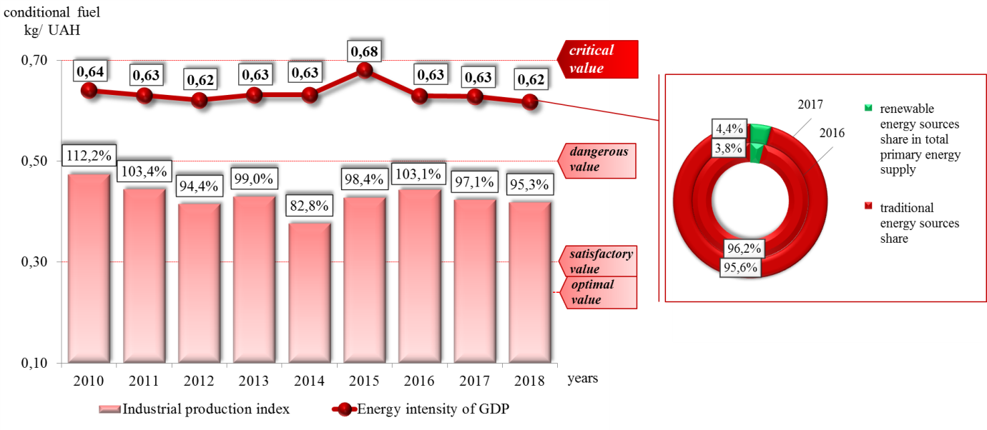

Fig. 1 Ukraine GDP Energy intensity in 2000–2018
Source: copyright development according data [11]

An important component of Ukraine's energy potential and improving energy security factor is renewable energy sources usage. Non-traditional types of energy demand in Ukraine is slow. Thus, the share of renewable energy sources in the primary energy supply structure remains low, although it increased by 0.6% compared to 2016. and was 4.4% in 2017.
Taking into account the above mentioned, it is legitimate to say that energy use in Ukraine remains insufficiently efficient at both the state and local levels, which leads to significant economic losses and has a negative impact on the development of the national economy. The main reasons for the high level of energy intensity GDP in the country are a large share of losses in energy transportation and inefficient production structure, dominated by energy-consuming industries (metallurgy, chemical production, fuel and energy sector, mining), consuming a lot of energy resources and electricity use outdated technologies and equipment [12]. The technological backwardness of the energy sector enterprises is manifested by the high degree of fixed assets depreciation and is caused by enterprises technological upgrading insufficient financing (Figure 2).
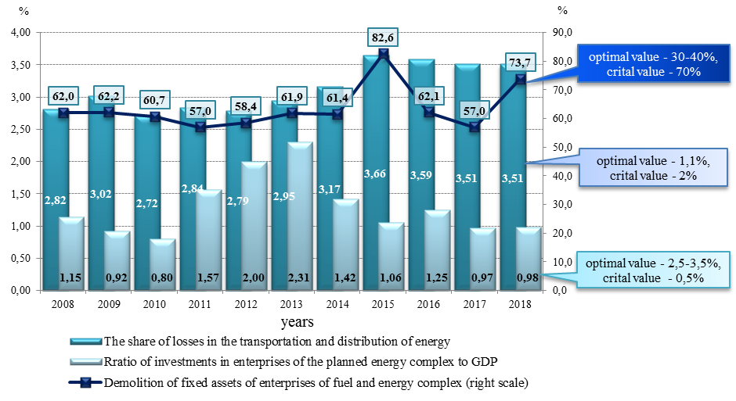
Fig. 2. Enterprises technical condition dynamics indicators in energy sector of Ukraine
Source: copyright development according to [11]
It is necessary to point out that the energy transit potential of Ukraine as a component of energy potential is represented by oil and gas transportation systems, which is a strategic development vector both fuel and energy complex and the national economy as a whole. The domestic gas transportation system supplies about 75 billion m3 of natural gas to domestic consumers and 110–120 billion m³ to consumers in 19 European countries each year. At the same time, GTS of Ukraine is characterized by high level of moral and physical deterioration technological equipment and low efficiency of gas pumping units at compressor stations equipment. Today, about 70% of gas pipelines total length and about 80% of gas pumping compressor stations units has been in operation more than 20 years. Underground gas storages technical conditions have been used since the beginning of gas injection into the reservoir from 20 to 44 years and they do not satisfy the requirements for their operation [13].
Gas transmission system significant deterioration is one of the major threats to Ukraine's energy security and a cause of national economy low energy efficiency leads to an increase in renewal of fixed assets every year [17]. In addition, during recent years it has been a steady tendency to reduce the volume of capital financing, current and planned repairs, which negatively affects the gas transmission system efficiency and reliability. Due to insufficient investment, the technical condition of the gas transportation system objects deteriorates, specific and unproductive costs of material and energy resources increase.
In addition to the technical condition of the gas transmission system, a potential threat to energy security is to legitimately determine the possibility of commissioning of the Nord Stream and South Stream gas pipelines, which may lead to a reduction in Russian gas transit through Ukraine through the redistribution of gas flows [14]. Also, the implementation of European projects to expand the underground gas storage network (UGS), particular the construction of new UGS in Poland, the Baltic States, Greece and Spain, can also have a negative impact on the energy transit potential and, accordingly, the level of energy efficiency of the national economy.
Thus, the realization of potential in the field of energy efficiency in Ukraine is hampered for a number of reasons. First, it is motivation for energy efficient consumption economic mechanisms imperfection. As there is no realization of energy savings in tariff and budget processes, the increase in energy prices does not motivate energy efficiency, but only causes further tariff increases and additional demand for budget financing [15].
Second, there is a lack of information support on the rational use of energy resources and a lack of experience in financing energy-efficient projects by investors or investment banks.
Thirdly, domestic energy transportation system low level competitiveness, which is caused by high moral and physical wear and tear.
In order to provide a basis for innovation development, to enhance energy-saving and energy-efficient entrepreneurship, to stimulate demand for energy-saving products and technologies, and to enhance the national economy competitiveness as a whole, it is necessary to create a favorable regulatory environment by implementing the following measures: the development and implementation energy efficiency policies through energy liberalization market and privatization utilities and regulation of competition; ensure a high level of awareness at educational institutions and professional organizations involved in education and training in energy efficiency; to implement conditions, resources and support for ensuring Energy Regulatory Authority impartiality and independence; support measures aimed at energy efficiency civil servants raising awareness and general public at the local and national levels [16]. In addition, by implementing a variety of energy efficiency programs, Ukraine should focus on global experience. Programmatic measures to improve energy efficiency should focus, first and foremost, on renewable energy the promotion.
Thus, these measures implementation and interaction between government, business and scientific potential effective form and mechanism creation will increase the national economy energy efficiency level.
Conclusions. National economy energy efficiency is the basis for enabling country's economic security energy component and its long-term competitiveness. Based on carried out research, it is legitimate to state a sufficiently sound regulatory basis for state policy implementation in the energy efficiency field.
State policy implementation in the field of energy efficiency due to its complex nature is quite a difficult problem, since its solution primarily involves a set of technological, political, economic, sociological and other factors the systematic consideration.
However, government measures practical implementation on energy conservation and energy efficiency extent of adoption remains low, as evidenced by GDP high energy intensity. Potential restraining realization Main reasons for energy efficiency implementation in the field in Ukraine are identified: motivation economic mechanisms imperfection for energy efficient consumption; lack of information support regarding the rational energy resources usage and lack of experience in financing energy-efficient projects by investors or investment banks; low level domestic energy transportation system of competitiveness, which is caused by high moral and physical wear and tear. A set of measures are proposed, which implementation is based on innovations development, entrepreneurial activities expansion in the field of energy saving and energy efficiency, stimulating the demand for energy-saving products and technologies, and improving the level national economy competitiveness and economic security as a whole.

REFERENCES:
1. Onyshchenko V.O., Onyshchenko S.V., Myroshnychenko V.V. Kontseptualno-metodychni zasady otsinky rivnia ekonomichnoi bezpeky derzhavy / V.O. Onyshchenko, S.V. Onyshchenko,
V.V. Myroshnychenko // Visnyk ekonomiky transportu i promyslovosti. – 2012. − №38. – P. 102−107.
2. Iskakov A.A. Enerhoefektyvnist natsionalnoi ekonomiky v konteksti yii ekoloho-ekonomichnoi bezpeky / A.A. Iskakov, I.M. Kobushko // Mekhanizm rehuliuvannia ekonomiky. – 2016. – № 3. – P. 88−96.
3. Kytskai L.I. Enerhoefektyvnist v Ukraini: analiz, problemy ta shliakhy pidvyshchennia /
L.I. Kytskai // Vseukrainskyi naukovo-vyrobnychyi zhurnal «Innovatsiina ekonomika». – 2013. – № 3 (41). –P. 32−37.
4. Hlushko A.D. Kontseptualni zasady realizatsii derzhavnoi rehuliatornoi polityky v napriamku zabezpechennia enerhoefektyvnosti natsionalnoi ekonomiky / A.D. Hlushko, L.A. Svystun, K.P. Shtepenko // Zbirnyk naukovykh prats II Mizhnarodnoi ukrainsko-azerbaidzhanskoi konferentsii «BUILDING INNOVATIONS – 2019», 23 – 24 travnia 2019 roku. – Poltava: PoltNTU, 2019. – P. 460−462 (634 p.).
5. Pro skhvalennia Enerhetychnoi stratehii Ukrainy na period do 2035 roku «Bezpeka, enerhoefektyvnist, konkurentospromozhnist»: Rozporiadzhennia Kabinetu ministriv Ukrainy vid 18 serpnia 2017 r. № 605-r. – Access mode: https://zakon.rada.gov.ua/laws/show/605-2017-%D1%80.
6. Pro zatverdzhennia Derzhavnoi tsilovoi ekonomichnoi prohramy enerhoefektyvnosti i rozvytku sfery vyrobnytstva enerhonosiiv z vidnovliuvanykh dzherel enerhii ta alternatyvnykh vydiv palyva na 2010-2020 roky: Postanova Kabinetu ministriv Ukrainy vid 1 bereznia 2010 r. № 243. – Access mode: https://zakon.rada.gov.ua/laws/show/243-2010-%D0%BF.
7. Pro Natsionalnyi plan dii z enerhoefektyvnosti na period do 2020 roku: Rozporiadzhennia Kabinetu ministriv Ukrainy vid 25 lystopada 2015 r. № 1228-r. – Access mode: https://zakon.rada.gov.ua/laws/show/1228-2015-%D1%80.
8. Pro Natsionalnyi plan dii z vidnovliuvanoi enerhetyky na period do 2020 roku: Rozporiadzhennia Kabinetu ministriv Ukrainy vid 1 zhovtnia 2014 r. № 902-r. – Access mode: https://zakon.rada.gov.ua/laws/show/902-2014-%D1%80.
9. Dani The World Economic Forum. – Access mode: http://reports.weforum.org/global-energy-architecture-performance-index 2017/economies/?doing_wp_cron=1542025928.2657608985900878906250%20-%20economy=UKR
10. Dosvid krain Yevrosoiuzu z pidvyshchennia enerhoefektyvnosti, enerhoaudytu ta enerhomenedzhmentu z enerhooshchadnosti v ekonomitsi krain [Elektronnyi resurs]. – Access mode: https://ua.energy/wp-content/uploads/2018/01/Pidvyshhennya-energoefektyvnosti-v-YES.pdf
11. Derzhavna sluzhba statystyky Ukrainy [Elektronnyi resurs]. – Access mode: http://www.ukrstat.gov.ua/
12. Babets I.H. Zabezpechennia enerhetychnoi bezpeky Ukrainy v umovakh heopolitychnykh transformatsii / I.H. Babets // Aktualni problemy mizhnarodnykh vidnosyn. – 2017. – Vypusk 132. – P. 125–137.
13. Ofitsiinyi sait DK «Ukrtranshaz» NAK «Naftohaz Ukrainy» [Elektronnyi resurs]. – Access mode: http://www.utg.ua/
14. Doroshkevych V.I. Hazotransportna systema Ukrainy yak skladova bezpeky natsionalnoho hospodarstva / V. I. Doroshkevych // Molodyi vchenyi. – 2018. – № 10(1). – S. 325–330. – Access mode: http://nbuv.gov.ua/UJRN/ molv_2018_10%281%29__79
15. Spivak Ya.O. Enerhozberezhennia yak faktor ekonomichnoho zrostannia Ukrainy / Ya.O. Spivak // Naukovyi visnyk Mizhnarodnoho humanitarnoho universytetu. –2015. – № 10. – P. 208–210.
16. Enerhetychna efektyvnist Ukrainy. Krashchi proektni idei [elektronne vydannia]: Proekt «Profesionalizatsiia ta stabilizatsiia enerhetychnoho menedzhmentu v Ukraini» / Uklad.: S.P. Denysiuk, O.V. Kotsar, Yu.V. Chernetska. – K.: KPI im. Ihoria Sikorskoho, 2016. –79 p. – Access mode: http://io.iee.kpi.ua/sites/default/files/HANDBOOK_of_BEST_ PRACTICES_2.pdf
17. Onyshchenko S.V., Analiz zahroz ekonomichnii bezpetsi Ukrainy v umovakh innovatsiinoho rozvytku ekonomiky / S.V. Onyshchenko, A.V. Matkovskyi, O.A. Puhach // Ekonomichnyi chasopys – ХХІ. – 2014. – № 1–2. – P.8 -11.
18. Zahrozy ekonomichnii bezpetsi Ukrainy: sutnist, otsiniuvannia ta mekhanizm uperedzhennia [monohrafiia] / S. V. Onyshchenko, O. A. Puhach. – Poltava: PoltNTU, 2015. – 337 p.

УДК 338.242(477)
Онищенко Світлана Володимирівна, доктор економічних наук, доцент. Глушко Аліна Дмитрівна, кандидат економічних наук, доцент. Маслій Олександра Анатоліївна, кандидат економічних наук, доцент. Полтавський національний технічний університет імені Юрія Кондратюка. Концептуальні засади забезпечення енергоефективності національної економіки. У статті розглянуто проблему підвищення рівня енергоефективності національної економіки. Здійснено аналіз нормативно-правової бази для реалізації державної політики щодо забезпечення енергоефективності економіки України. Охарактеризовано динамічний аналіз ряду показників економічного розвитку держави в контексті визначення стану та потенціалу енергоефективності національної економіки. Відзначено низький ступінь практичної реалізації державних заходів стосовно енергозбереження й енергоефективності. Визначено основні фактори стримування розвитку енергоефективності національної економіки та запропоновано ряд заходів відносно підвищення її рівня. Енергоефективність національної економіки є базисом для забезпечення енергетичної складової економічної безпеки країни та її конкурентоспроможності в довгостроковій перспективі. На основі проведеного дослідження правомірно констатувати достатньо ґрунтовну регуляторну базу реалізації державної політики у сфері енергоефективності. Проте ступінь практичної реалізації державних заходів з енергозбереження та енергоефективності залишається низьким, що підтверджується високим рівнем енергоємності ВВП. Головними причинами стримування реалізації потенціалу у сфері енергоефективності в Україні визначено: недосконалість економічних механізмів мотивації до енергоефективного споживання; недостатність інформаційного забезпечення щодо раціонального використання енергетичних ресурсів та недостатність досвіду з фінансування енергоефективних проектів з боку інвесторів чи інвестиційних банків; низький рівень конкурентоспроможності вітчизняної енерготранспортної системи, що зумовлено високим моральним і фізичним зносом. Запропоновано ряд заходів, реалізація яких є базисом для розвитку інновацій, розширення можливостей підприємницької діяльності у сфері енергозбереження й енергоефективності, стимулювання попиту на енергозберігаючі продукти і технології та підвищення рівня конкурентоспроможності національної економіки й економічної безпеки в цілому.
Ключові слова: енергоефективність національної економіки, енергозбереження, державна регуляторна політика, енергетична незалежність, економічна безпека, енергетичний потенціал.

UDK 338.242(477)
Onyshchenko Svitlana, DSc in Economics, Associate Professor. Hlushko Alina, PhD in Economics, Assistant Professor. Maslii Oleksandra, PhD in Economics, Associate Professor. Poltava National Technical Yuri Kondratyuk University. National economy energy efficiency conceptual principles. The article addresses the problem of increasing the national economy energy efficiency level. Analysis of the regulatory framework for the implementation of state policy towards ensuring energy efficiency of the Ukrainian economy is carried out. A dynamic analysis of a number of indicators for the state economic development in the context of determining the state and potential of energy efficiency of the national economy is characterized. A low degree of practical implementation of state measures on energy conservation and energy efficiency is noted. The main factors of restraining the national economy energy efficiency development are identified and a number of measures to increase its level are suggested.
Key words: national economy energy efficiency, energy saving, state regulatory policy, energy independence, economic security, energy potential.
УДК 338.242(477)
Онищенко Светлана Владимировна, доктор экономических наук, доцент. Глушко Алина Дмитриевна, кандидат экономических наук, доцент. Маслий Александра Анатольевна, кандидат экономических наук, доцент. Полтавский национальный технический университет имени Юрия Кондратюка. Концептуальные основы обеспечения энергоэффективности национальной экономики. В статье рассматривается проблема повышения уровня энергоэффективности национальной экономики. Проведен анализ нормативно-правовой базы для реализации государственной политики по обеспечению энергоэффективности экономики Украины. Охарактеризован динамический анализ ряда показателей развития экономики государства в контексте определения состояния и потенциала энергоэффективности национальной экономики. Отмечается низкая степень практической реализации государственных мер по энергосбережению и повышению энергоэффективности. Определены основные факторы сдерживания развития энергоэффективности национальной экономики и предложен ряд мер по повышению ее уровня.
Ключевые слова: энергоэффективность национальной экономики, энергосбережение, государственная регуляторная политика, энергетическая независимость, экономическая безопасность, энергетический потенциал.

