UDC 338.242(477):681.142 DOI 10.26906/еір.2019.4(75).1814
JEL О032

OPTIMAL RESERVATION OF DATA IN THE SYSTEM OF RESIDUAL CLASSES IN THE DIRECTION OF ENSURING INFORMATION SECURITY OF THE NATIONAL ECONOMY

Alina Hlushko*, PhD in Economics, Assistant Professor
Alina Yanko**, PhD in Technical Sciences, Assistant Professor
National University «Yuri Kondratyuk Poltava Polytechnic»

*ORCID 0000-0002-4086-1513
**ORCID 0000-0003-2876-9316
_____________________
© Hlushko A., 2019.
© Yanko A., 2019.

Стаття отримана редакцією 02.12.2019 р.
The article was received by editorial board on 02.12.2019

Introduction. A characteristic feature of an industrial society is the development and use of new, progressive information technologies based on the widespread use of superproductive and reliable dual-use highly reliable computer systems for processing economic data (HRCSPED). The development and improvement of over-productive and reliable dual-purpose HRCSPED is a strategically important and topical issue and is under the special control of the heads of states and governments of the advanced countries of the world. Today, there are a number of areas of science and technology, where there is a need for fast, reliable and high-precision integer arithmetic calculations: arithmetic operations on integers and polynomials; integer linear programming; operations on numbers and sets in the banking sector; solution of multidimensional NP-complete problems; implementation of routing algorithms; multiplication of vectors and matrices; the problem of the Fourier transform and its application; neural network data processing systems; digital economy data processing systems; tasks for military purposes; digital signal processing; digital image processing; cryptographic transformations; highly-precise integer arithmetic; the solution of problems related to the space research; highly-precise digital-to-analog and analog-to-digital conversions, etc.
Modern global processes of digitalization fundamentally are changing the economic landscape of the world. Economic growth, increase of competitiveness of national economies and quality of life of the population is impossible without digital business processes because of its positive externalities, the cumulative impact on social, economic, technological, intellectual and infrastructural capacity through Samode a synergistic effect. The overall effect is an increase in labor productivity, growth of GDP per capita on a national scale.
Digital trends gradually cover all branches of economic activity in Ukraine. Information is the main source of competitiveness of a business entity, region or state. The economic impact of information and communication technologies on the industries or areas of life (macro-level), specific product or services (variation) is determined by added value. Digital tools and technologies allow to increase the level of production of innovative products, to reduce the period from design concept to implementation of finished products, to ensure an appropriate level of profitability from the introduction of advanced technologies and to create competitive advantage for the state [1].
At the same time digitalization is not only a tool for the realization of national economic interests, which creates new opportunities for strengthening the economic security of the state, but also a source of new risks and security threats of the national economy in all its components (production, demographic, energy, foreign trade, investment and innovation, macroeconomic, food, social, financial security).
In this regard the urgency of ensuring information security of the national economy is indisputable.
Strengthening information security is based on ensuring the reliability, confidentiality, integrity and accessibility of public information resources, information with limited access, in particular, that circulates on objects of economic information infrastructure in conditions of information and hybrid wars. Modern methods and tools of information and communication technologies and digital technologies can not fully ensure the productive and reliable processing of ever-growing masses of information in the economy. Digitization processes require a significant increase in the speed and reliability of economic data processing, which is possible based on the application of new machine arithmetic, since the existing positional binary numerical system has disadvantages, and the existing methods of unauthorized access, hacking, viruses and other types of hacking and intrusion using the binary position code. Therefore, it is necessary to look for the use of such arithmetic in which the data was protected and the system itself was highly productive. In this aspect, the non-positioned numerical system in residual classes (SRC) opens wide opportunities for building not only new machine arithmetic, but also a fundamentally new schematic implementation of computer systems, which in turn significantly expands the use of machine arithmetic and is reliable, since existing threats are not adapted to non-positioned code structures and do not pose any threat to the data.
Overview of recent researches and publications.. In the context of the current problem of ensuring the stability of the national economy against the negative impact of a wide range of threats in the context of ensuring the economic security of the state are widely actualized in the works by domestic scientists, in particular V. Heiets, Z. Varnalii, O. Baranovskyi, A. Sukhorukov, O. Vlasiuk, M. Yermoshenko, V. Kyrylenko, H. Kozachenko, V. Shlemko, V. Onyshchenko, Y. Zhalil, V. Predborskyi, S. Kirieiev, V. Muntian, S. Pyrozhkov, V. Martyniuk, O. Komelina, N. Yurkov, A. Halchynskyi, T. Momot, D. Burkaltseva, B. Hubskyi, L. Ptashchenko, T. Kovalchuk , V. Kasianenko, S. Onyishchenko, O. Saienko, O. Starodubtseva and many others.
It is quite clear that in the context of digitization there is no field of knowledge where security research would not occupy a significant place in the system of scientific provisions. However, the issue of ensuring information security of Ukraine as a basis for improving the level of economic security of the country and its competitiveness in the world market needs further research.
The purpose of the article is to consider the issues to the reliability of the processing of integer data by developing and implementing methods for monitoring, diagnosis and correction of errors in the SRC. The basis of the project is the principles of data processing in the SRC. It is also possible to increase the productivity of the СSС and the reliability of processing integer data based on the use of new machine arithmetic. In the positional numeral system (PNS), the execution of an arithmetic operation involves the sequential processing of the digits of operands according to the rules determined by the content of the operation, and can not be completed until the values of all intermediate results are sequentially determined taking into account all the connections between the digits. Thus, PNSs, in which information is presented and processed in modern computers, have a significant drawback - the presence of inter-bit relations, which impose its imprint on the methods of implementing arithmetic operations, complicate the equipment and limit the speed. Therefore, it is natural to look for possibilities of using such arithmetic, in which there would be no queuing connections. In this regard, the system of calculus in the residual classes draws attention to itself. The system of residual classes has a valuable property of the independence of the residuals from each other on the basis of the adopted system. This independence offers wide opportunities for constructing not only new machine arithmetic, but also a fundamentally new scheme for the implementation of HRCSPED, which in turn significantly expands the use of machine arithmetic. The numerical system to a greater extent affects the structure of the operating unit (OU) of the HRCSPED.
The results of studies of methods for increasing the productivity and reliability of calculations of computer systems and data processing tools, which are presented in integer form, and which have been carried out over the past decades, have shown that it is practically impossible to achieve this within the limits of the positional systems of the calculus. This is due to the main disadvantage of modern HRCSPED operating in PNS: the presence of inter-bit relations between working operands. These relationships affect the architecture of the HRCSPED and the methods of implementing arithmetic operations, complicate the equipment and limit the speed of execution of arithmetic operations. In this regard, the increase in HRCSPED performance in PNS is carried out primarily by increasing clock speed, the development and application of parallel processing methods and tools, as well as through the use of different types of redundancy.
Application of the basic methods of increasing the productivity of the HRCSPED, based on the parallelization of computations, by using some properties of solvable tasks and algorithms cannot increase the productivity of HRCSPED in each and every case. The scope of their application is limited to a class of tasks to be solved. In addition, the process of artificial dismemberment of the algorithm itself, the determination and allocation of independent computing branches and related operations requires large labor costs, and it is not always possible to parallelize arbitrary algorithms in general. It should be noted that all existing methods of increasing productivity in PNS have a general disadvantage: the impossibility of parsing the maximum algorithms that are solved at the level of elementary operations. This fact led to the need to find ways to increase productivity, for example, based on the use of new structural solutions in the creation of HRCSPED, through the use of non-positional machine arithmetic. In particular, it is on the basis of the use of a non-positional numerical system in residual classes.
The results of research in the field of the creation of high-speed HRCSPED by well-known authors (Valakh M., Svoboda A., Sabo N., Akushskyi I.Ya., Yuditskyi D.I., Glushkov V.М., Torgashov V.А., Amberbaev V.М., Koliada A.A., Shimbo A., Paulier P., Thornton M.A., Dreschler R., Miller D.M., and others) showed that the use of SRC as a system of calculations of HRCSPED, intended for the implementation of integer arithmetic operations of addition, subtraction and multiplication numbers in the positive numerical range, significantly increases the speed of the solution of problems of a certain class. In recent years, the following HRCSPED have been developed in the SRC: On-board computer Star (USA); specialized DFT processors (USA, South Korea); a number of military specialized on-board computers (USA, Japan); specialized DSP processors (USA); Sprint Computers for Robotics (USA, Japan); in the Chinese company "Tpv Display Technology (Wuhan, China) Co., Ltd" in the development and implementation of a wireless sensor network monitoring system for industrial equipment in the manufacture of monitors; at the enterprise "Relcom-Podillia Ltd." in developing the system of video surveillance on the basis of wireless multimedia sensor networks; at "Cypress Semiconductors Corporation" in developing hardware software for CY8CKIT-050 PsoC 5 and CyFi (CYRF7936) modules that can be used in wireless sensor networks.
Now in Ukraine, with the participation of the authors of the Project, more than 40 research, development and design works have been performed. The Project Manager Dr.Sci.Tech., Professor V.A. Krasnobaiev has developed methods and algorithms aimed at increasing the speed and reliability of data processing in the SRC. Results of researches of methods and means of fast and reliable processing of integer data, presented in the non-positional number system of residual classes, are published in 4 monographs and 50 scientific articles. On the basis of developed algorithms 180 copyright certificates of the USSR, patents of Ukraine and Russia were obtained. Under the guidance of Prof. V.A. Krasnobaiev 4 doctoral and 20 candidate's theses on the porect's problems were defended. In the doctoral dissertation of one of the authors of the project O.A. Zamula for the first time, methods for implementing arithmetic modular operations of addition, multiplication and subtraction, which are based on the tabular principle of implementation of arithmetic operations, have been obtained, which allows to increase the speed of modular operations during the formation of signal-code structures with improved properties. The use of such structures can significantly improve characteristics of the computer systems and networks such as information security, impedance, reliability, secrecy, etc.
The purpose of the paper. The purpose of the article is to formulate and solve the problem of optimal reservation of economic data presented in the system of residual classes, as one way to achieve reliability in the direction of ensuring information security of the national economy.
The main body and results of the research. Considering information security from the perspective of the system approach, it is legitimate to note two aspects of its interpretation. On the one hand, information security is an independent element of national security of any country, and on the other – an integral part of any other security, in particular economic.
A number of foreign and domestic scientists (among them N. Arseniev, M. Beketov, V. Boldyrev, A. Khaustov) provide information security at all levels of utmost importance. In Particular, N. Beketov offers to view information security not as a form of national security, and as a relatively independent supranational form of common security, which provides progressive development of not only the information environment, but also society as a whole [2]. The globalization of the world and national information systems determine the growth of the information component in all kinds of national security.
The importance of information security declared at the highest level. In article 17 of the Constitution expressly provide that along with the protection of sovereignty and territorial integrity of Ukraine, ensuring its economic and informational security are the most important functions of the state, matter of all Ukrainian people" [3].
Economic research areas are considering the concept of "information security" from the perspective of protection of national economic interests and compare the cost of implementing and operating information security systems in the sphere of economic security and potential losses from risks and threats. The role of information security is determined, as a rule, the capacity of the means and methods of information security as important components of economic security at all levels to confront the threats of economic integrity of the state.
Analysis of the theoretical developments of specialists in the field of security provides an opportunity to systematize the main conceptual scientific approaches regarding the interpretation of the category "information security" (Fig. 1.).
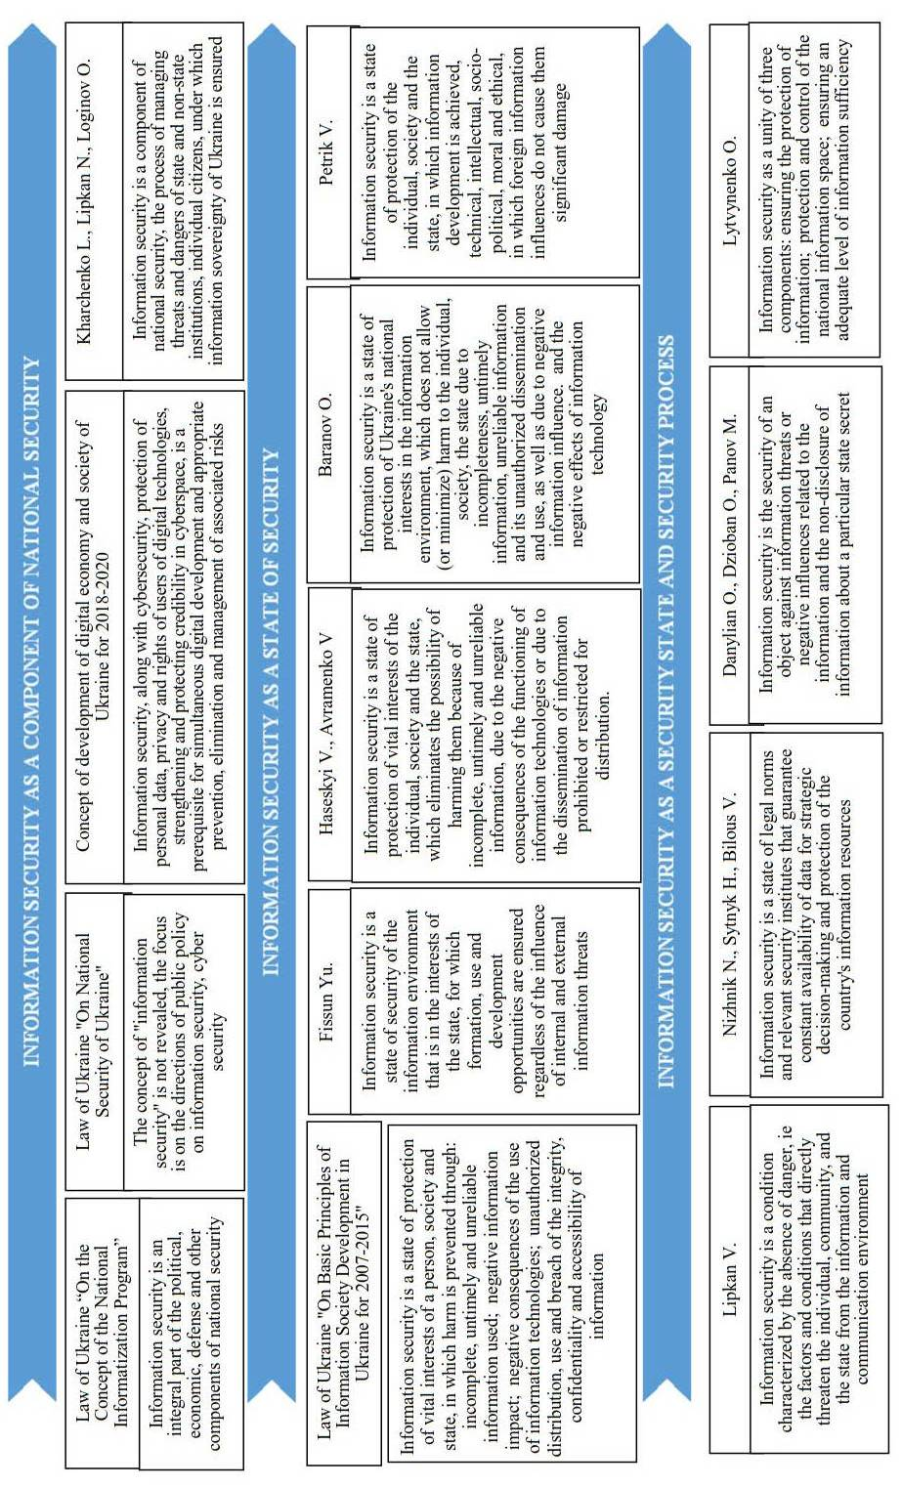
Fig. 1. Approaches to the interpretation of the concept of "information security
In the scientific literature at present there are three main conceptual approaches to defining the essence of information security:
1) information security as a component of national security;
2) information security as a condition of protection of the information environment and national interests from possible threats;
3) information security as the state of the system, which is able to ensure appropriate security settings.
Generalizing existing approaches, information security of the national economy is lawful to define as a condition of protection of the information environment, ensuring the realization of national economic interests, the stability of objects at the macro, meso- and micro-levels to both internal and external, real and potential threats, including those associated with the rapid development of it technologies.
Relying on a conflicting and protective approach to understanding the key category of national security information science in the context of digitization, we hold that the most important elements of national security information security are stability, stability, economic independence and the ability to develop economically and progressively [4].
The systematic approach of the study is:
- in a logically sound sequence of complex study of an object, identifying and attracting reserves to improve its functioning;
- in the consideration of each object as an integral part of the economic system of the highest order, and the results of its activity - as a consequence of the complex interaction of internal and external factors,
- in the perception of an object as a system or an orderly set of interrelated elements that interact in order to achieve a common goal.
The justified dual influence of digitization on the emergence of opportunities and threats to the functioning of the national economy necessitates the development of tools for the reliability of economic information, which is to reservation the data presented in the non-positioned number system.
After the theoretical substantiation of possibility of efficiently using the SRC codes for increasing the fault tolerance of HRCSPED has been carried out we move to the formulation of the optimal reservation problem in the SRC. The results of solving the problem of optimal reservation can give a general answer about the degree of efficiency of the use of SRC to improve the fault tolerance of HRCSPED.
We will consider the reliability scheme of HRCSPED, which is represented by a serial connection of information processing channels (IPC). To improve the reliability of HRCSPED, backup information processing paths (IPP) are introduced into the respective IPCs. It is assumed that, firstly, it is known what reliability of the i-th IPC of HRCSPED we can achieve if we additionally introduce redundant IPPs, i.e. we should know the reliability function (). Secondly, the use of a single IPP backup for the i-th IPC is associated with economic expenses. In general, costs can be measured not only in value units, but also in units of weight, volume, etc. Moreover, several types of costs can exist at the same time, however, for simplicity, we will not consider such relatively complex situations. Next, we will consider the costs in the form of an additionally introduced amount of equipment necessary to ensure the required level of reliability of HRCSPED [5].
If the state vector of HRCSPED is obtained in the following form, where – number of IPP in the i-th IPC, then the HRCSPED reliability indicator (for example, the probability of trouble-free operation or availability factor) can be represented as follows:
where R_{i}(x_{i}) – total number of IPPs in the i-th IPC;
n – the number of IPCs in HRCSPED.
At the same time, the total cost of organizing such a HRCSPED structure is:
where с_{i} – cost of one IPP in the i-th IPC.
The simplest and best-known optimal reliability problems are associated with reservation problems. In the general case, we can formulate the following direct and inverse optimal reservation problems.
Direct problem. Find the value of under the following constraint where С – is the maximum possible cost.
Inverse problem. Find the value under the condition , where – minimal acceptable value of the reliability index of the switching system of information processing (SSIP).
There are several different and sufficiently effective methods for the mathematical solution of the problems considered for optimal reservation.
One of the known simplest engineering methods for solving the problem of optimal reservation, which gives a practically sufficiently accurate solution, and in some cases an absolutely exact solution, is the method of coordinatewise steepest descent, which is as follows [6].
For each section of the compiled reliability scheme of HRCSPED, the values of the relative increments of the logarithm of the function characterizing the reliability of HRCSPED are calculated per unit cost when adding one i-th backup element (one IPP for the i-th IPC):
.
It is shown that when the function R_{i}(x_{i}) is convex (and it is really logarithmically convex for most practical cases), the procedure for optimally building up reserve elements in the system is to add the element for which the value Y_{i}(х_{i}) is the greatest. It should be noted that such a procedure does not make it possible to obtain an exact solution in all cases, but there is no particular need for excessive accuracy of the results of solving the task in practice, since the reliability statistics used in the calculations are, unfortunately, far from the desired authenticity, and the specified restrictions are not as categorical in practice as they appear in the conditions of a mathematical problem. This suggests that the solution obtained using this algorithm is quite satisfactory for practical engineering applications. More stringent solutions can be obtained, for example, by using the dynamic programming method or by using some kind of integer nonlinear programming algorithm [7].
Thus, in the literature, it is shown that the use of codes in the SRC significantly improves the performance of information processing in real time compared to the binary codes widely used in positional numbering systems of binary codes. The studies, the results of which are given in the literature, showed that the use of SRC can significantly increase the fault tolerance, reliability and survivability of systems and means of processing digital information. This is due to the structure of the original (unreserved) HRCSPED in SRC, shown in Fig. 2.
The class (type) of the tasks of digital signal processing, where the most effective use of codes in the SRC is defined. This applies, first of all, to the class of problems of modular processing of digital information, presented in integer form.
To obtain a final answer to the question about the effectiveness of using SRC to improve the resiliency of the basis for ensuring the reliability of HRCSPED, it is necessary to clearly formulate and solve the problem of optimal redundancy in the SRC, as well as to carry out a calculation and comparative analysis of the reliability of HRCSPED in the SRC and HRCSPED in the PNS. The results of solving problems of optimal reservation in SRC can answer two scientific and practical questions:
- how to ensure the required (specified) level of reliability of HRCSPED at the minimum cost (mass and size, energy, etc.) (the direct problem of optimal redundancy in reliability theory);
- how to ensure the maximum value at a given cost (the inverse problem of optimal reservation) [8].
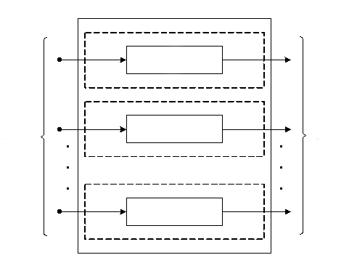
Input
Output
1
2
n
2
1
n
Fig. 2. The original structure of unreserved HRCSPED in SRC

In the literature, in general terms, the mathematical problem of the optimal reservation in the SRC is formulated as follows:
(1)
where – reliability of l-byte HRCSPED in SRC;
– amount of equipment (cost of) HRCSPED in SRC;
– set maximum possible amount of equipment.
It is known that for real-time HRCSPED reliability is a most important factor. As an indicator for the quantitative assessment of the reliability of HRCSPED, it is advisable to use the probability of failure-free operation. In addition, as a value In addition, as a value, we will consider the relative amount of equipment of a positional triple majority structure (which is widely used to increase the reliability of HRCSPED in the PNS) of an l-byte HRCSPED, reduced to the unit of the bit grid, i.e. . As the volume of equipment of the reserved HRCSPED in SRC, we will consider the relative amount of equipment in the reserved HRCSPED in SrC, which is determined by the expression:
,
where ,
– number of single-type information processing paths in the information processing channel modulo SRC, of which the reserved HRCSPED in SRC consists (fig. 3).
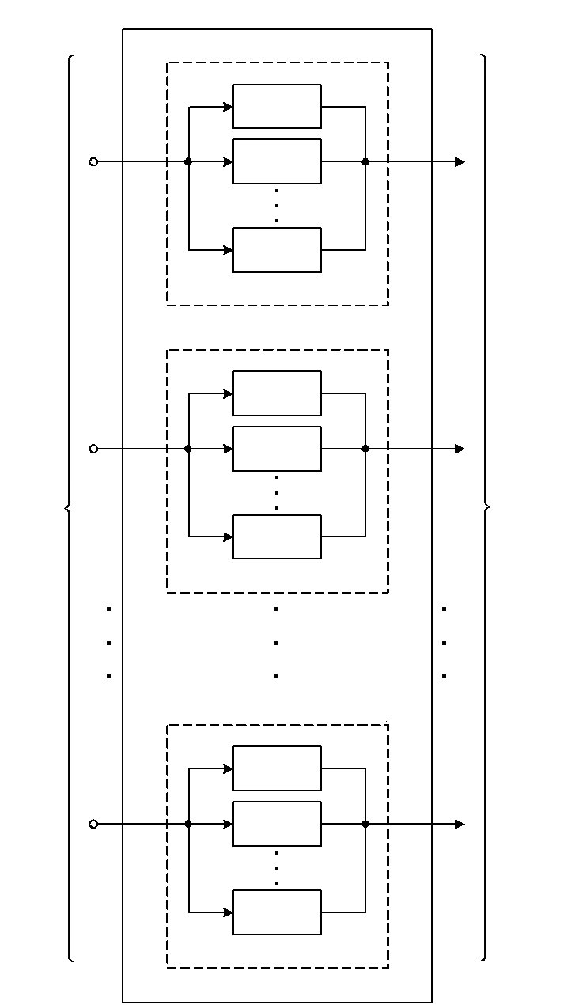

Input
Output
1
1
2
2
n
n

Fig. 3. Reserved structure of HRCSPED in SRC

Taking into account the above, and also taking into account the results of the formulation of the optimal reservation problem, we formulate (in a formalized form), respectively, the direct (2) and inverse (3) problems of the optimal reservation in the SRC as follows:
(2)

(3)
General source data for solving the problem of optimal reservation in SRC are given in Table 1.
This table shows the totality of the optimal bases of SRC for l-byte bit grids of HRCSPED.
Table 1
Set of optimal bases of SRC
 | SRC bases
1 | 3 | 4 | 5 | 7 | – | – | – | – | – | – | – | – | – | – | – | –
1 | 2 | 2 | 3 | 3 | – | – | – | – | – | – | – | – | – | – | – | –
2 | 2 | 5 | 7 | 9 | 11 | 13 | – | – | – | – | – | – | – | – | – | –
2 | 1 | 3 | 3 | 4 | 4 | 4 | – | – | – | – | – | – | – | – | – | –
3 | 3 | 4 | 5 | 11 | 13 | 17 | 19 | – | – | – | – | – | – | – | – | –
3 | 2 | 2 | 3 | 4 | 4 | 5 | 5 | – | – | – | – | – | – | – | – | –
4 | 2 | 3 | 5 | 7 | 11 | 13 | 17 | 19 | 23 | 29 | – | – | – | – | – | –
4 | 1 | 2 | 3 | 3 | 4 | 4 | 5 | 5 | 5 | 5 | – | – | – | – | – | –
8 | 2 | 3 | 5 | 7 | 11 | 13 | 17 | 19 | 23 | 29 | 31 | 37 | 41 | 43 | 47 | 53
8 | 1 | 2 | 3 | 3 | 4 | 4 | 5 | 5 | 5 | 5 | 5 | 6 | 6 | 6 | 6 | 6

Conclusions. In the course of the research, it was found that ensuring information security of the national economy, taking into account the processes of digitization, is possible provided that the principles of cohesion, systematicity, synergism are observed, which implies the use of a joint cooperative effect of the interaction of security system components at the macro and micro levels. The analysis of scientific concepts of consideration of the concept of "information security of the national economy" indicates that there are different approaches to its understanding. The justified dual impact of digitization on the emergence of opportunities and threats to the functioning of the national economy necessitated the development of methods of optimal data backup in the system of residual classes as a basis for ensuring information security of the national economy. The introduction of the theoretical and practical results will contribute to the creation, development and operation of high-performance HRCSPED with increased reliability of data processing. The methodological basis for building a HRCSPED in the SRC involves a comprehensive solution to the problem of increasing the productivity and integrity of the processing of integer data, as well as providing information security, impedance, performance and durability of the functioning of the digital economy and the economy as a whole.

REFERENCES:
1. Alina Hlushko. Institutional provision of the state regulatory policy in Ukraine / Alina Hlushko, Olga Marchyshynets // Journal of Advanced Research in Law and Economics. – ASERS Publishing House. – 2018. – Volume 9, Issue 3. – рр. 941-948.
2. Shulha V.I. Suchasni pidkhody do traktuvannia poniattia informatsiina bezpeka [Elektronnyi resurs] / V.I. Shulha // Elektronne naukove fakhove vydannia «Efektyvna ekonomika». – 2015. - # 4. – Rezhym dostupu: http://www.economy.nayka.com.ua/?op=1&z=5514.
3. Konstytutsiia Ukrainy vid 28.06.1996 r. # 254 k/96-VR [Elektronnyi resurs]. – Rezhym dostupu: http://rada.gov.ua.
4. Zahrozy ekonomichnii bezpetsi Ukrainy: sutnist, otsiniuvannia ta mekhanizm zapobihannia [monohrafiia] / S.V. Onyshchenko, O. A. Puhach. – Poltava: PoltNTU, 2015. – 337 s.
5. Akushskiy, I. Ya. Mashynnaya aryfmetyka v ostatochnyh klassah [Tekst] / I. Ya. Akushskiy, D. I. Yuditszkiy. – M.: Radio i svyaz, 1968. – 444 s.
6. Krasnobaiev V. Data processing in the system of residual classes [monograph] / V. Krasnobaiev, A. Kuznetsov, A. Yanko, S. Koshman, A. Zamula and T. Kuznetsova. // ASC Academic Publishing, 2019, 208 p. – ISBN: 978-0-9989826-6-3 (Hardback), ISBN: 978-0-9989826-7-0 (Ebook).
7. Yanko, A. S. The method of error correction in the system of residual classes / V. A. Krasnobaiev, A. S. Yanko, S. A. Koshman // Chemia i chemiczne technologie techniczne nauki ekologia nauk biologicznyhch geografia i geologia rolnictwo medycyna. – Przemyśl : Nauka i Sdudia, 2015. – 5(136). – P. 51-62.
8. Shu S. A research of architecture-based reliability with fault propagation for software-intensive systems / S. Shu , Y. Wang and Y. Wang // 2016 Annual Reliability and Maintainability Symposium (RAMS), Tucson, AZ, 2016, pp. 1–6.
9. Modeli i metody povysheniya otkazoustoychivosti i proizvoditelnosti upravlyayushhih vychislitelnyh kompleksov spetsyalizirovannyh sistem upravleniya realnogo vremenyi na osnove pryimeneniya nepozitsionnyh kodovyh struktur modulyarnoy arifmetiki [Tekst] / V. I. Barsov, L. S. Soroka, V. A. Krasnobaev, A. A. Kheri. – X.: UIPA, 2008. – 147 s.

УДК 338.242(477)
Глушко Аліна Дмитрівна, кандидат економічних наук, доцент. Янко Аліна Сергіївна, кандидат технічних наук. Національний університет «Полтавська політехніка імені Юрія Кондратюка». Оптимальне резервування даних у системі залишкових класів у напрямі забезпечення інформаційної безпеки національної економіки. Актуалізовано проблему підвищення рівня інформаційної безпеки національної економіки. Систематизовано наукові підходи до розгляду поняття «інформаційна безпека національної економіки». Обґрунтовано дуальний вплив діджиталізації на появу можливостей і загроз функціонуванню національної економіки, що обумовлює необхідність розробення інструментів для підвищення рівня достовірності економічної інформації. Проведено аналіз стану захищеності інформації в сучасних комп’ютерних системах обробки економічних даних; обґрунтовано вимоги та напрями розвитку високонадійних комп’ютерних систем для обробки економічних даних. Отримано нові наукові й науково-технічні досягнення в галузі розроблення оптимального резервування даних в економічній сфері із застосування непозиційної системи числення у залишкових класах, що підвищує безпеку та достовірніст обробки інформації.
Ключові слова: діджиталізація, інформаційна безпека, національна економіка, високонадійна комп’ютерна система обробки економічних даних, непозиційна система числення, оптимальне резервування, система залишкових класів.

UDC 338.242(477)
Hlushko Alina, PhD in Economics, Assistant Professor. Yanko Alina, PhD in Technical Sciences. National University «Yuri Kondratyuk Poltava Polytechnic». Optimal Reservation of Data in the System of Residual Classes in the Direction of Ensuring Information Security of the National Economy. The problem of increasing the level of information security of the national economy is actualized in the article. Scientific approaches to the concept of "information security of the national economy" are systematized. The dual impact of digitization on the emergence of opportunities and threats to the functioning of the national economy is substantiated, which necessitates the development of tools to improve the level of reliability of economic information. The state of information security in modern computer systems of economic data processing is analyzed; requirements and directions of development of highly reliable computer systems for processing of economic data are substantiated. New scientific and scientific and technical achievements in the field of developing an optimal data backup in the economic sphere were obtained with the use of the non-positioned numerical system in residual classes, which improves the security and reliability of information processing.
Keywords: digitization, information security, national economy, highly reliable computer system of economic data processing, non-positioned numerical system, optimal redundancy, system of residual classes.
УДК 338.242(477)
Глушко Алина Дмитриевна, кандидат экономических наук, доцент. Янко Алина Сергеевна, кандидат технических наук. Национальный университет «Полтавская политехника имени Юрия Кондратюка». Оптимальное резервирование данных в системе остаточных классов в направлении обеспечения информационной безопасности национальной экономики. Актуализирована проблема повышения уровня информационной безопасности национальной экономики. Систематизированы научные подходы к рассмотрению понятия «информационная безопасность национальной экономики». Обосновано дуальное влияние диджитализации на возникновение возможностей и угроз функционированию национальной экономики, что обусловливает необходимость разработки инструментов для повышения уровня достоверности экономической информации. Проведен анализ защищенности информации в современных компьютерных системах обработки экономических данных; обоснованы требования и направления развития высоконадежных компьютерных систем для обработки экономических данных. Получены новые научные и научно-технические достижения в области разработки оптимального резервирования данных в экономической сфере по применению непозиционной системы исчисления в остаточных классах, что повышает безопасность и достоверность обработки информации.
Ключевые слова: диджитализация, информационная безопасность, национальная экономика, высоконадежная компьютерная система обработки экономических данных, непозиционная система исчисления, оптимальное резервирование, система остаточных классов.

